Candoursoft.com

23

Sukam Admin

User Manual

CSPL

Admin Online Operations

User Manual Guide

    - Introduction .……………………………………………………………….
- User Login ………………………………………………………………..
- Home Page …….…………………………………………………………..
- Dashboard ………………………………………………………………...
- Job status ………………………………………………………….
- Pending calls ageing ………………………………………………………....
- Faulty Model Detail …………………………………………………………..
- Closed calls TAT ……………………………………………………………
- Brand ASP Mapping ..…………………………………………………………
- ASP Part Sales ..………………………………………………………….
- State Ageing with Model ……………………………………………………………
- ASP Wise TAT ……………………………………………………………
- State Wise TAT …………………………………………………………….
- Call details …………………………………………………………….
- Masters ………………………………………………………………
- Admin users ………..………....………………………………………..
- City .......…………….………………………………………..
- Product ……..……………………………………………………….
- Brand ……………..……………………………………………….
- Purchase from ………………………………………………………………
- Location …….......………………………………………………….
- Model ……………………………………………………………….
- Partcode …..…………………………………………………………..
- State ……………………………………………………………….
- VOC ……………………………………………………………….
- Repair Action .………………………………………………………………
- % HSN Tax .….………………………………………………………..
- Supplier .…………………………………………………………….
- Add Software ……………………………………………………………..
- Notice ………………………………………….....................
- Job search …..…………………………………………………........
- Claim ……………………………………………………………..
- Holiday …………………………………………………………....
- Create Pincode ……………………………………………………………..
- Fault ………………………………………………………...….
- Feedback ……………………………………………………...........
- Pending Reason …………………………………………......................
- PIN Re-Mapping ……………………………………………………………….
- Pincode Uploader ………………………………………………………………..
- Reports ……………………………………..………………………...
- All job .………………………………………………………………..
- Part Consumption ……………………………………………......................
- PO/PNA ………………………………………………………………….
- Sales / Dispatch …………………………………………………………………
- Party Account status …………………………………………………………………
- Stock Details ………………………………………………………………….
- Sales Return ………………………………………………………………….
- Stock Movement ……………………………………………………….............
- Pending PO ………………………………………………………………....
- Part price list ….………………………………………………………………
- ASC Location …………………………………………………………………..
- Attendance ………………………………………………………………….
- Approvals …………………………………………………………………..
- ASP Claim Approval …………………………………………………………………..
- Labour claim Generate …………………………………………………………………..
- Job Assign …………………………………………………………………..
- Travel Claim Generate …………………………………………………………………..
- ASP Claim Invoice …………………………………………………………………..
- Vendor PO Approval …………………………………………………………………..
- Request Approval …………………………………………………………………..
- Invoice Cancel …………………………………………………………………...
- Job Status Change …………………………………………………………………...
- Pending PO Cancel …………………………………………………………………….
- Stock Adjustment ……………………………………………………………………..
- Job Uploader ………………………………………………………………
- Logout ……………………………………………………………………..

Introduction

Customer Relationship Management (CRM) refers to a collaborative philosophy or system of business practices Implemented across an enterprise to organize the acquisition, aggregation, and analysis of customer profiles. Customer information is already captured from numerous points, such as sales information systems, call centers, and surveys. CRM Services allow this information to be shared across the company in order to create a customer-Centric organization.
The methods and software used for dissecting the collected customer data are called business intelligence systems. Once the data is analyzed, the most profitable customer demographics for the company can be targeted and catered to, and the long-term retention of this group will result in increased customer satisfaction and therefore increased revenue.
Customer-focused organizational intelligence is also a way to differentiate a company. It can unify disparate Candour Software (P) ltd. departmental goals, and improve the customer buying experience, effective lead generation, marketing campaign management, sales, order fulfillment, and customer service. The process generally requires an enterprise architecture composed of various configurable Web Services that allow for the company-wide integration of customer information input via the Internet.
The telephone continues to be the main point of customer contact for companies, and call centers are generally created to handle a large volume of calls. Therefore, of the various kinds of customer interaction services that should be integrated into a CRM strategy, quality, user-friendly call center software, including any voice recognition software, Voice XML applications, or IVR systems that recognize and reply to customer voice inquiries, are critical.

User login

First of all,, By using URL YOU have to login ,,After that you have to entered your User ID and Password.
After that you can choose your options and use your services .if you don’t have user id and Password ,you can’t access CRM Services.
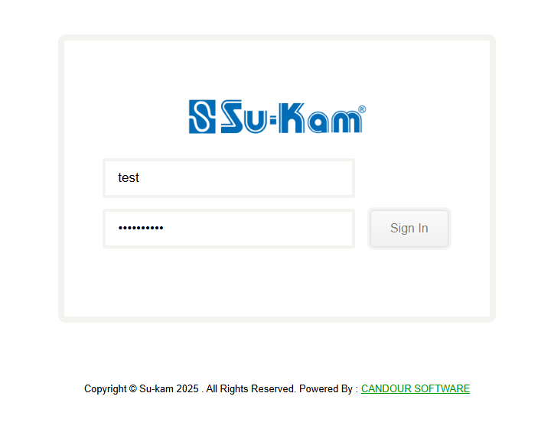

Home
Here , we show the Home page of RV Admin User as it is shown in the given image:
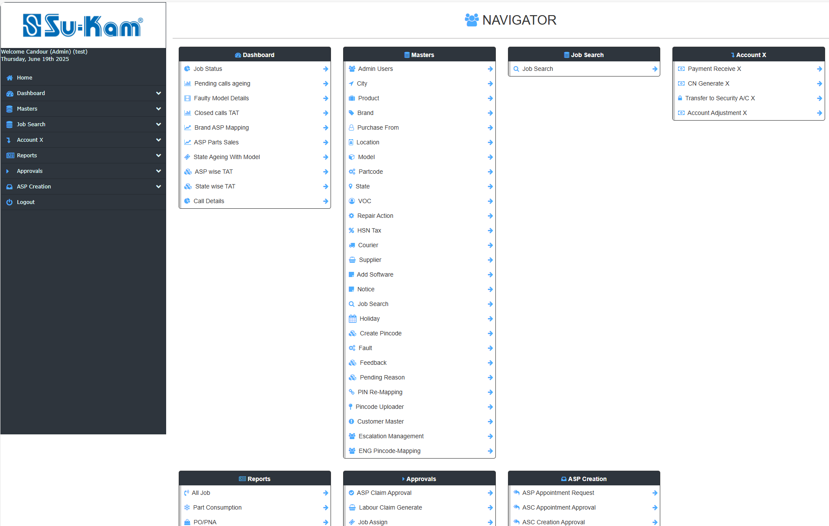

Dashboard

After Login this home page /Dashboard will open in this way :
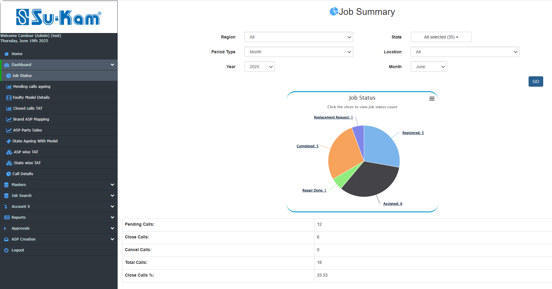

Admin Operations
This menu item contains some sub-menu items such as given below: -

- Dashboard-
- Job Status
- Pending Calls Ageing
- FAULTY MODEL DETAILS
- Closed Calls TAT
- BRAND ASP MAPPING
- ASP PART SALES
- STATE AGEING WITH MODEL
- ASP WISE TAT
- STATE WISE TAT
- CALL DETAILS

JOB STATUS

This menu provides to you create total no. of calls regarding region ,state, location and period wise data types:

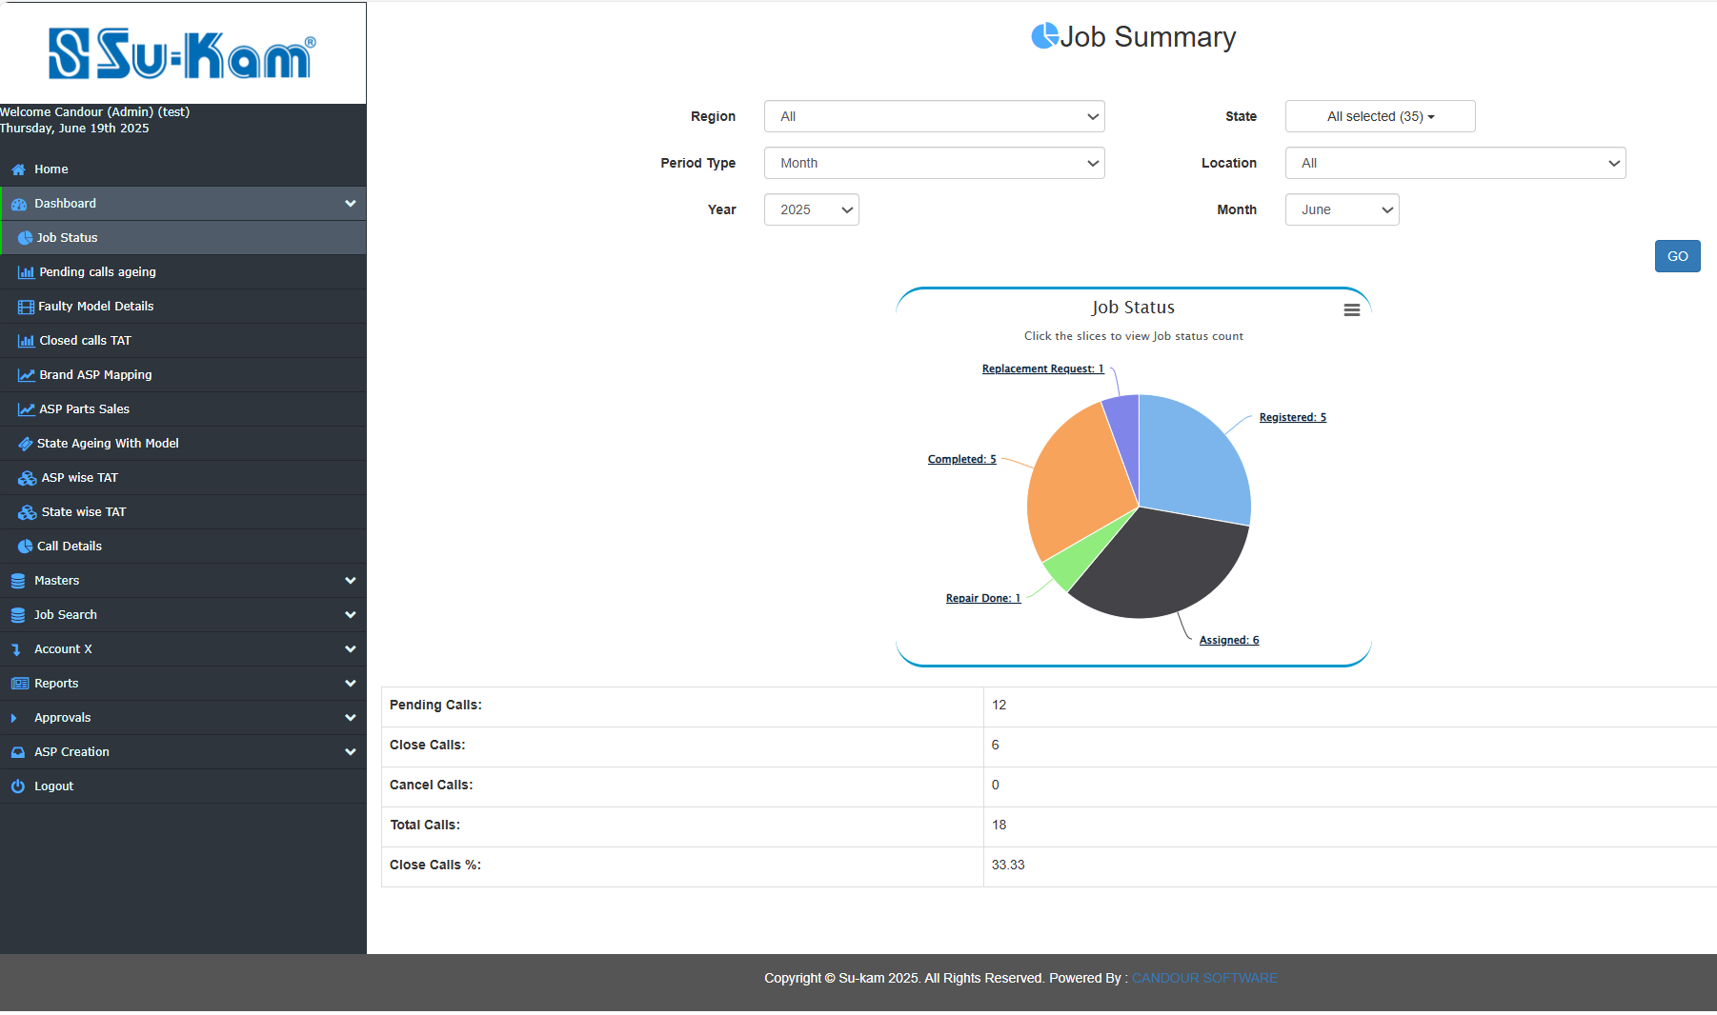
Fill all the information according to your requirements and click on Go button.

Pending calls ageing TAT

This menu provides you to create how much percent ageing is to be done with pending calls as shown below:
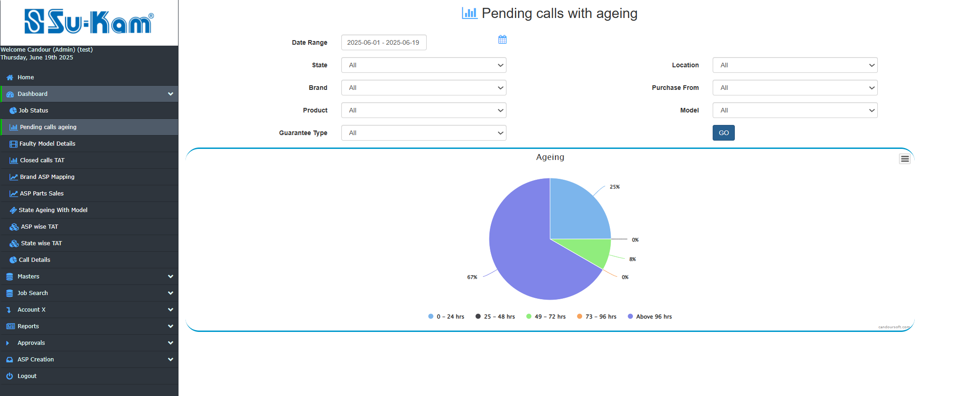

Fill all the information according to your requirements and click on GO button.
- Date Range
- State
- Location
- Brand
- Purchase from
- Product
- Model
- Guarantee Type

Faulty Model details
This Menu provides you to create the report of faulty or defect Model in terms of No. of models given as shown in below image:

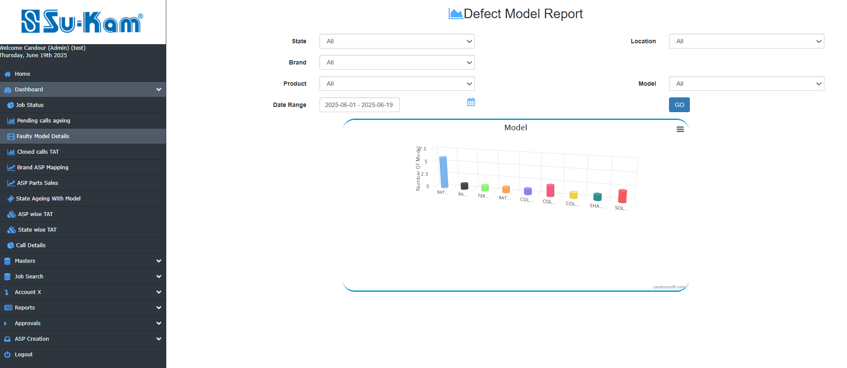
Fill all the information according to your requirements and click on GO button.
- Date Range
- State
- Location
- Brand
- Product
- Model

Closed calls TAT
This menu provides you to create closed calls percent on the basis of the TAT provided on it by fill all the information below:
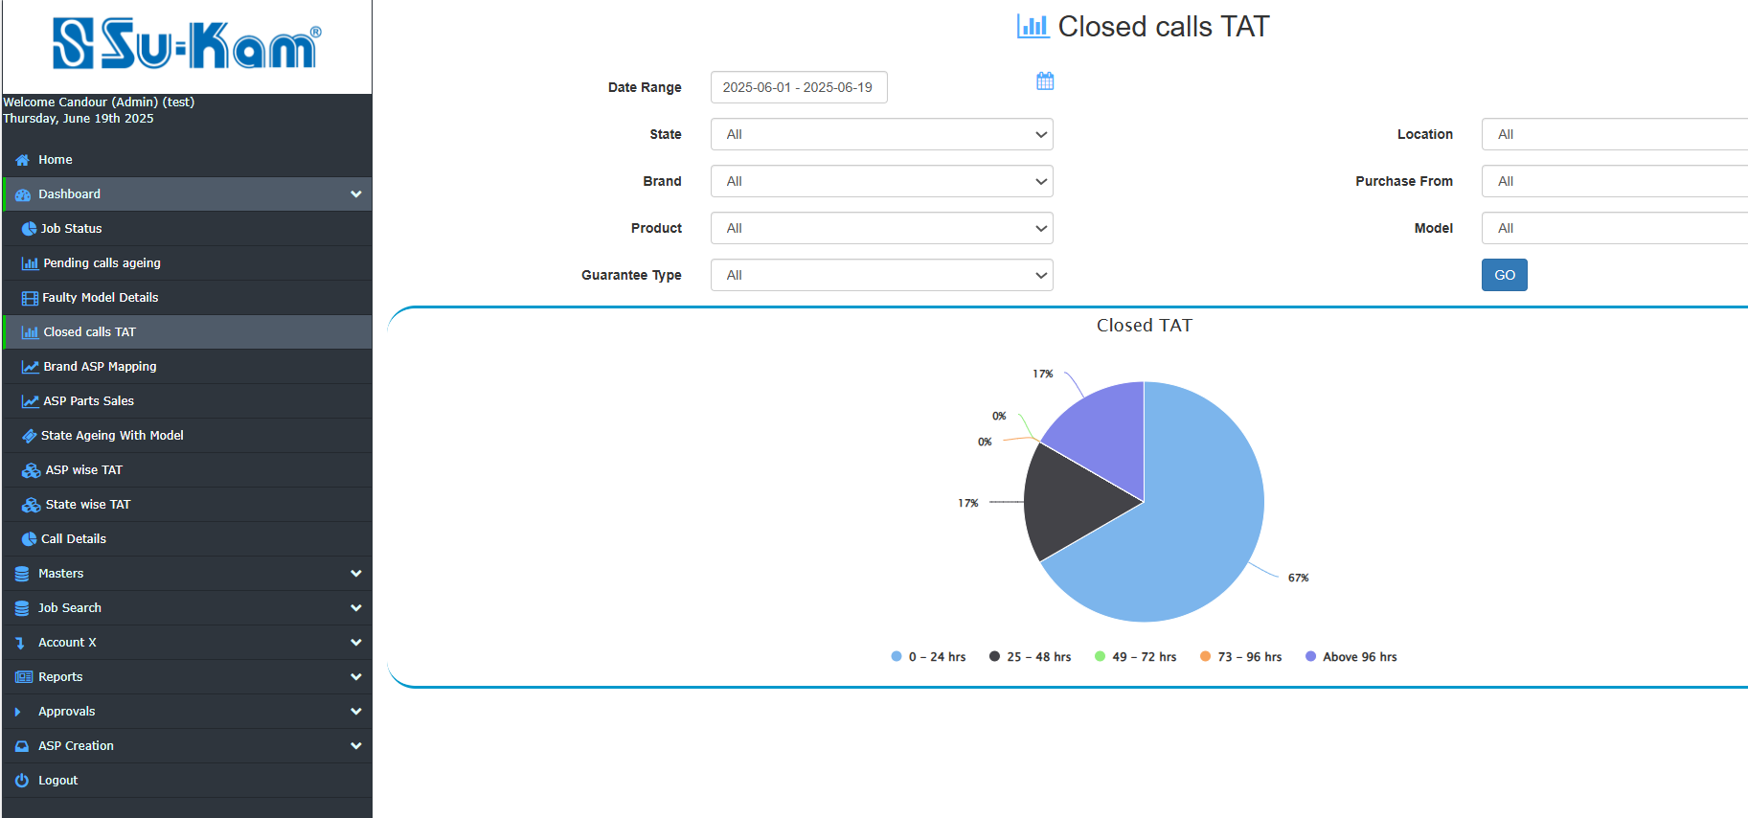
- Date Range
- State
- Brand
- Product
- Location
- Purchase from
- Model
- Guarantee Type
Fill all the details according to your requirements and click on go.

Brand ASP Mapping
In this dashboard the Brand mapping with all ASP is showing zone wise.
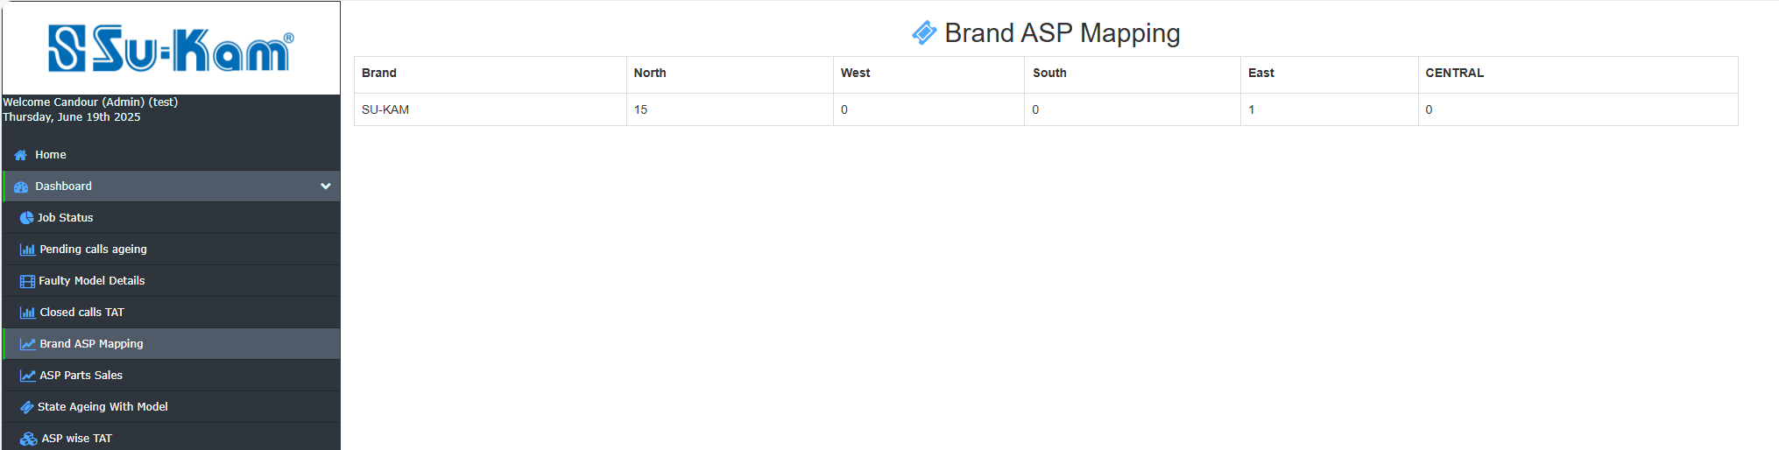

ASP Part Sales
This Menu showing the following details regarding parts sales on different pcs of :
- State
- Product
- Brand
- Location
- Purchase from
- Parts
- Date range

On the basis of the following information to be fill according to your requirements and click on Go:

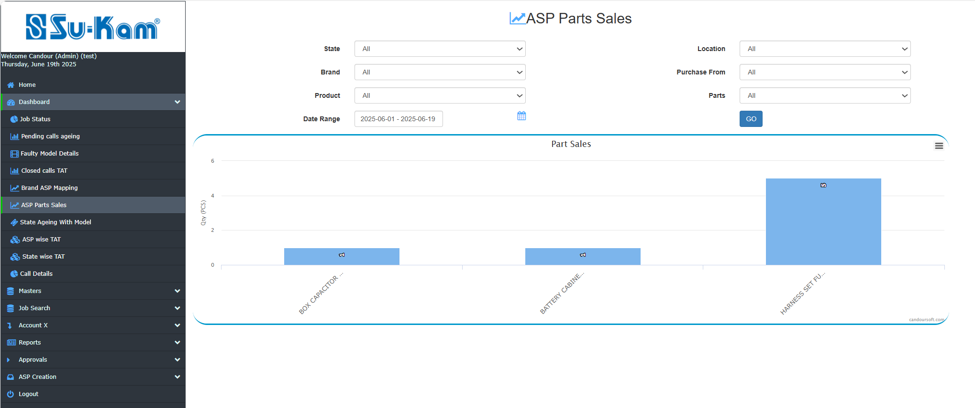

State Ageing with Model
This dashboard is showing all the pending complaint state wise and product wise.
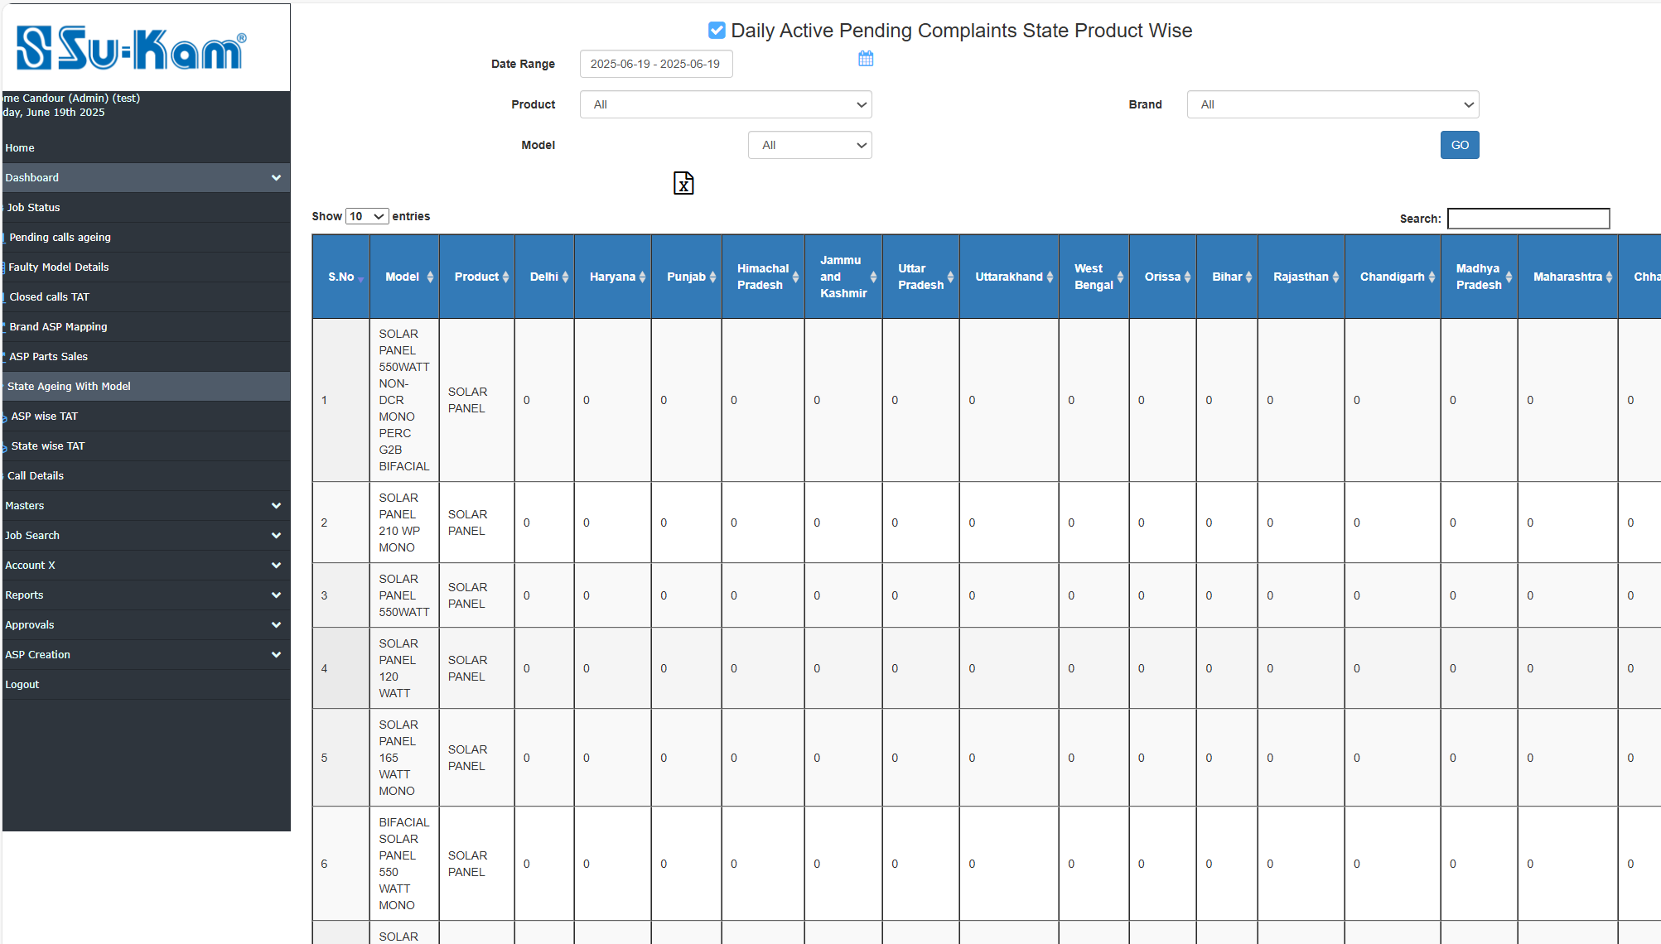

ASP Wise TAT
In this dashboard Ageing of all the complaints of all the ASP's.
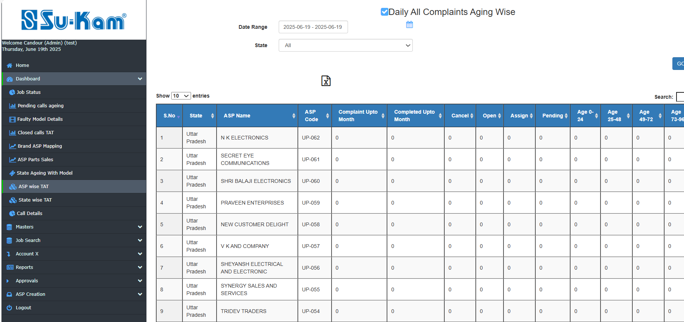

State Wise TAT
The state wise TAT% is shown in this dashboard in of all the complaints.
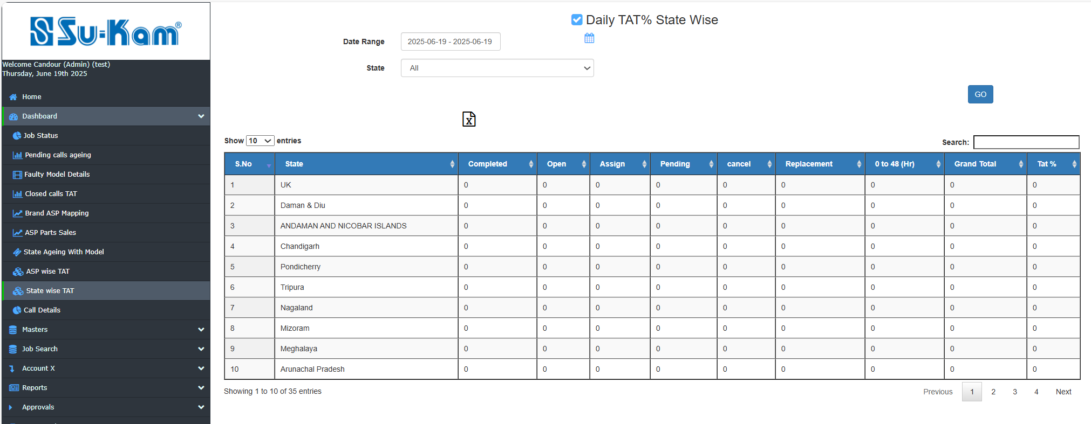

Call Details
This Menu provides you to create the call details with closed TAT and Ageing status on the basis of no. of days and no. of Jobs to create:
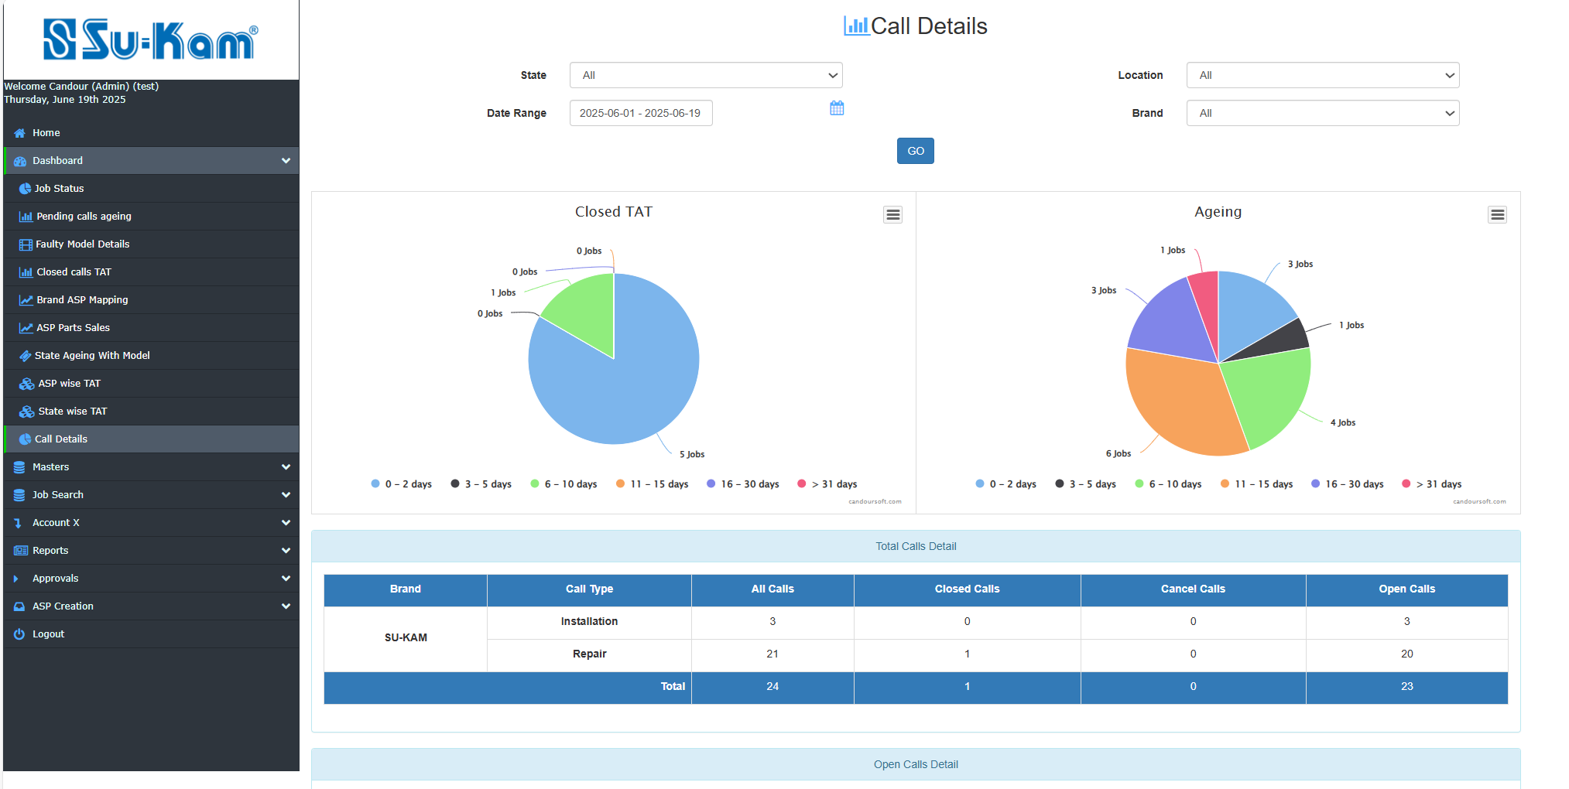
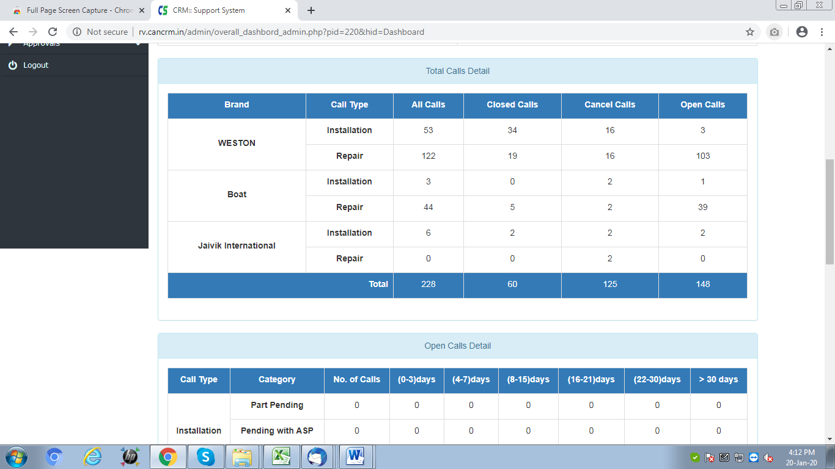
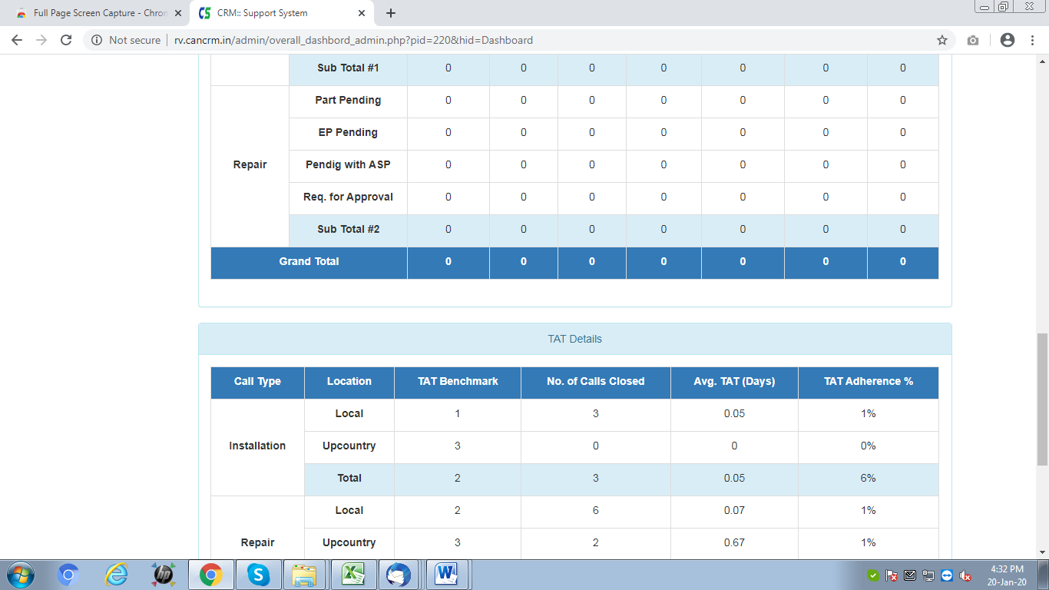

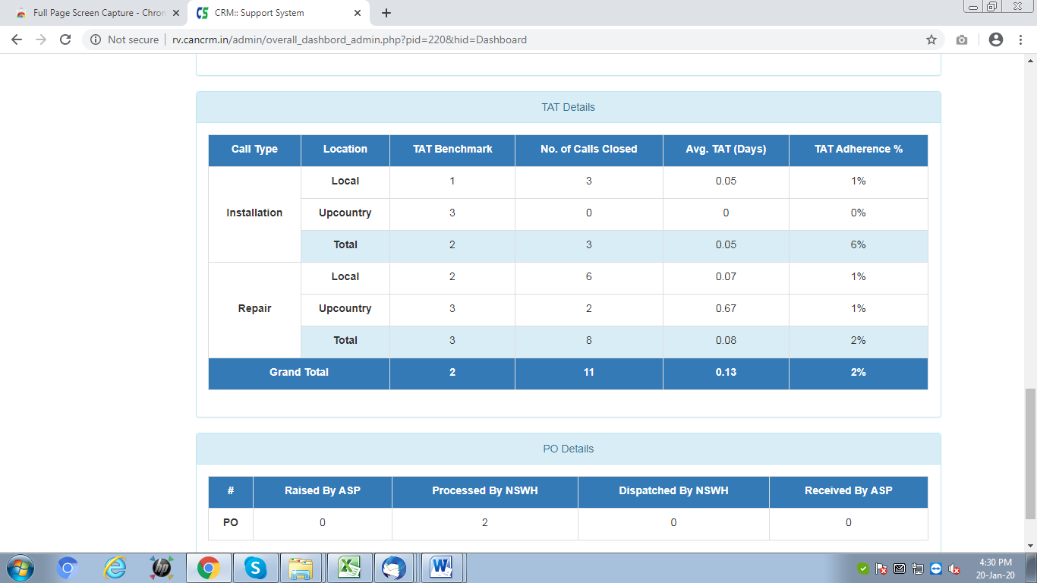

Masters
This Menu provides the details of the following listed sub menu items as shown in the figure:
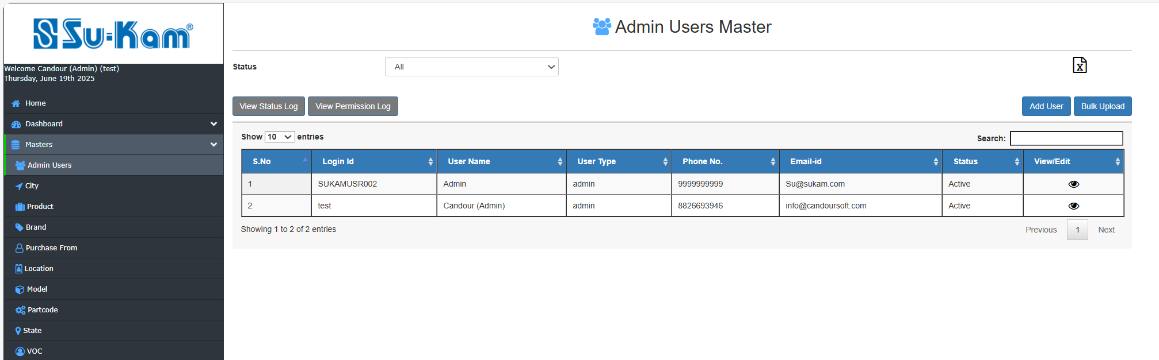

Admin users Masters
This Menu Provides you to create new admin user by click on Add User . First of all click on Status and Add User to get all the details:

- Select status
- Click on Add User
- Go on Edit user
- Fill all the details under it …

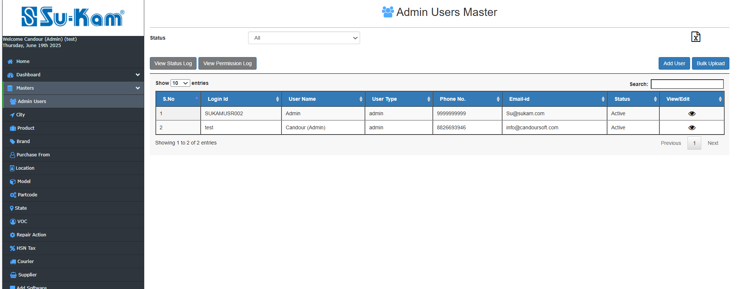
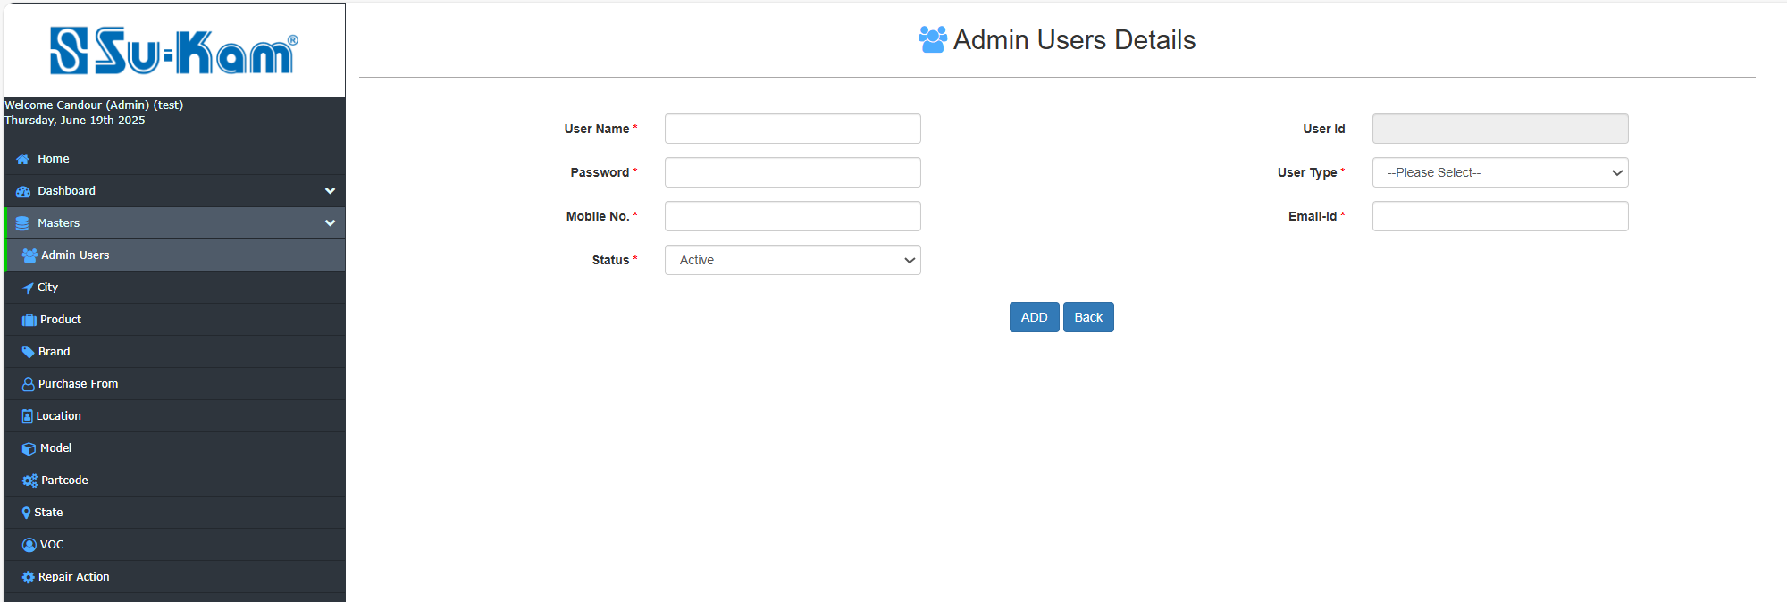
It has View details as shown under by click on above eye icon on the above page the following image will open:
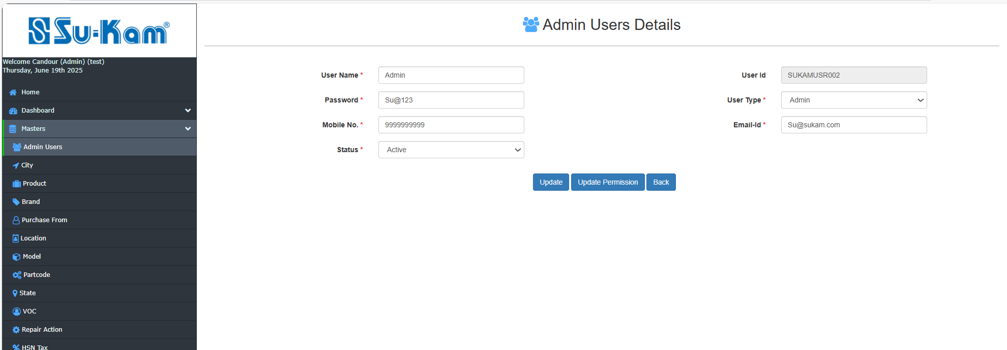
Check all the updates as per below images and ask user permission updation as shown in below figures…to be continued.

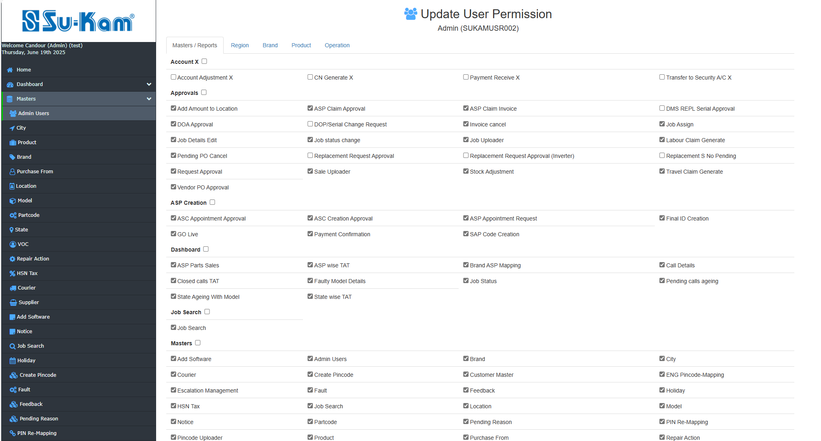
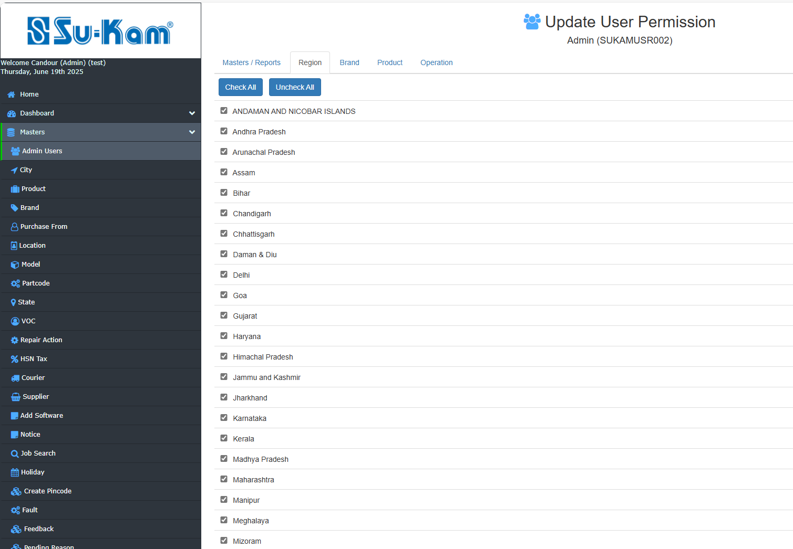
To be continued…….

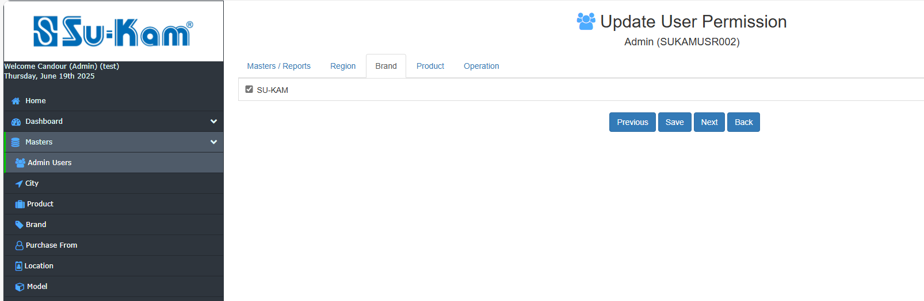
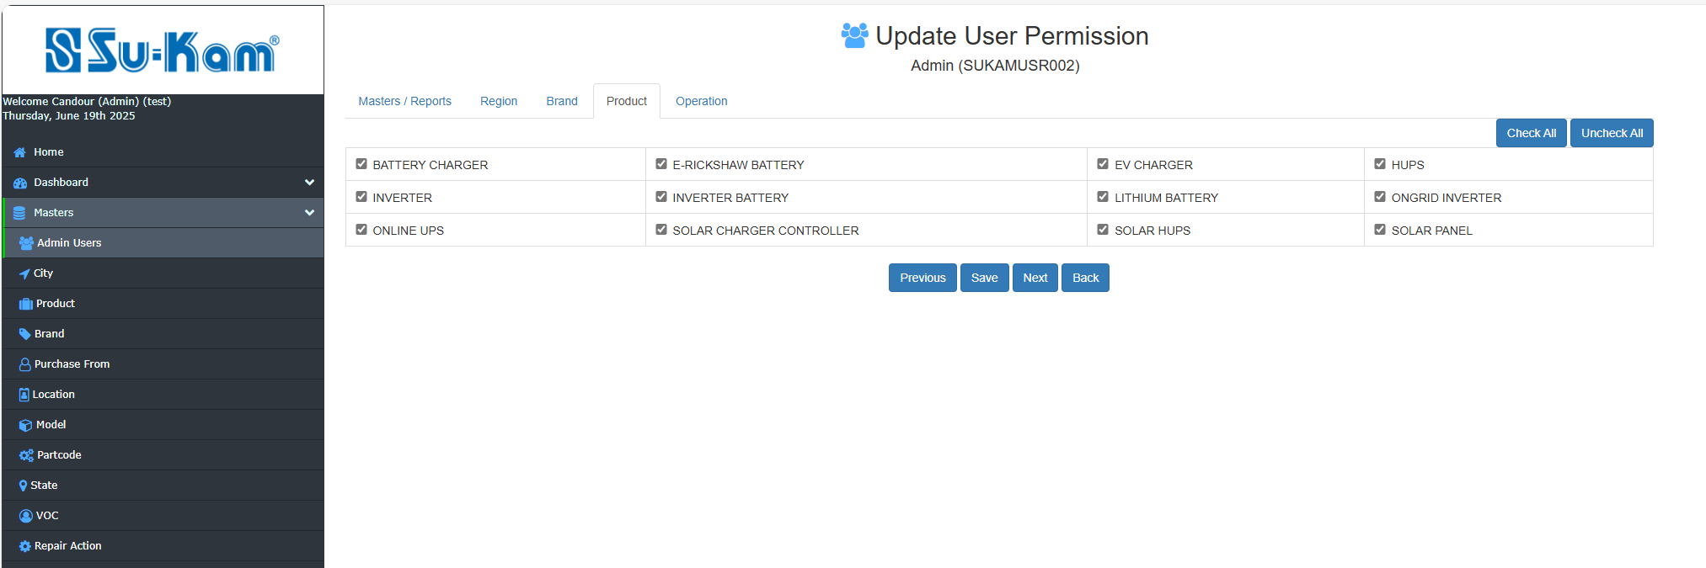
Click on next icon as shown above to go for the next page as depict below given image:
To be continued….

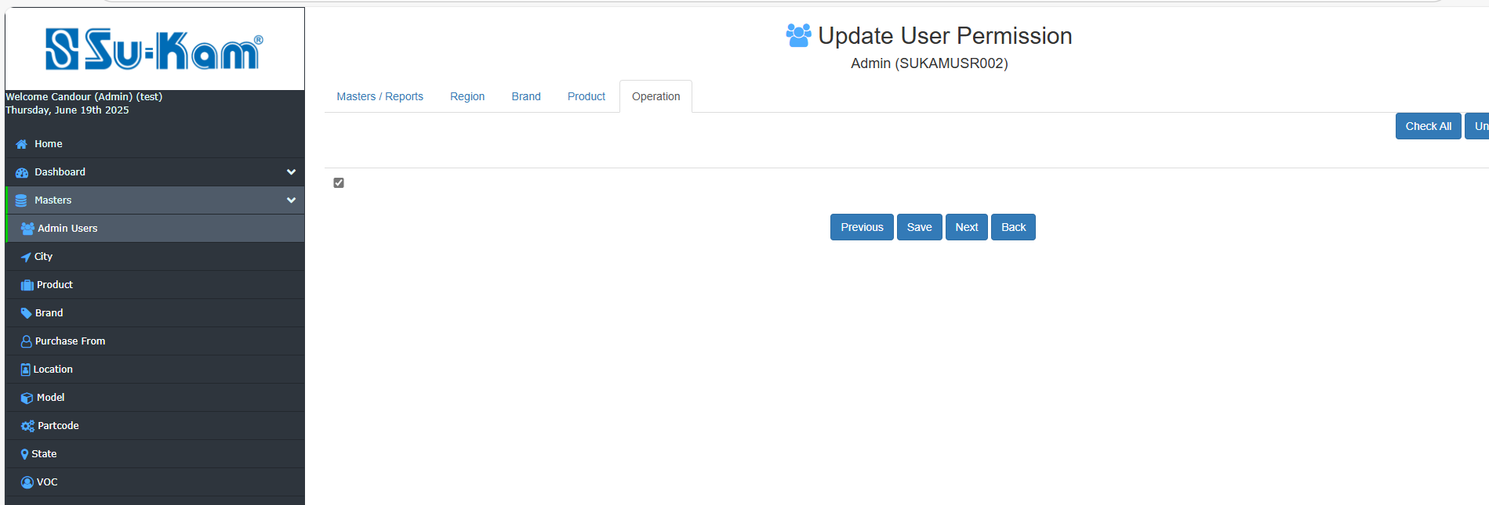
Check all the details and click on save button as shown above.

City Master
This Menu provides the details on the following information to be added:
- Add New City
- Click on Edit /view city
- GO On search .

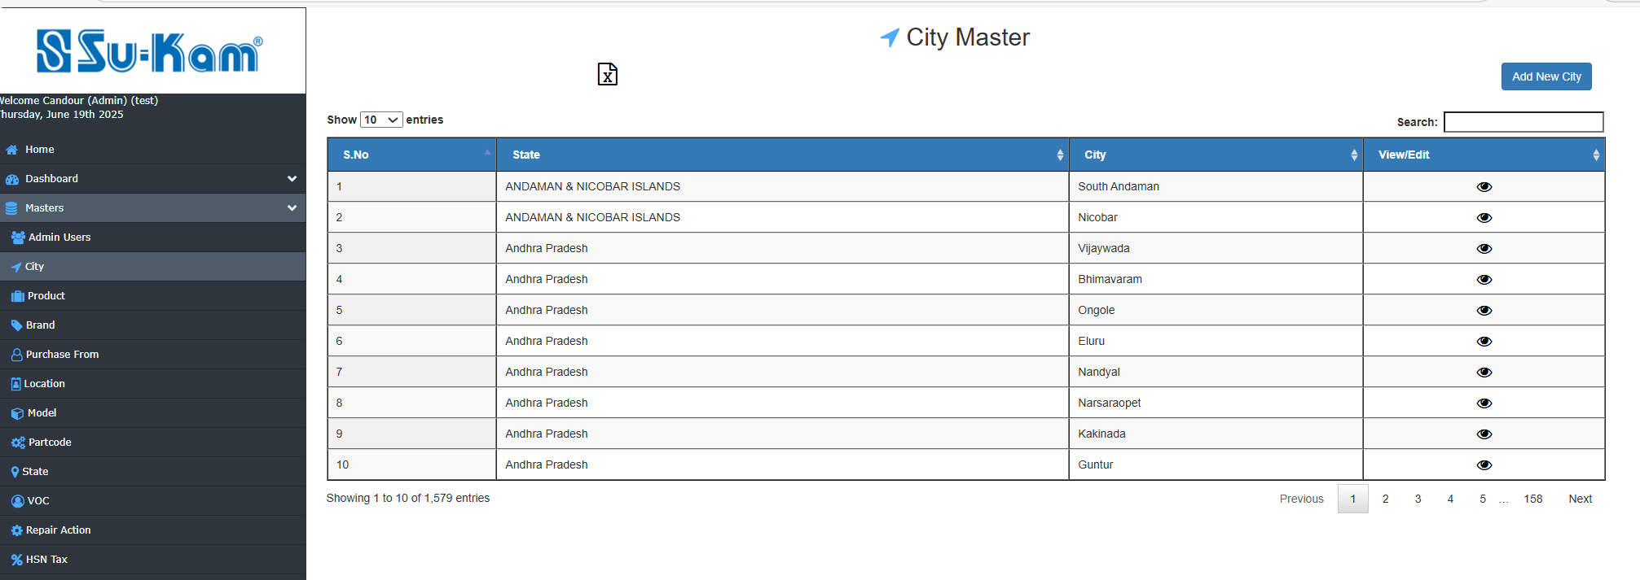
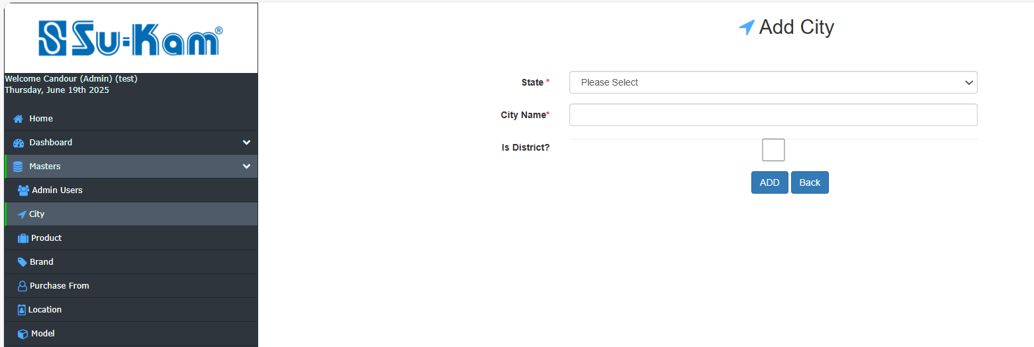

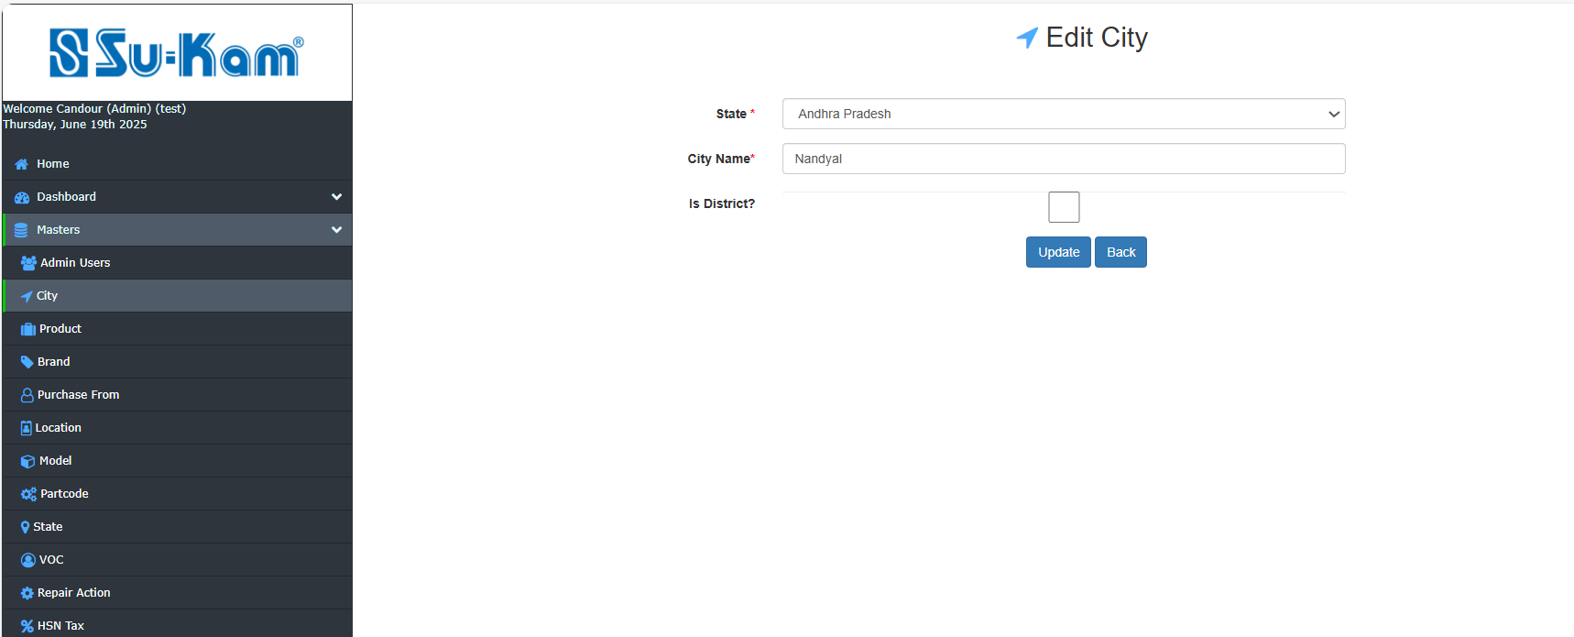
Fill all the details as according to your requirements, update and save back.

Product Master

This Menu Provides to add new product and edit/ view product by fill all the details :
- Select status
- Click on Add new product
- Go on Edit/ View product
- Go on Search
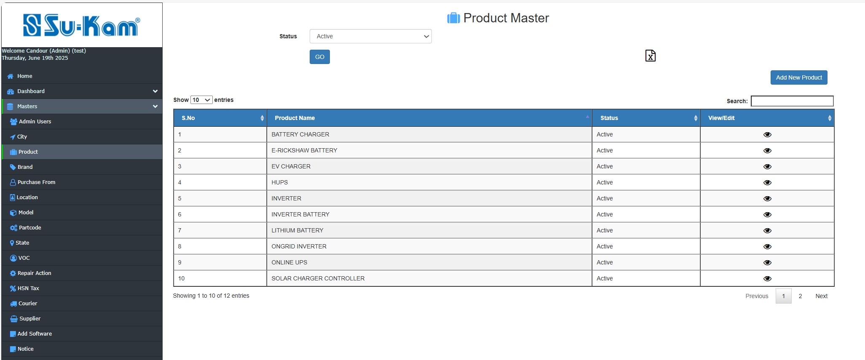

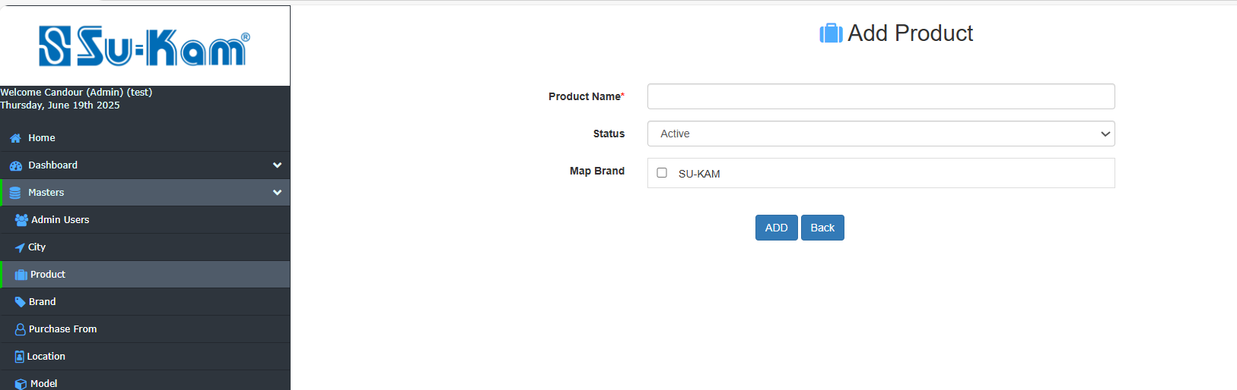

Update all the information and save back.

Brand Master
This Menu Provides to add new brand and edit/ view brand by fill all the details :
- Select status
- Click on Add new brand
- Go on Edit/ View brand
- Go on Search

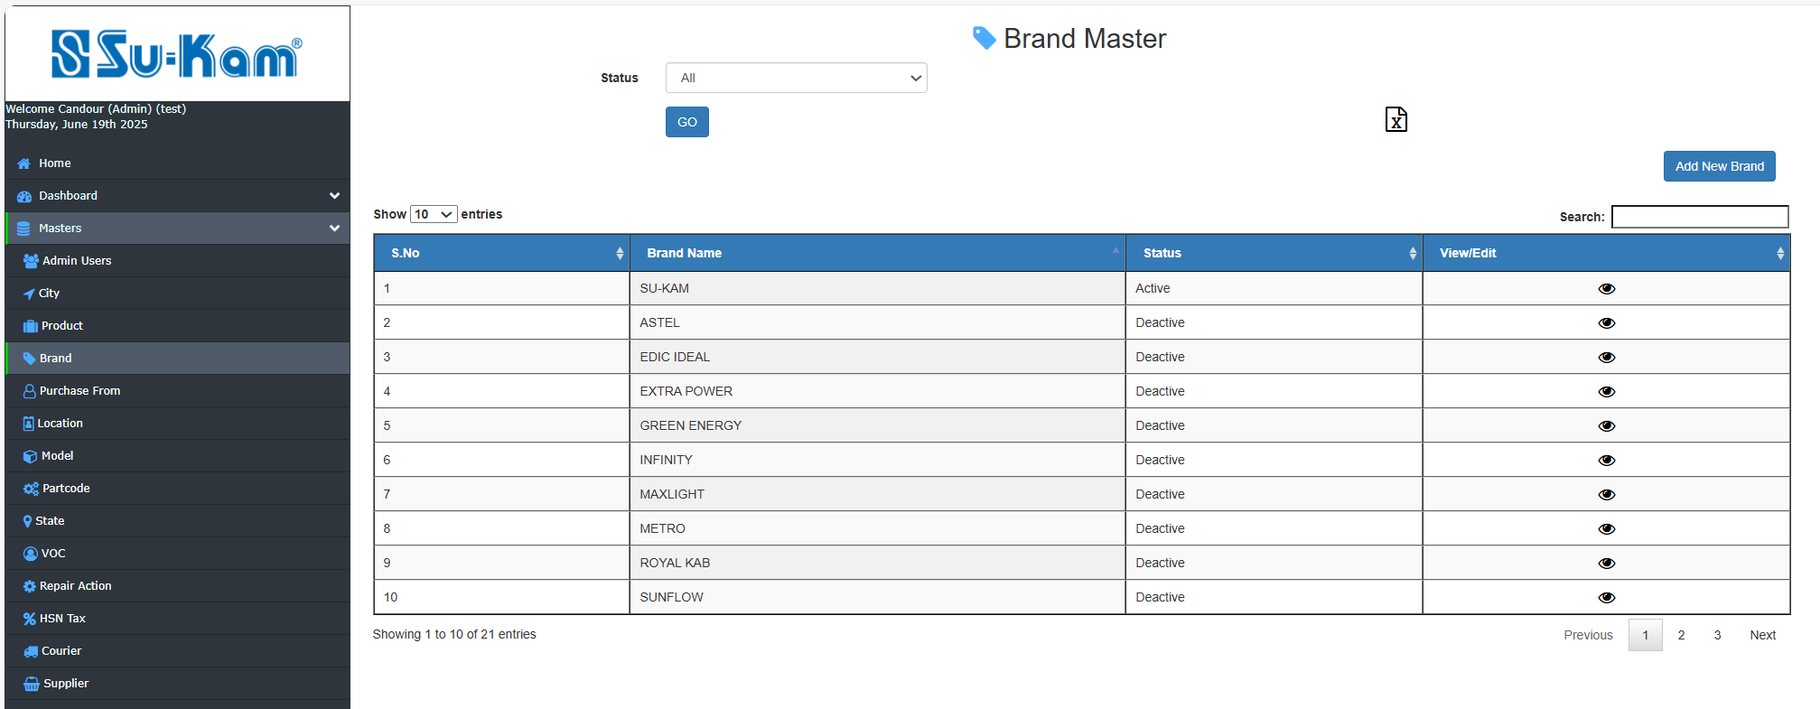

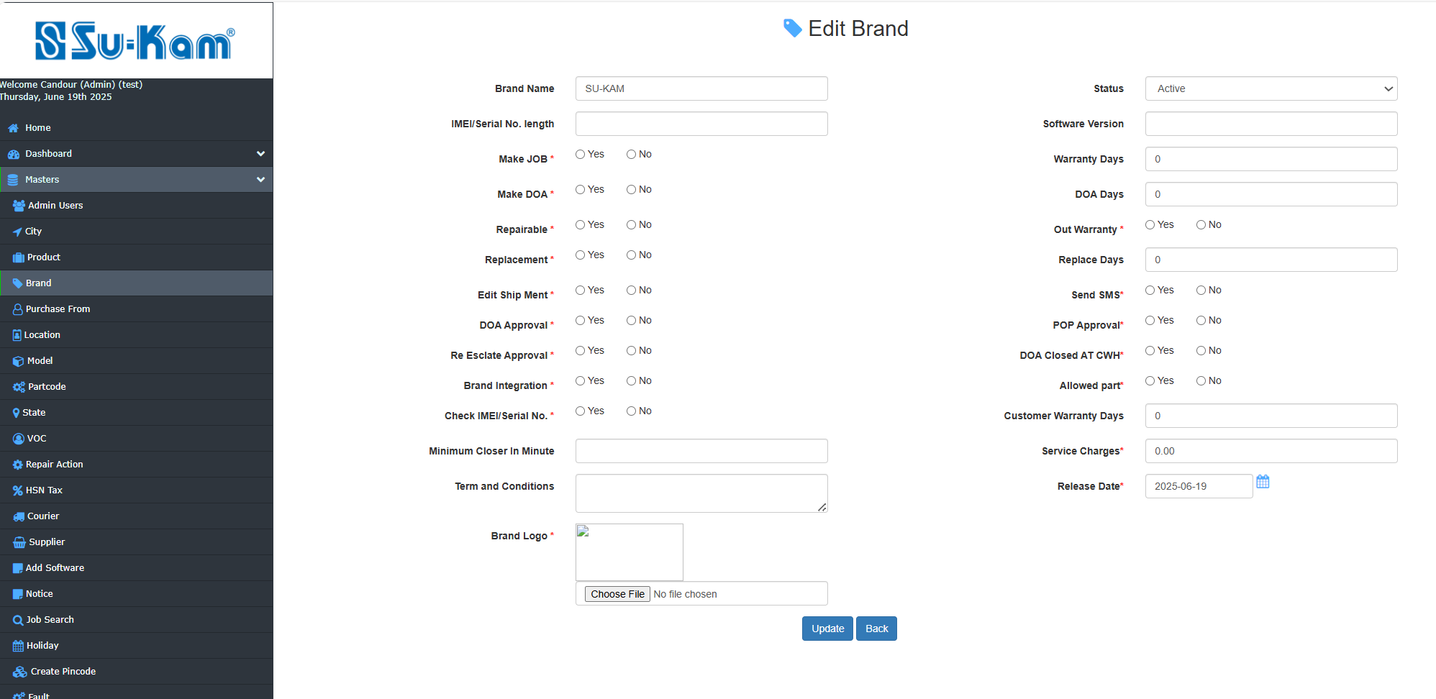

Update and Save back.
Purchase From
This Menu Provides to add new Purchase from and edit/ view Purchase from by fill all the details :
- Select status
- Click on Add new Purchase from
- Go on Edit/ View Purchase from
- Go on Search…

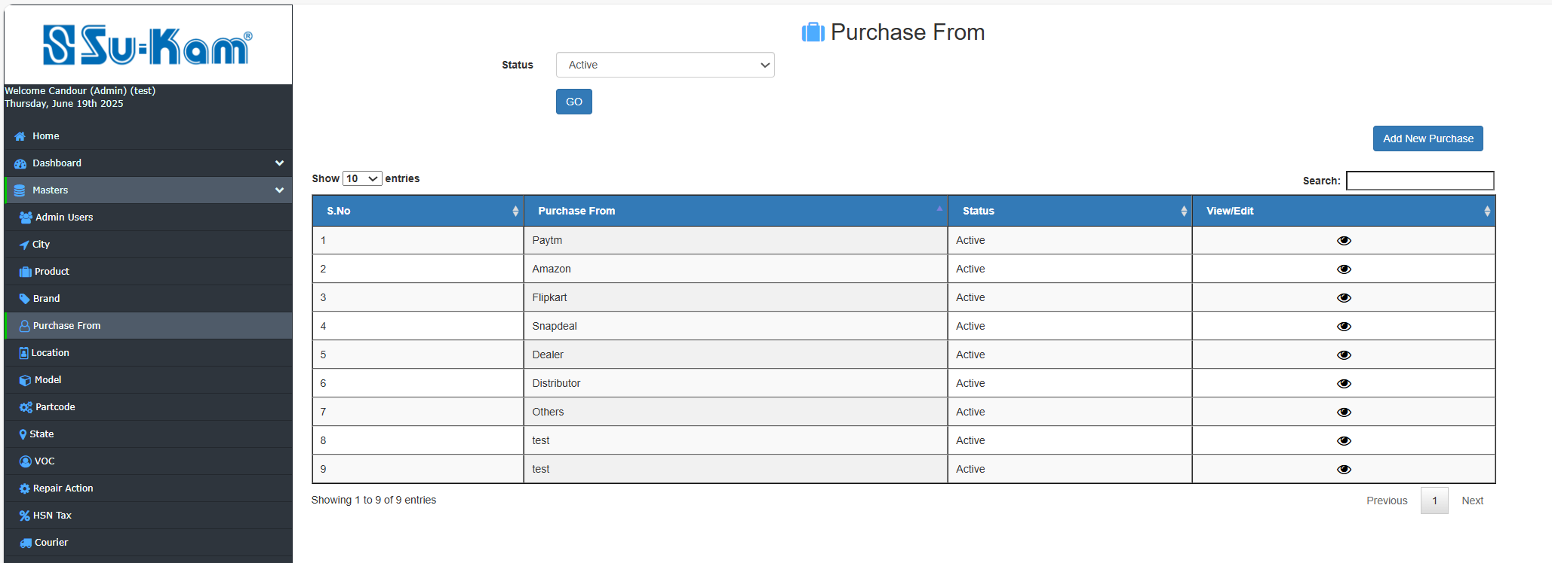

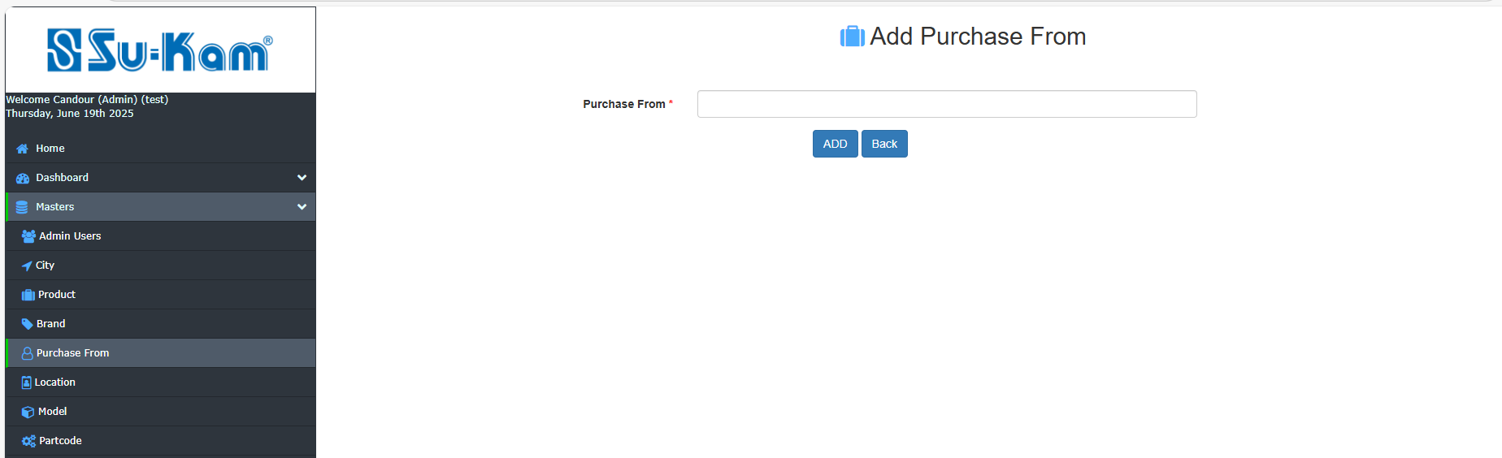
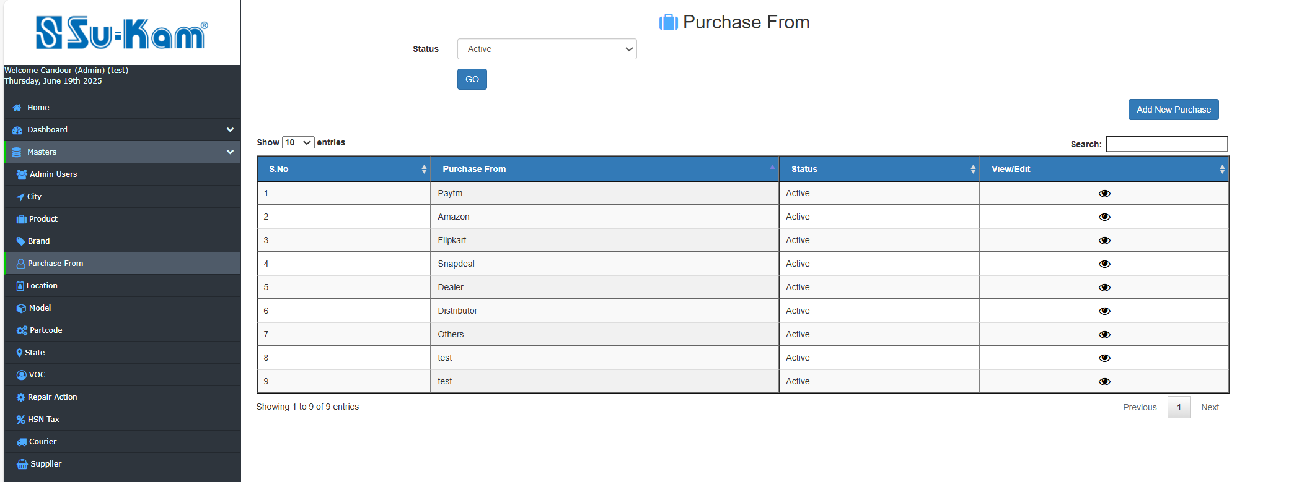
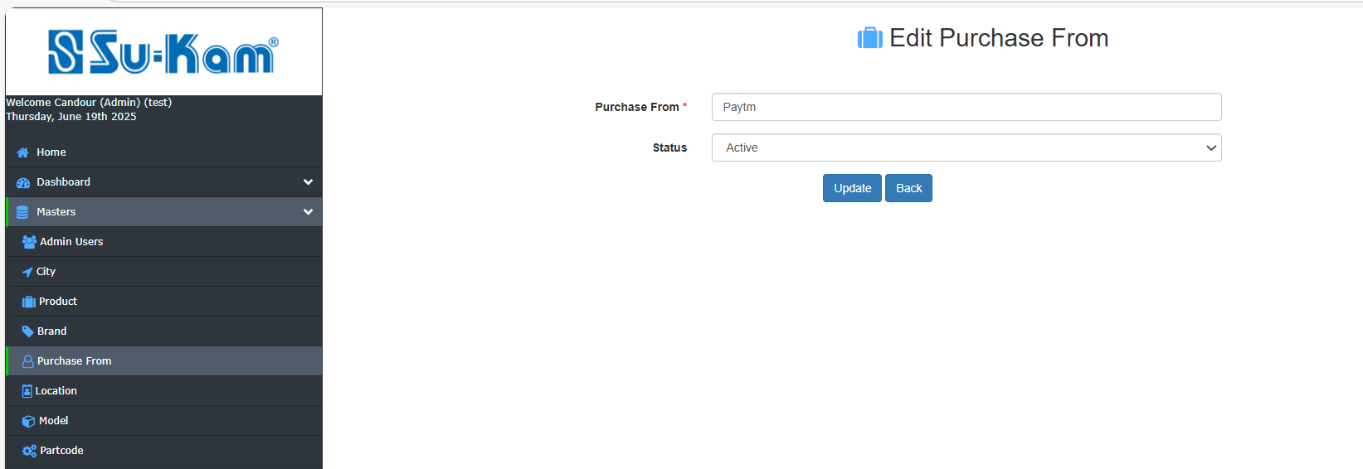
Update all the information and Save back.

Location Master
This Menu provides the information regarding new location added and edit location by fill all the details:

- Select status
- Add new location
- View/ Edit Location
- Go on search

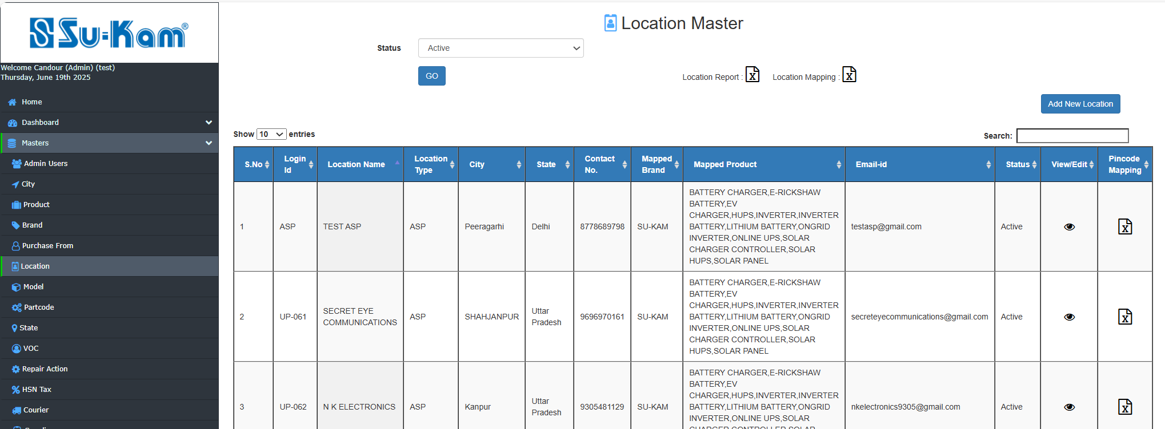

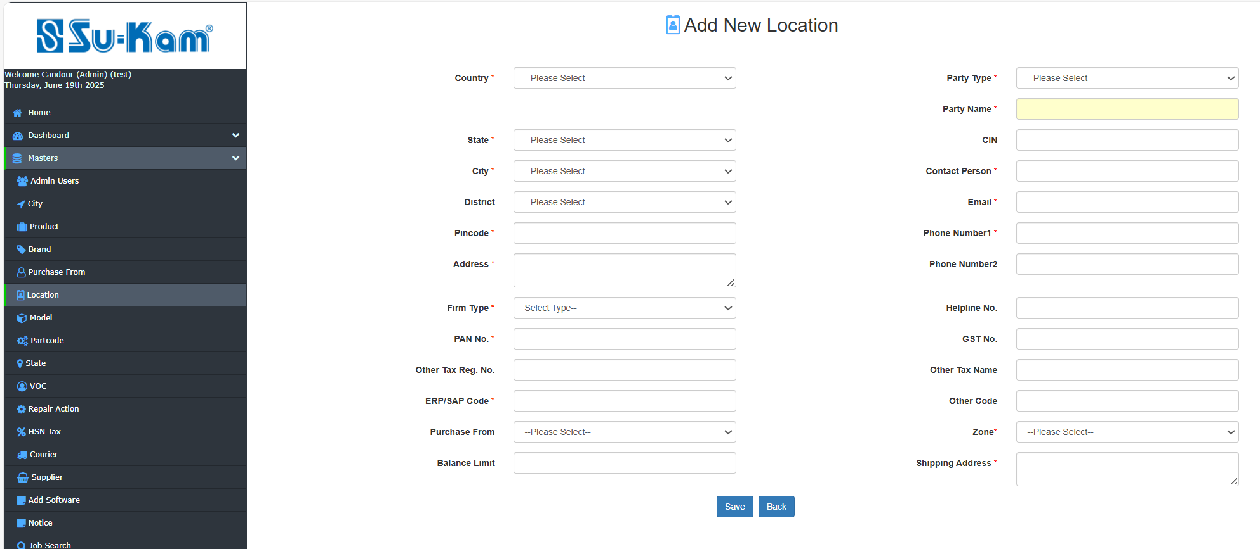
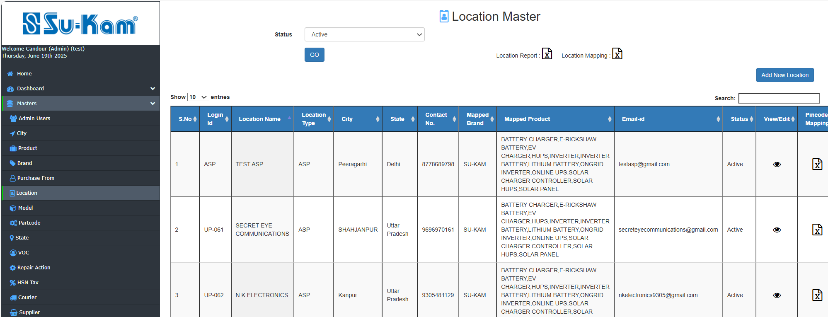
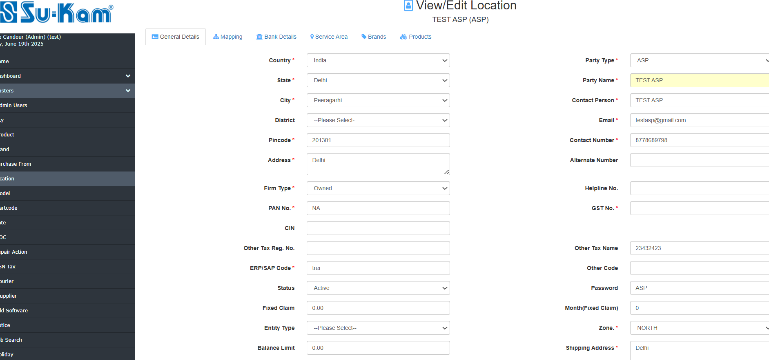
Fill all the details according to your requirements and save it.

To be Continued on the next page….

Mapping details…

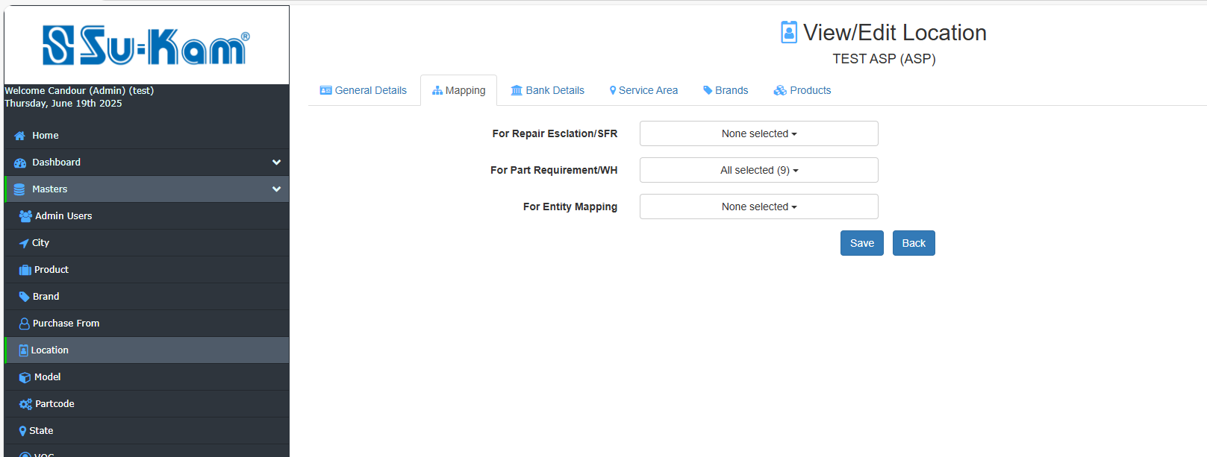

Bank details…..
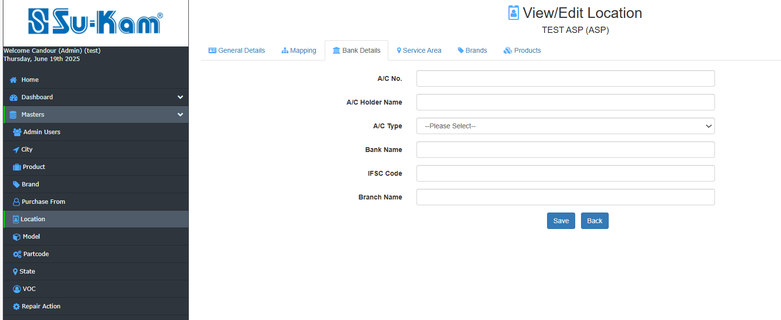
Fill all the information according to the requirements and tab on Save .
Service Area…
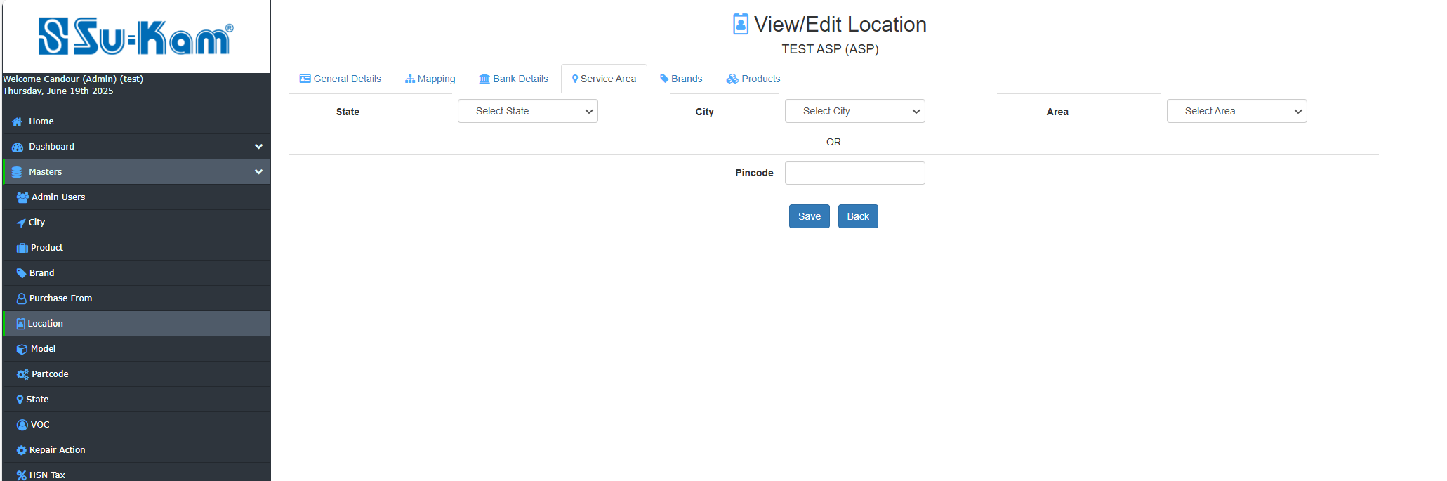
Brands…
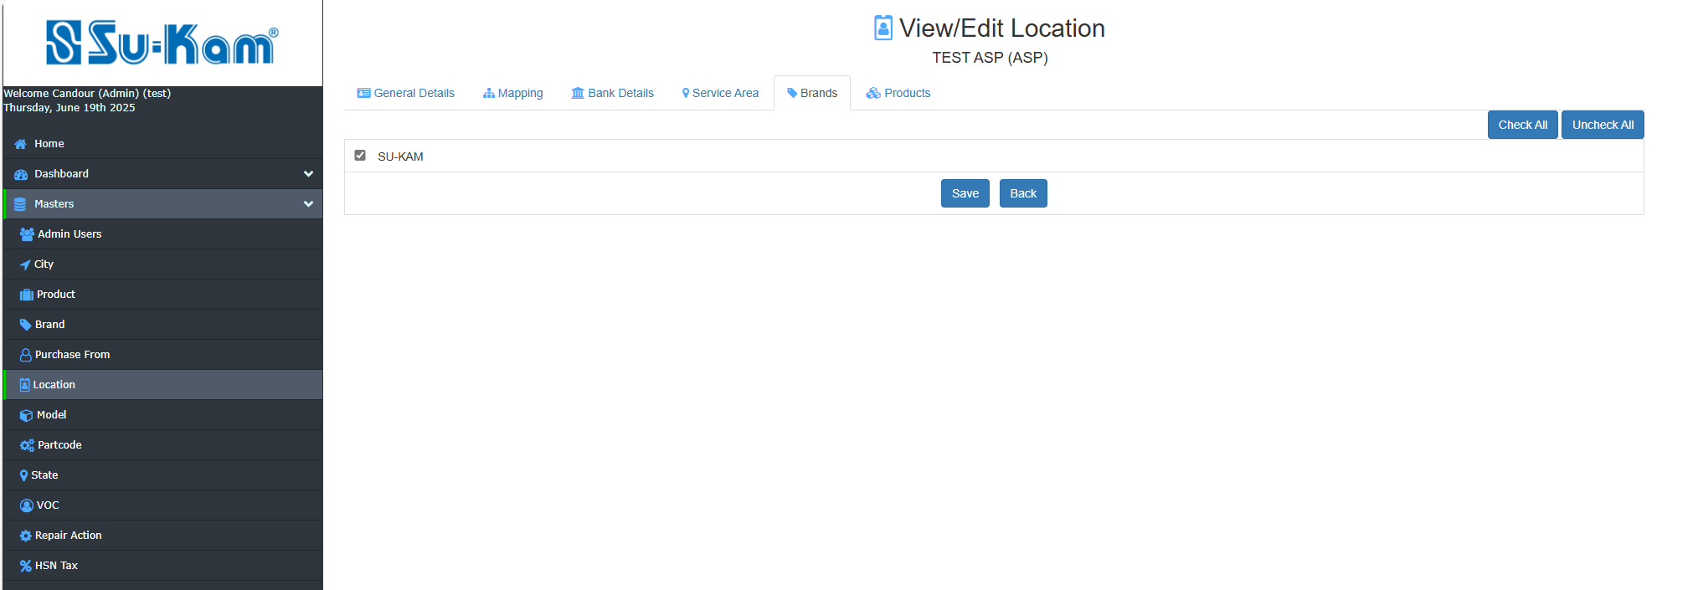

Products…
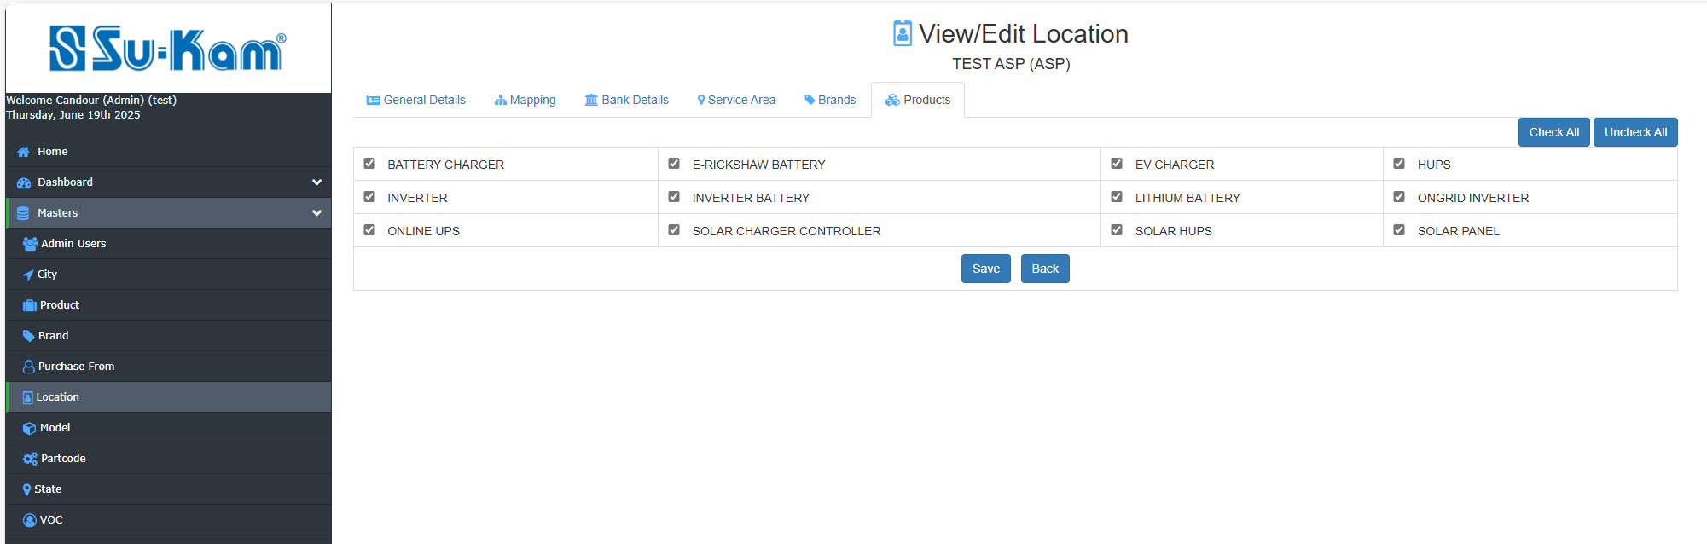
After filling and updating all the information ,Save it back

Model Master

This Menu contains the following options to be selected:
- Select status
- Add new model
- Click on upload new model
- Check on edit model

As shown below:

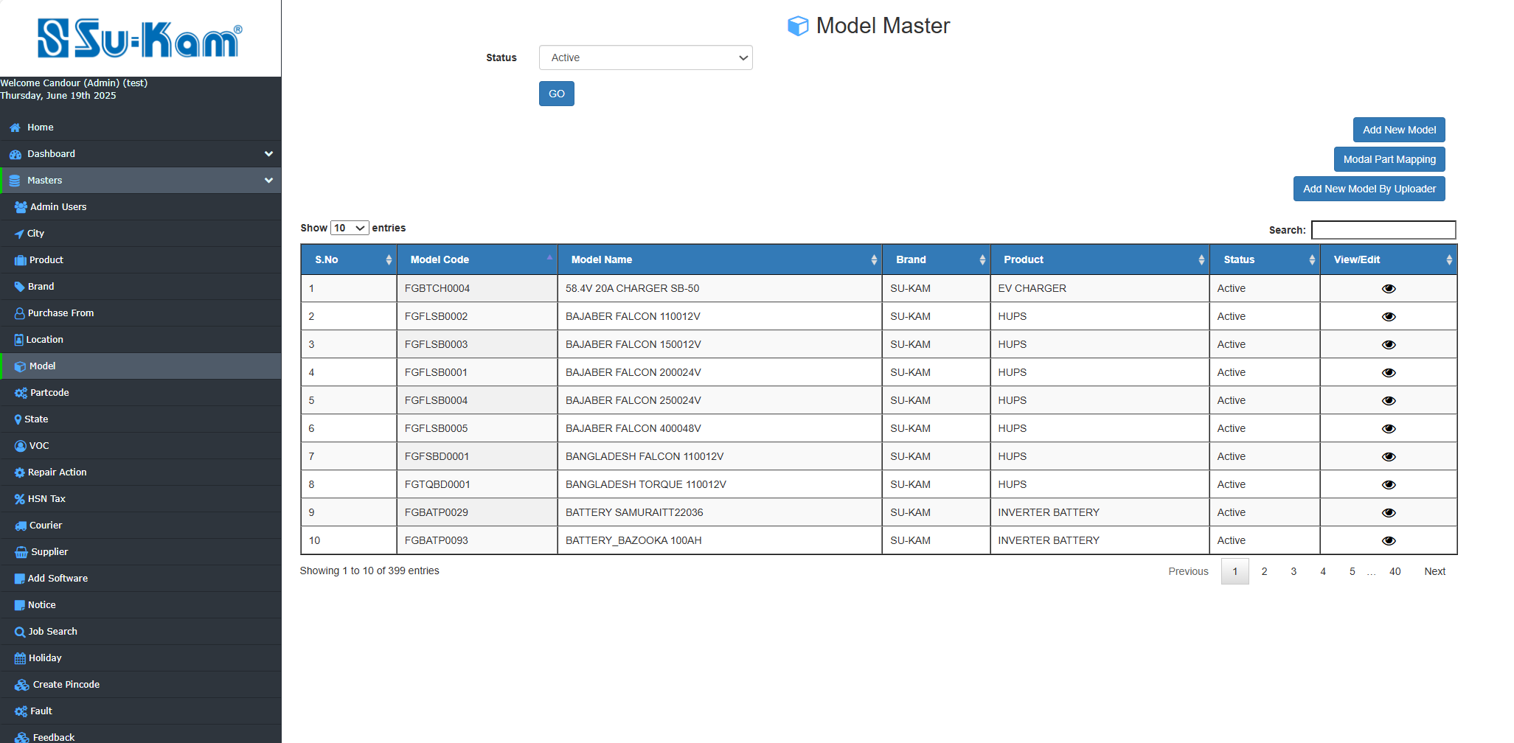

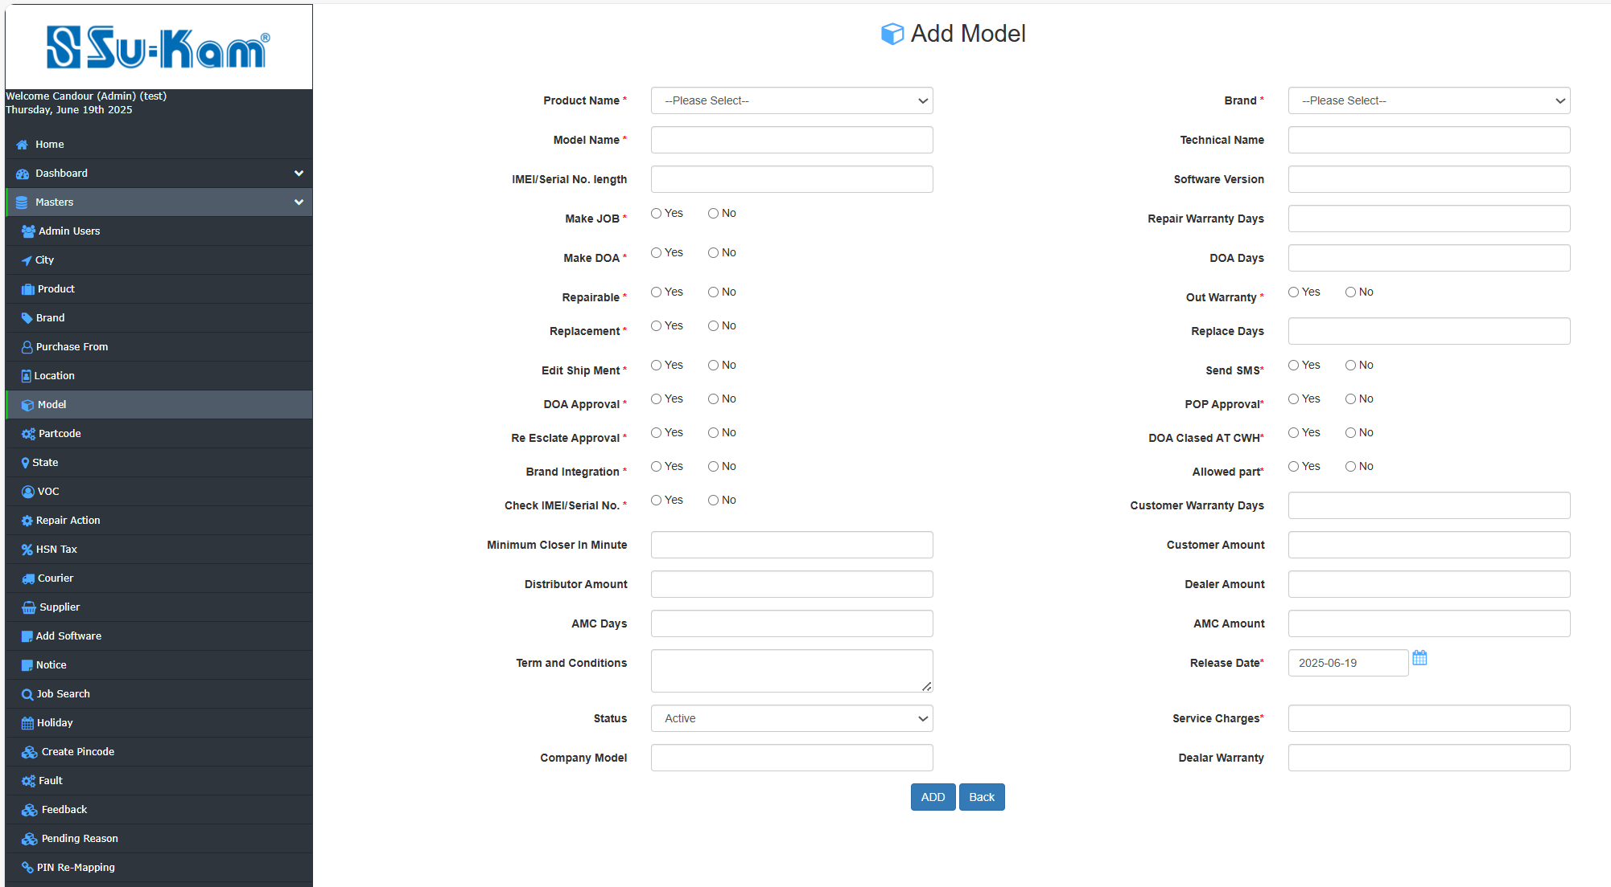
Upload New Model :
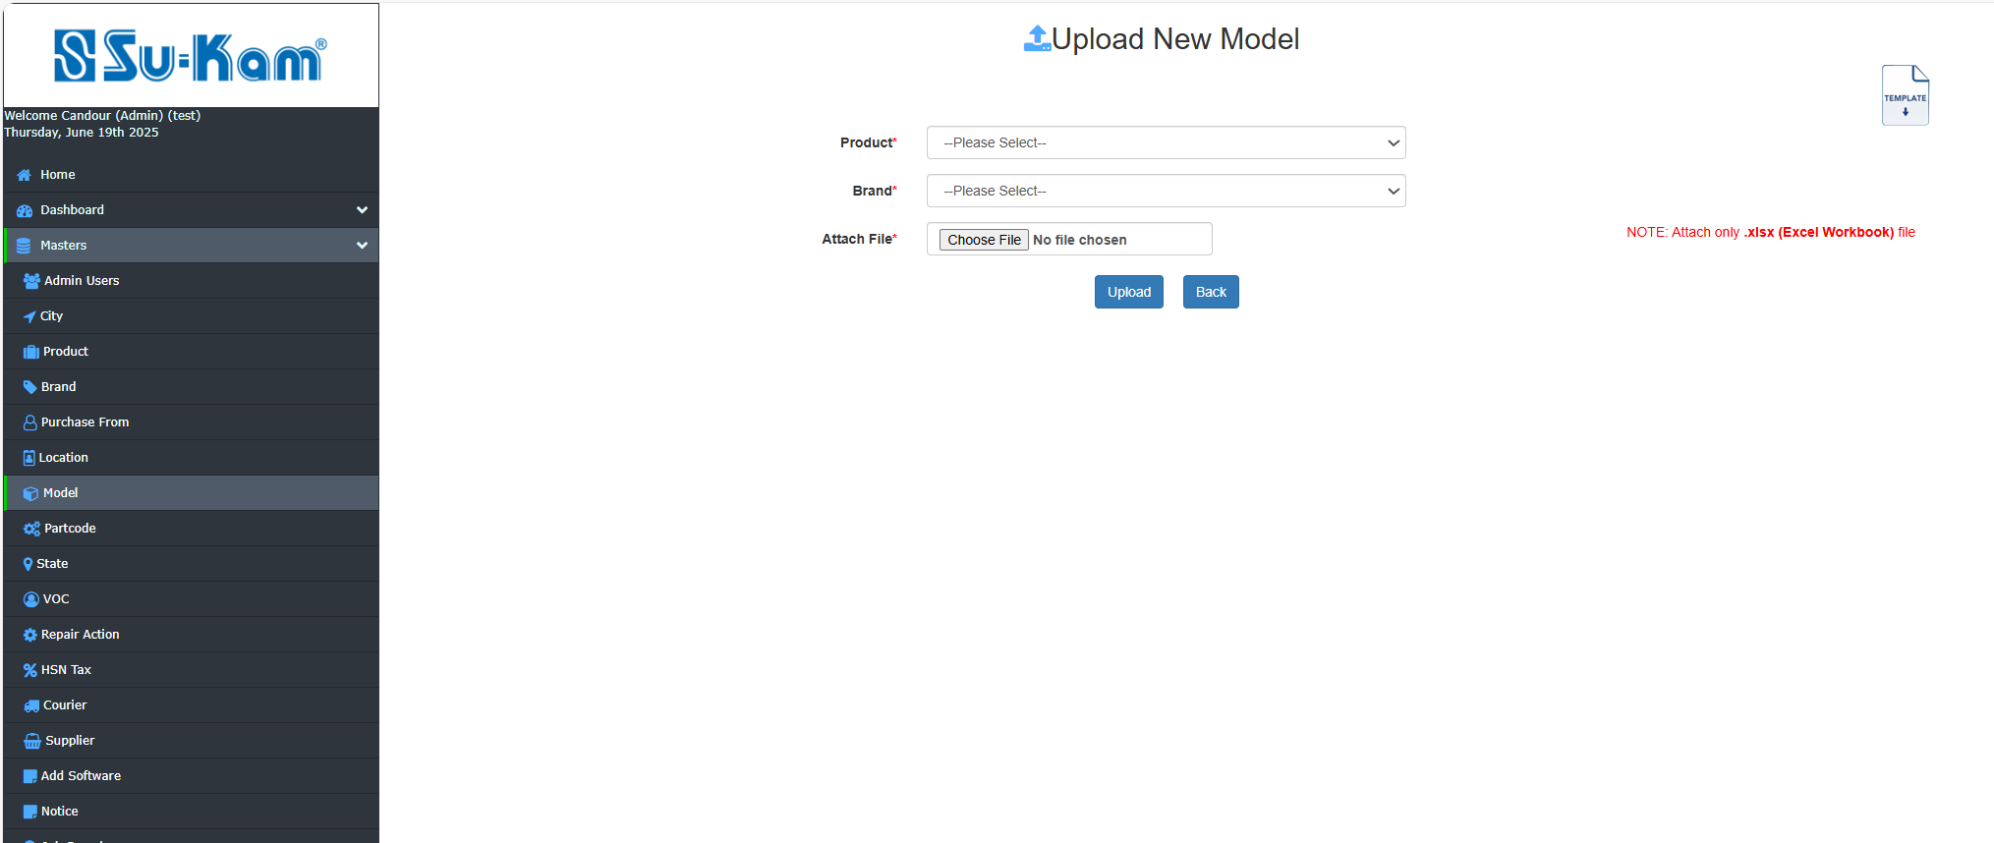
View / Edit details :
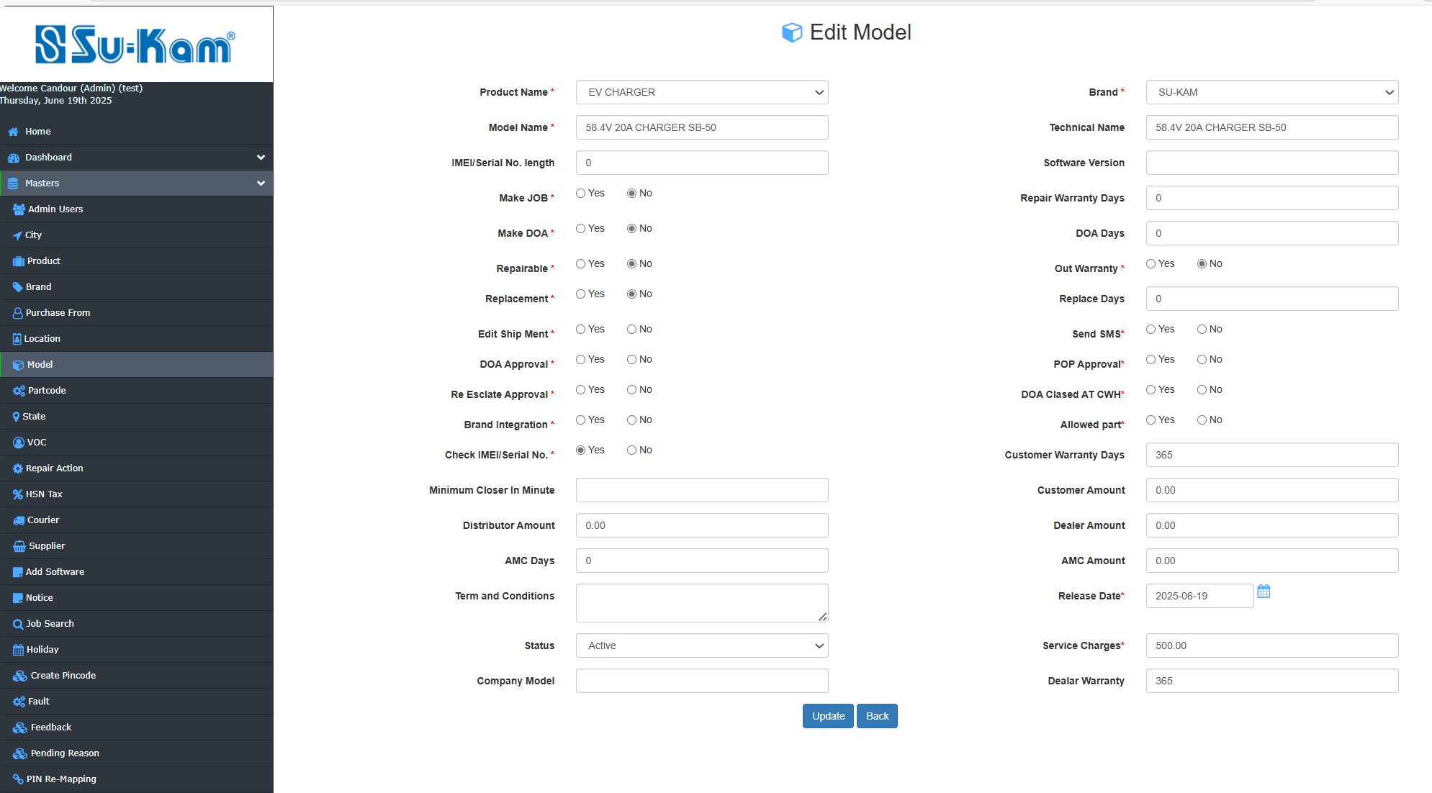
Fill and Check all the details according to your requirements . Click on Add and save.

Part code Master
This menu contains the following details to be selected:
- Select Status
- Select Model
- Add new partcode
- Check on edit partcode

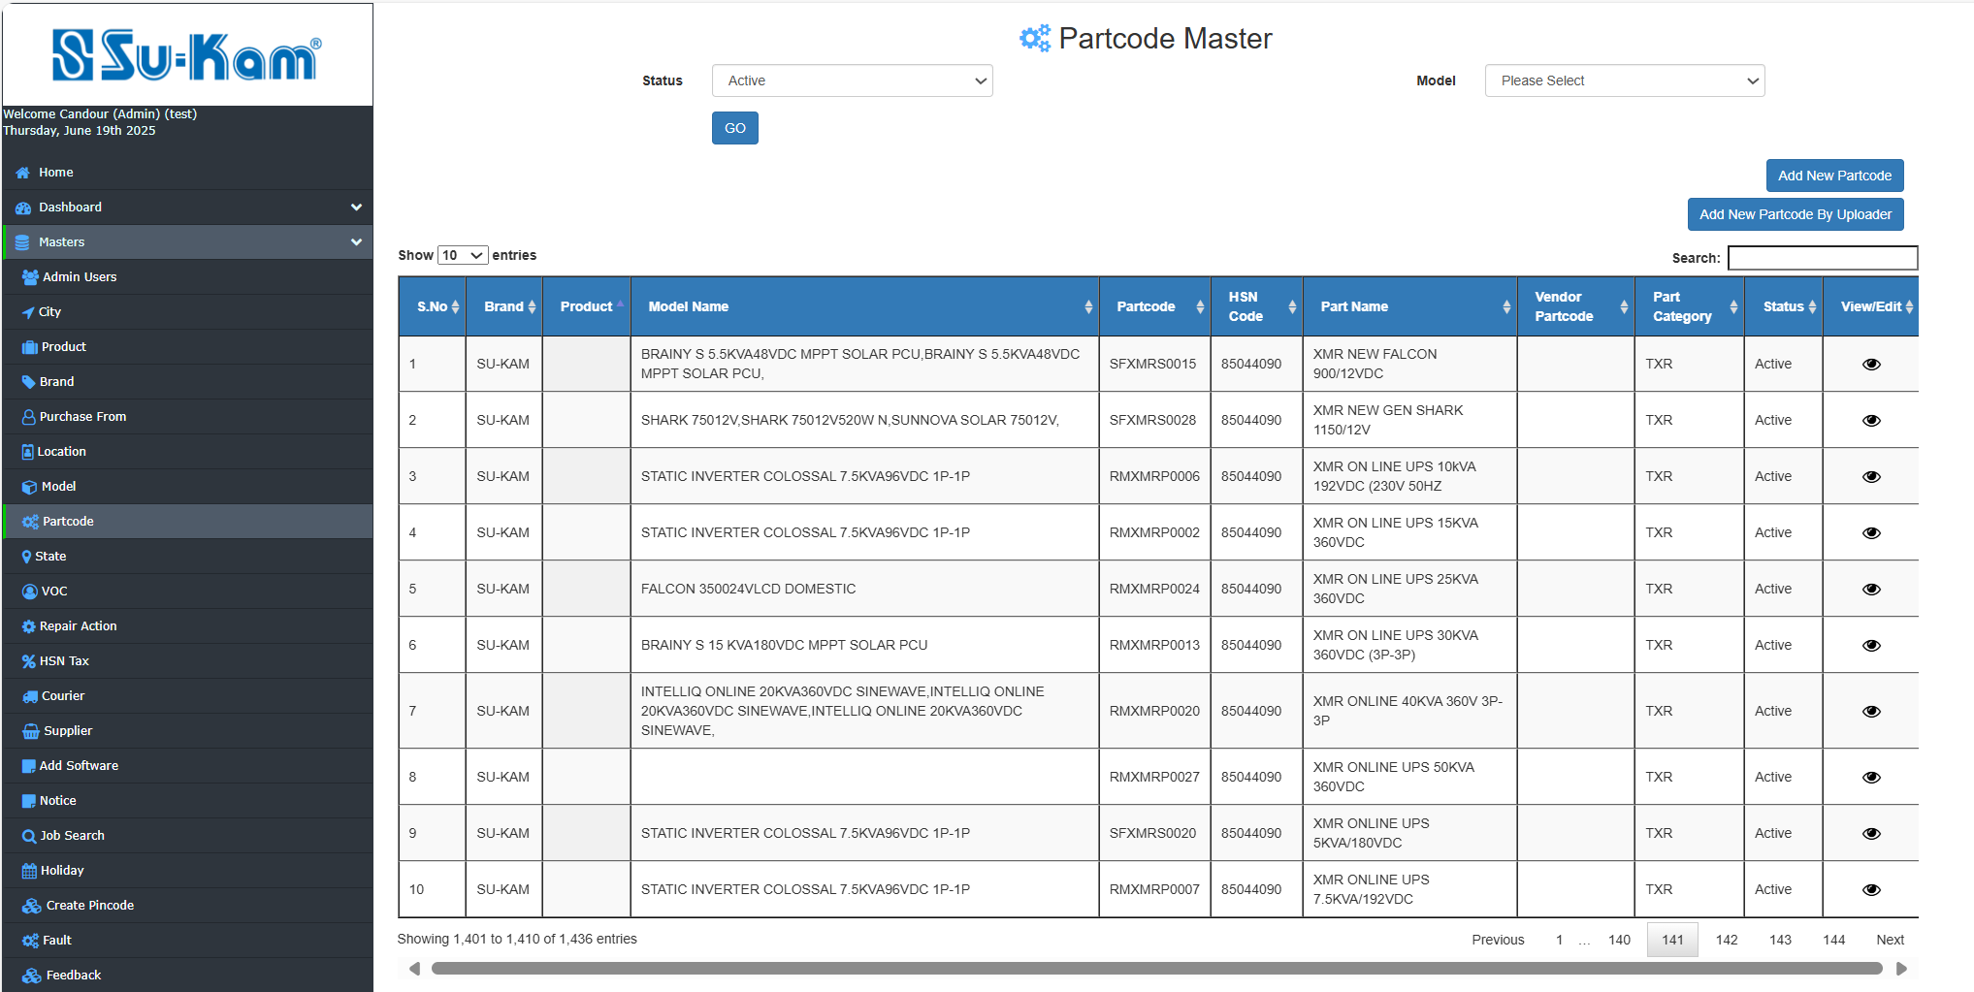
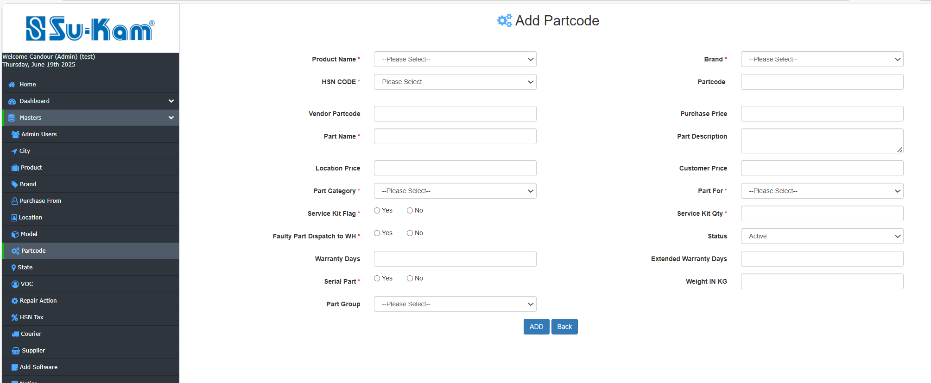

Fill all the information above shown and Upload it.
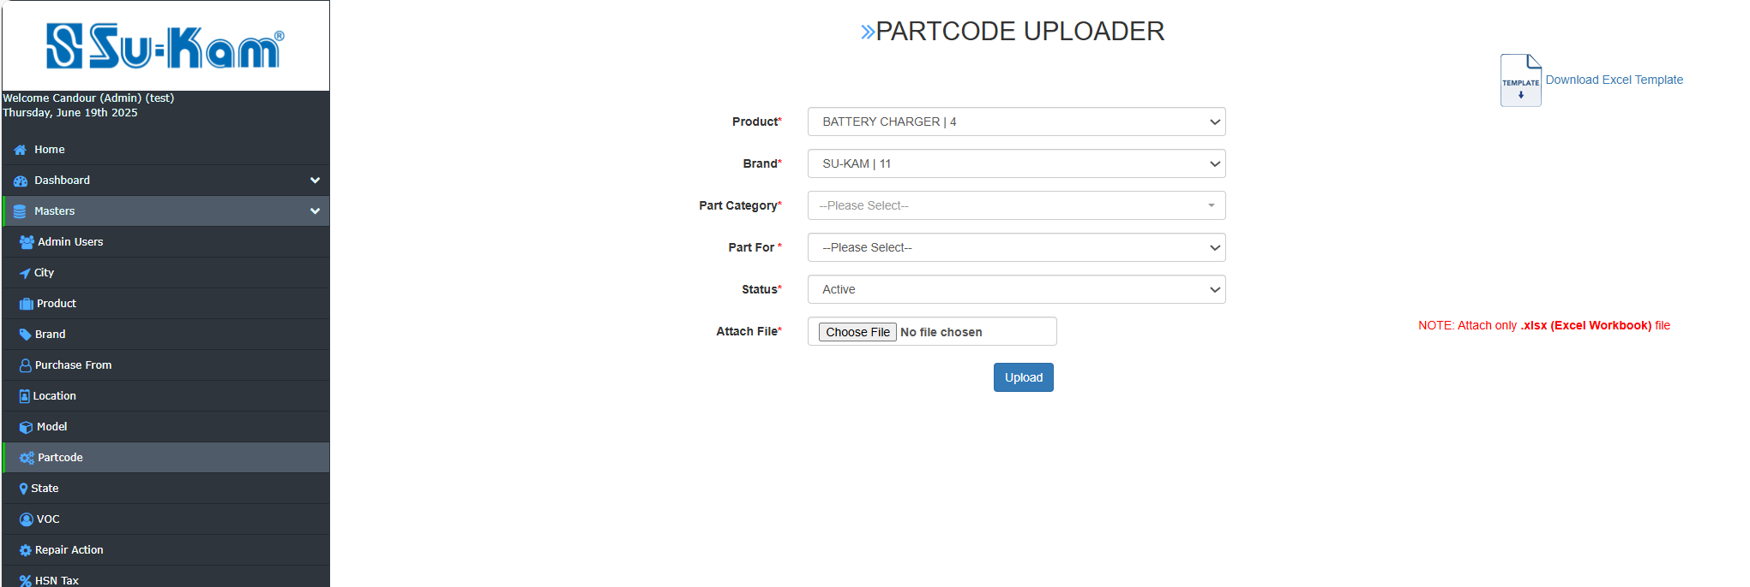

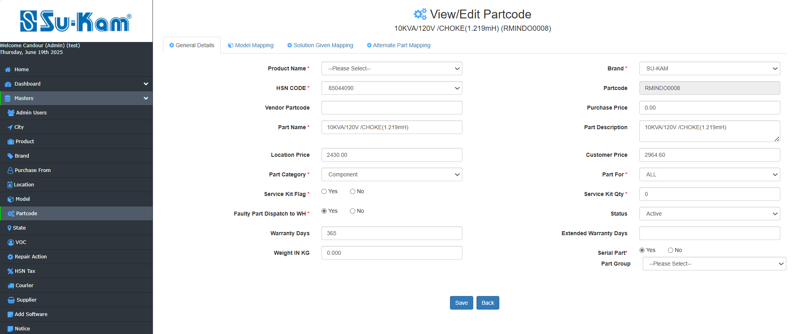
Check sub other edit partcode modules on next page as per given below images:

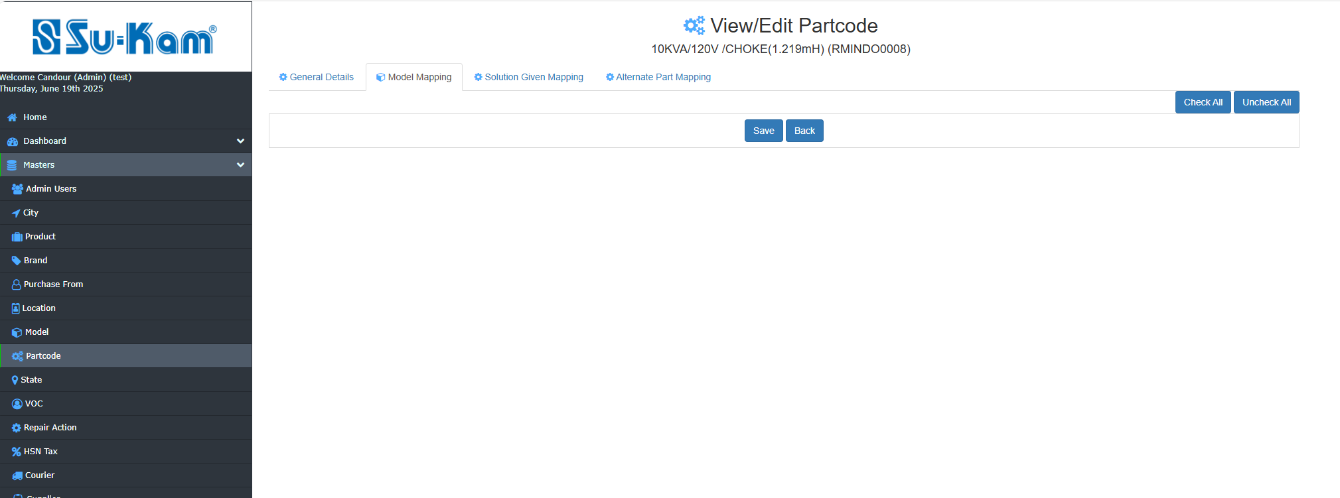

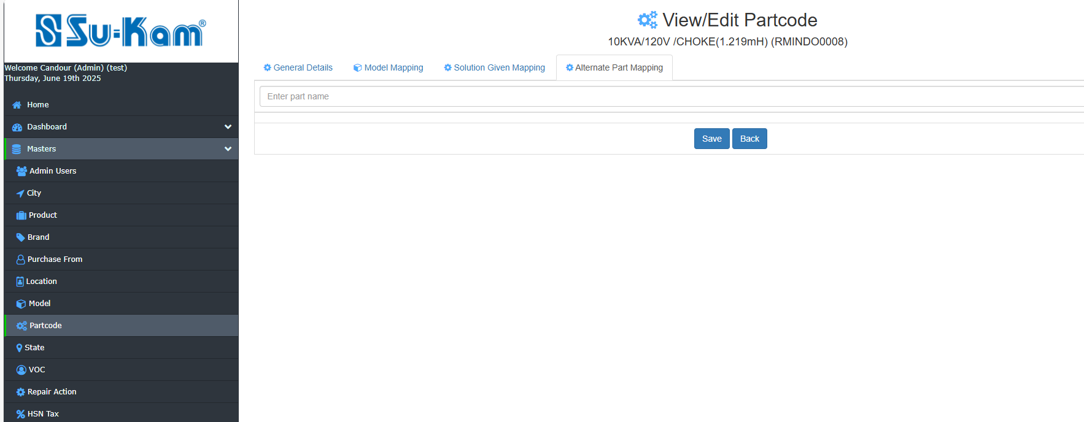
Fill and check all the details according to your requirements . Click on Add and Save.

State Master
This menu contains the following details to be selected on:

- Add New State
- Click on edit State
- Check on edit State

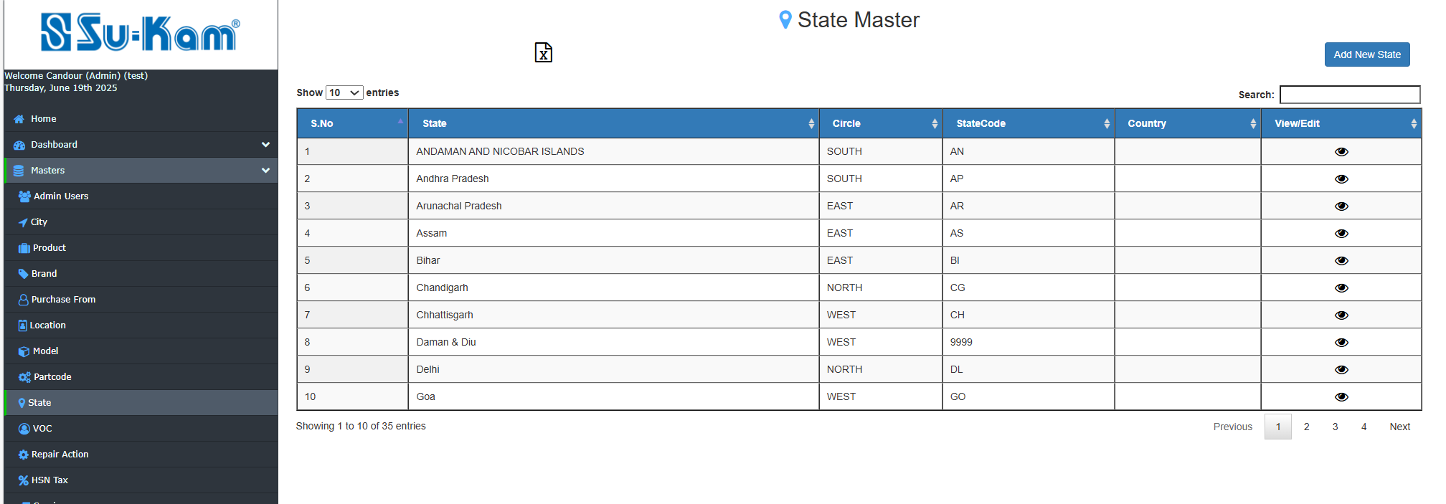

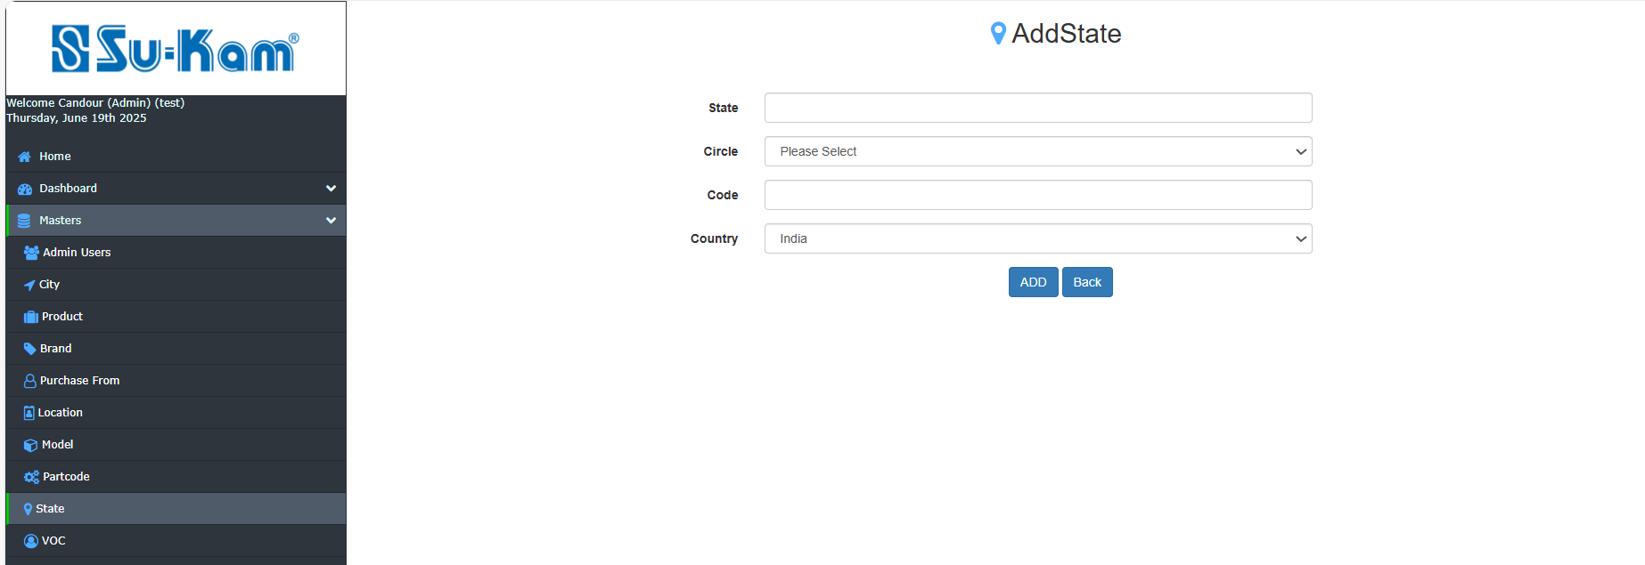
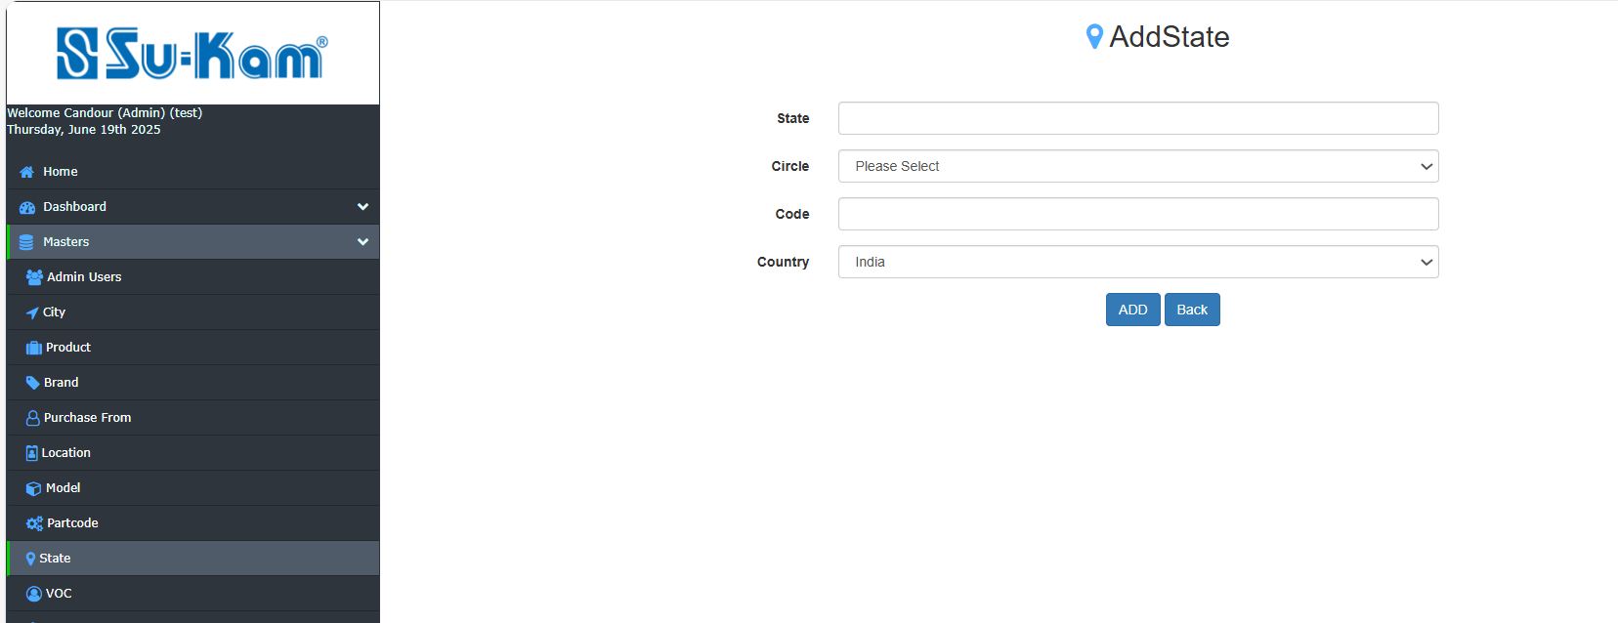

Fill all the details according to your requirements , make update and save back.

VOC Master
This menu contains the following details to be selected on:

- Add New VOC
- Click on edit VOC
- Check on edit VOC

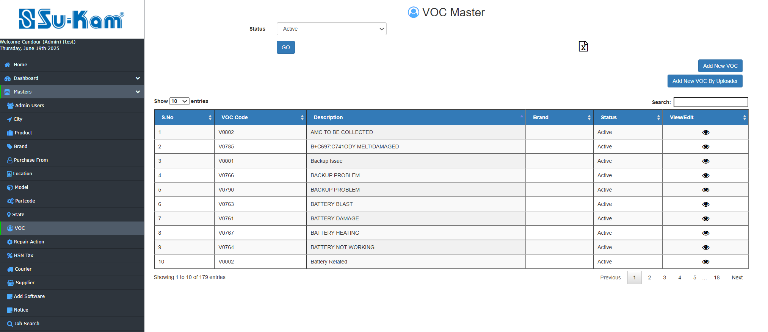
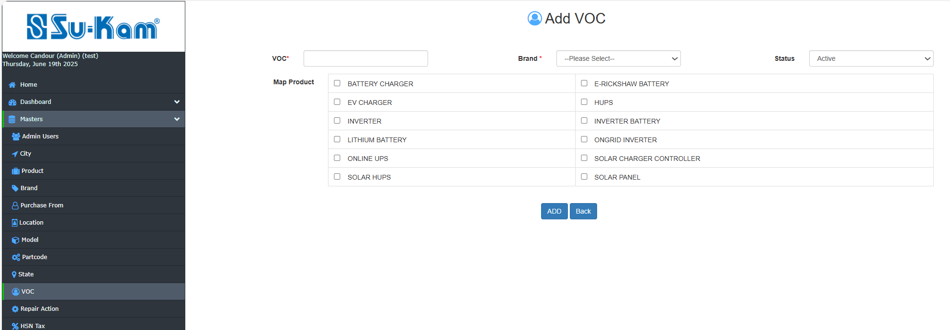
Add New VOC By Uploader :
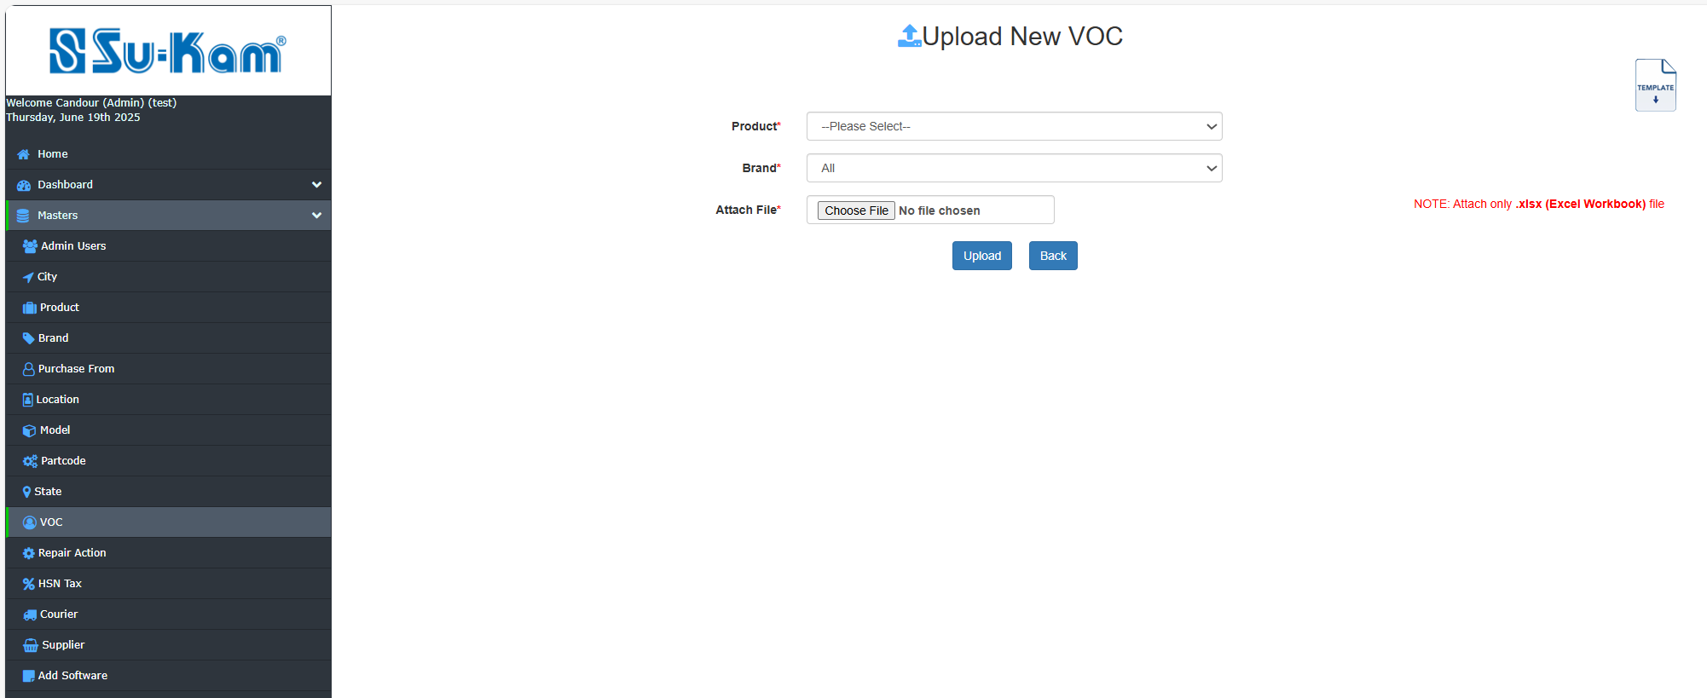
Edit / View VOC :
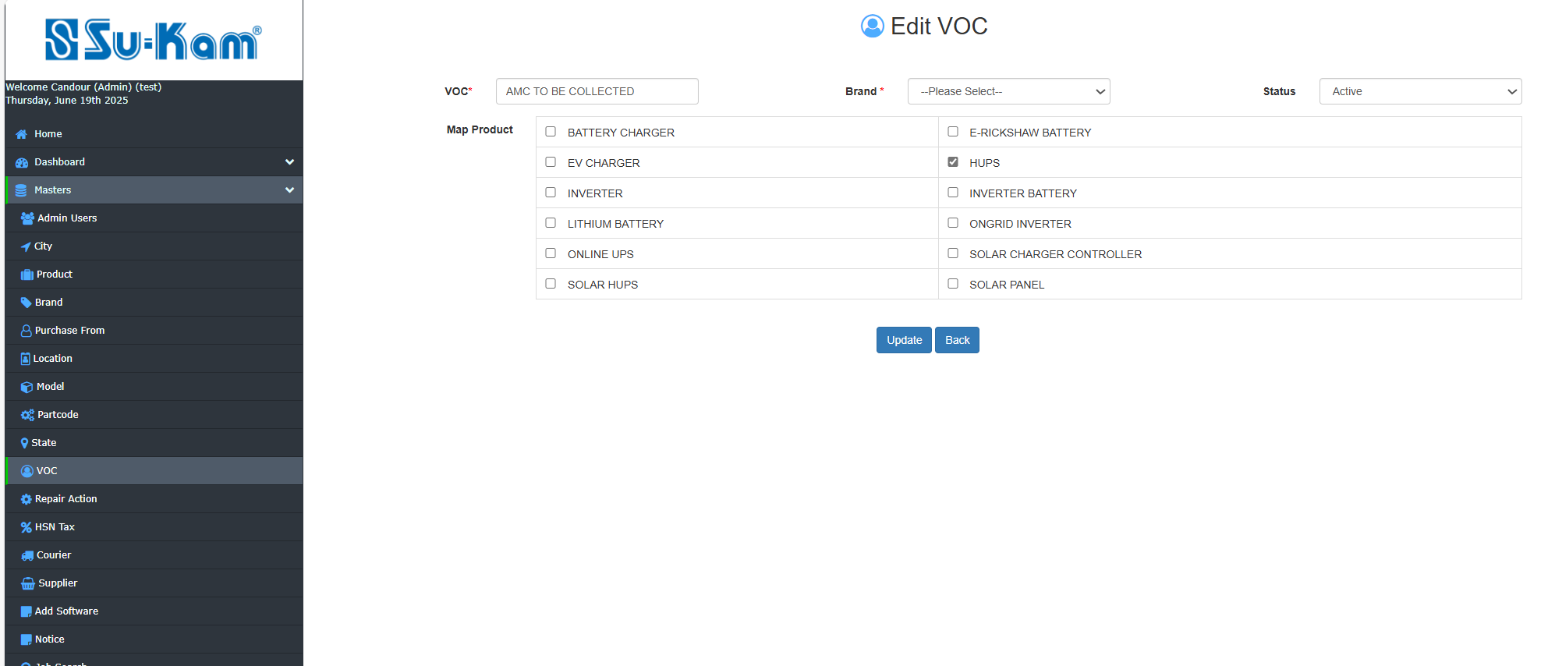
Update and Save back all the information required.

Repair Action
This menu provides you to create new repair action on the following accessories selected:
- Select Add New Repair action
- Click edit /view Repair action
- Check it ,update as well

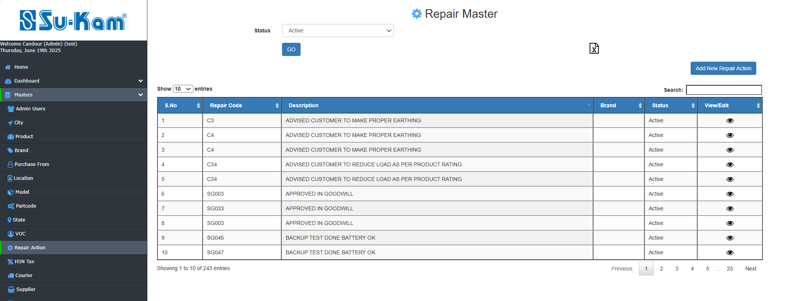
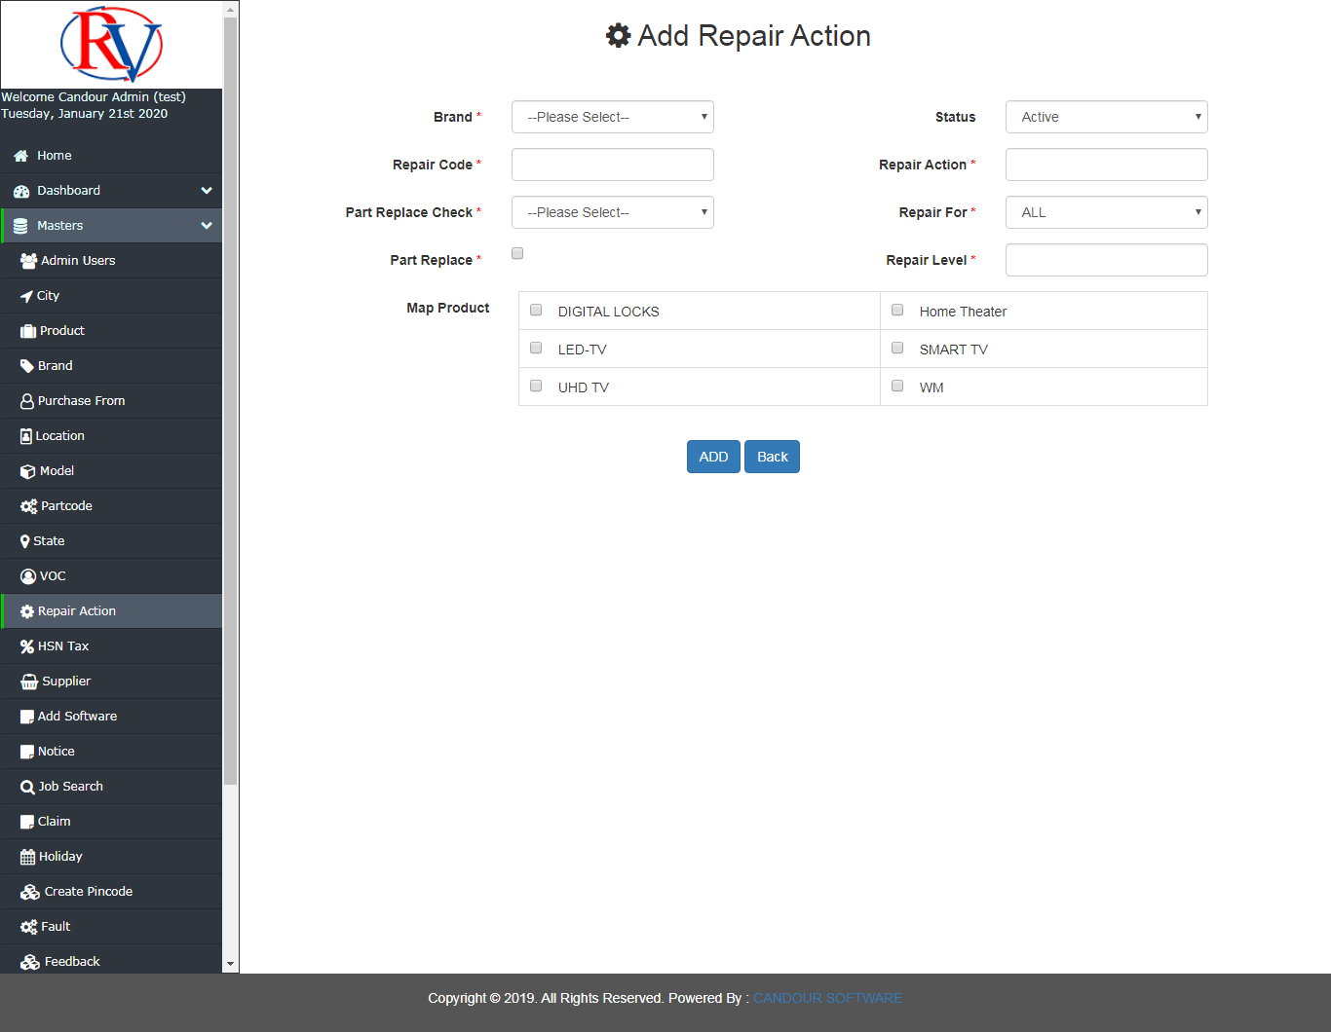
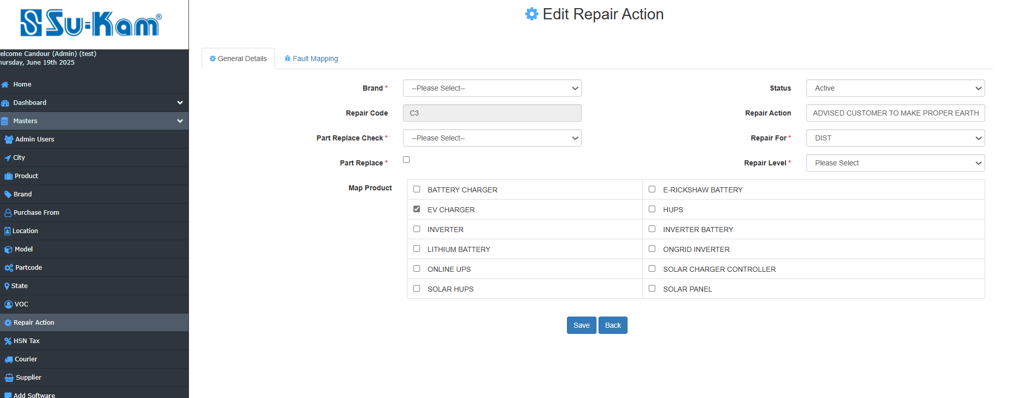

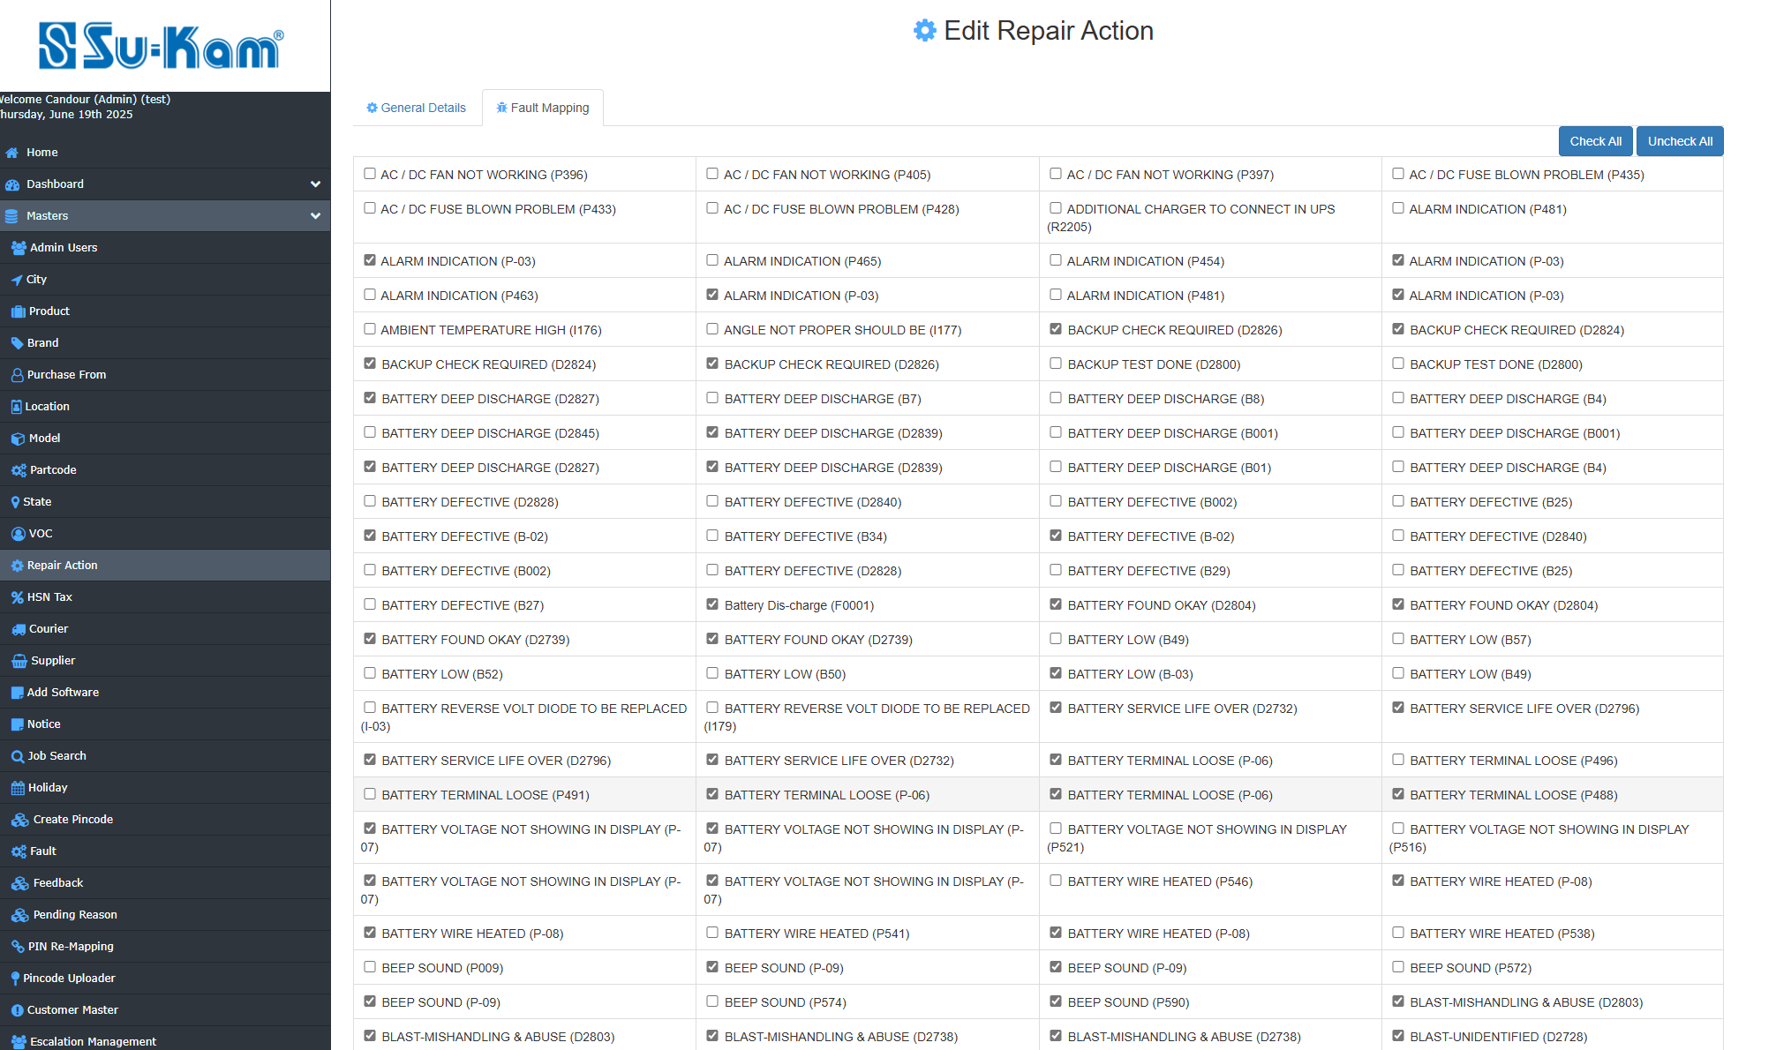
Fill all the details according to your requirements and save it .

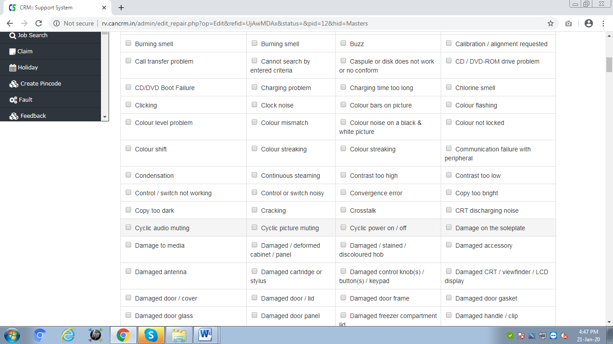
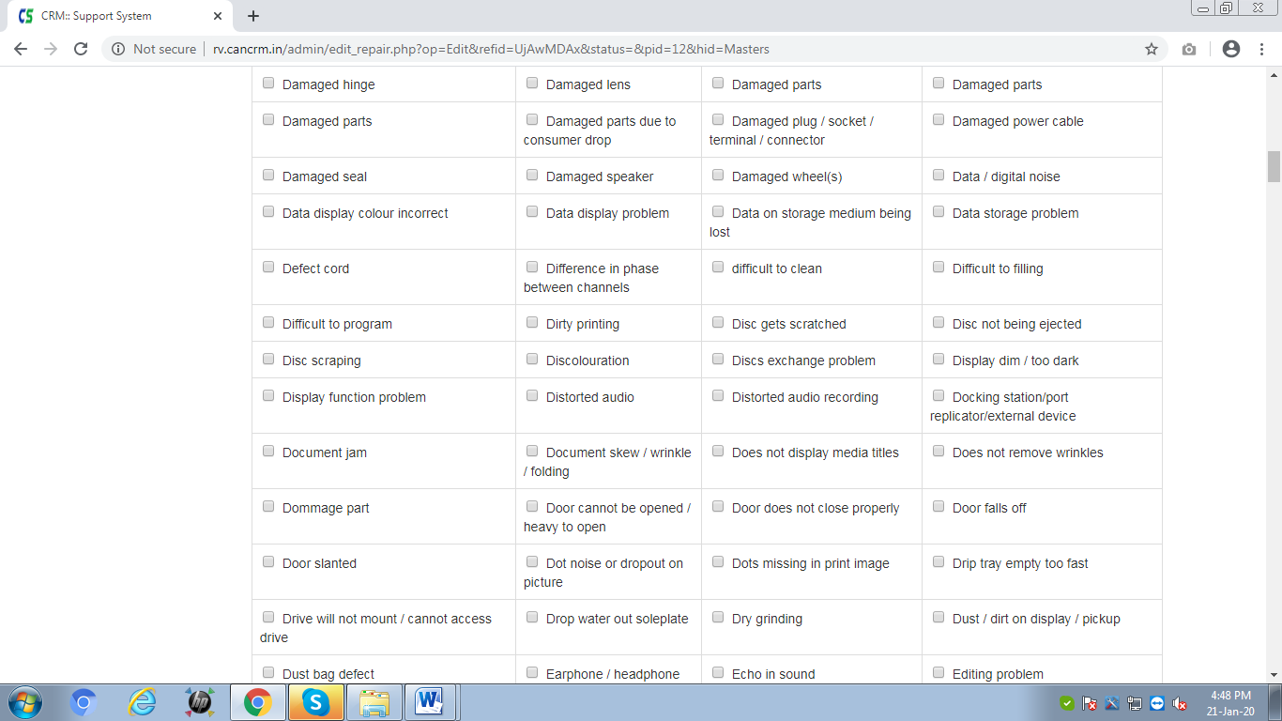

HSN Tax Master

This Menu provides you to create new HSN Code on the following description given below:
- Select New HSN code
- Click on edit / view HSN code
- Check it and save it.

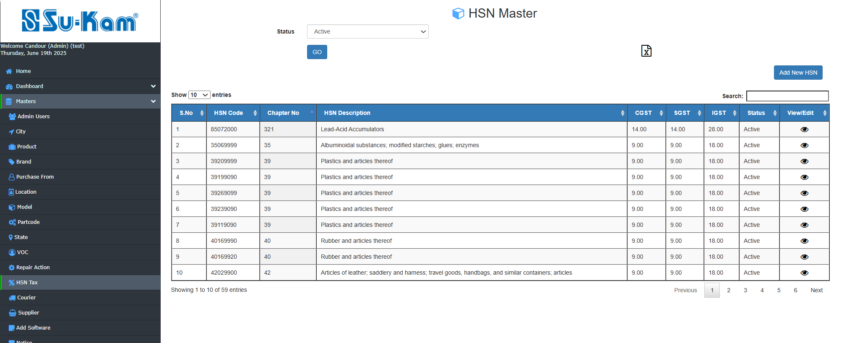

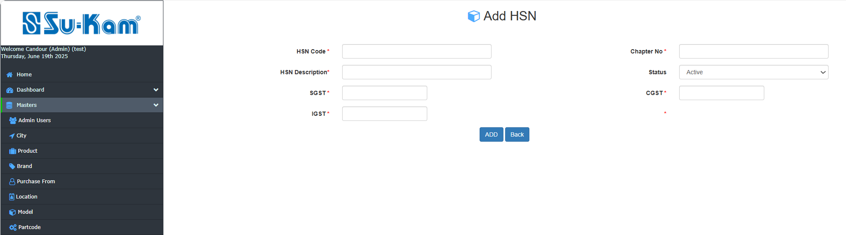
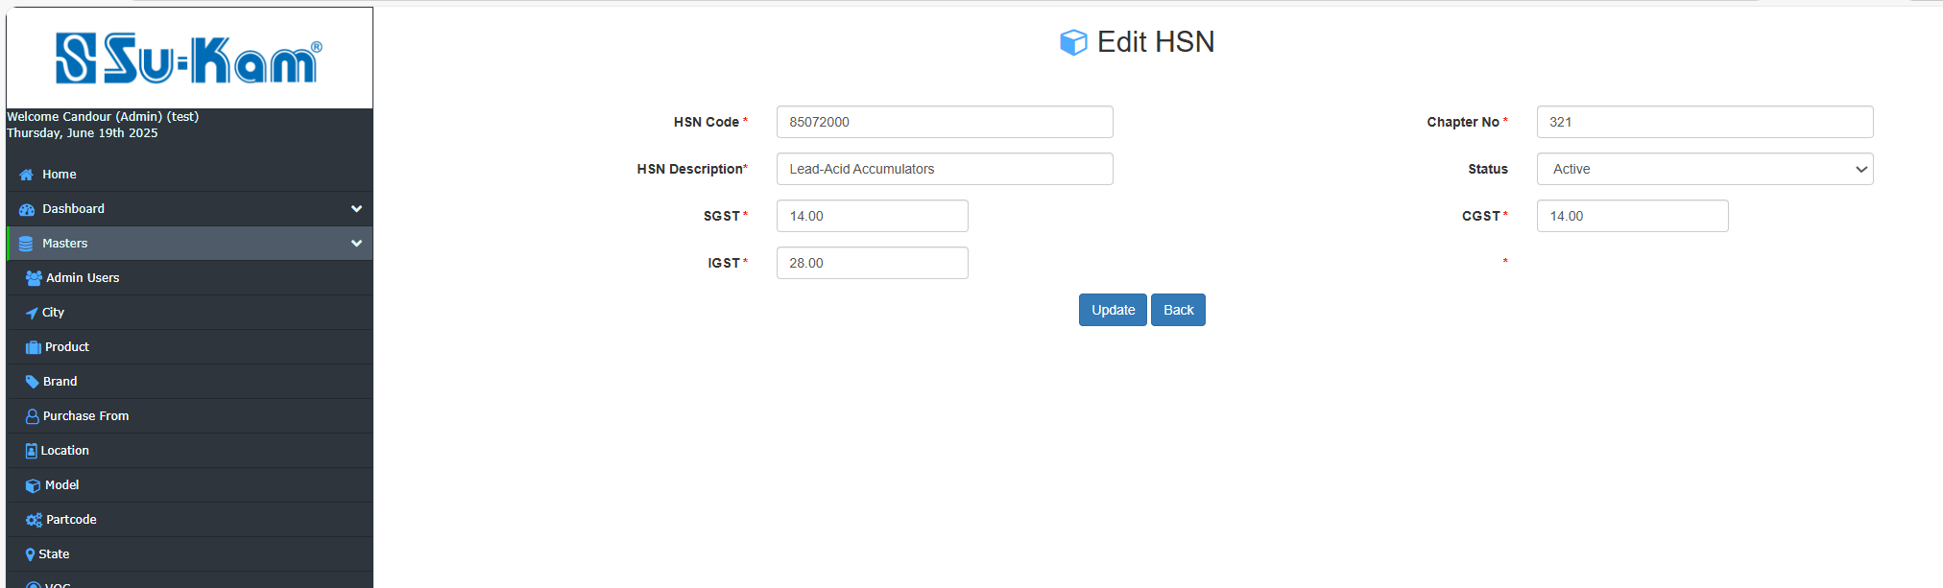

Fill all the details above according to your requirements and update it.

Supplier Master
This menu provides you to create new domestic and new foreign supplier , First of all click on:
- Select new domestic supplier ,add it
- Select new foreign supplier ,add it
- Click on edit /view domestic supplier
- Check it and update

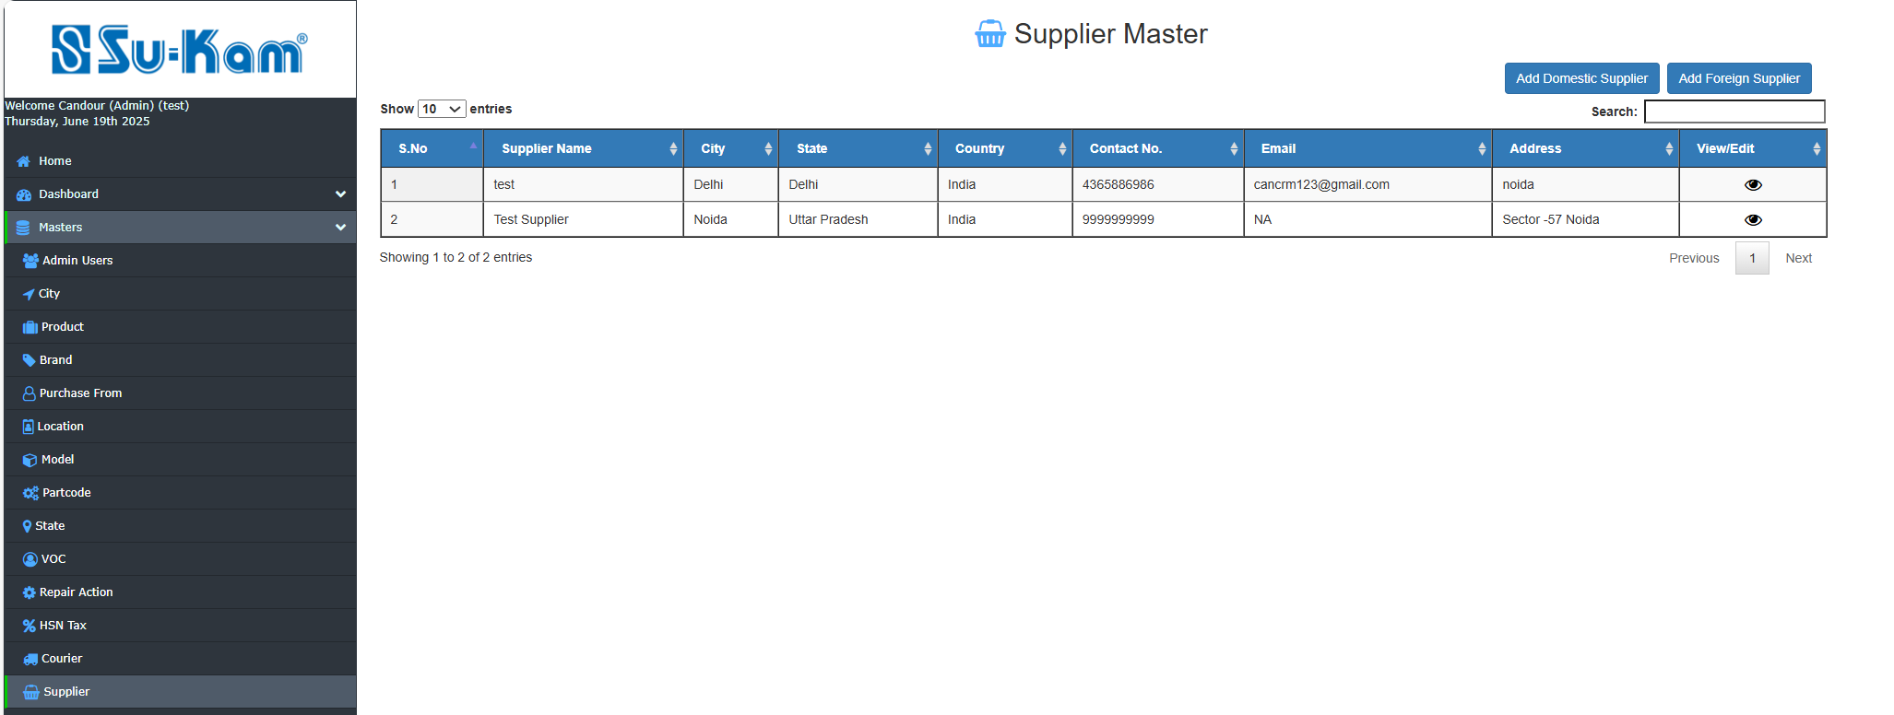

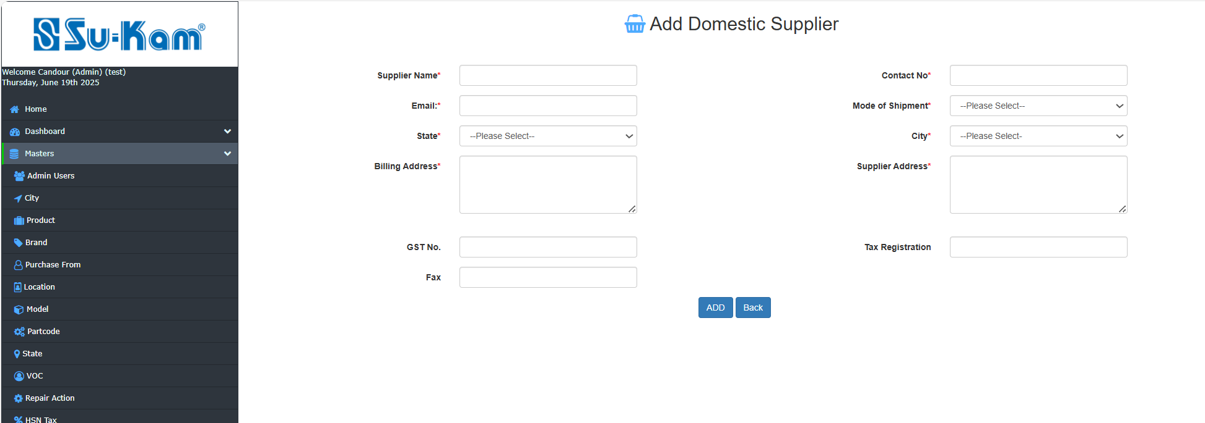

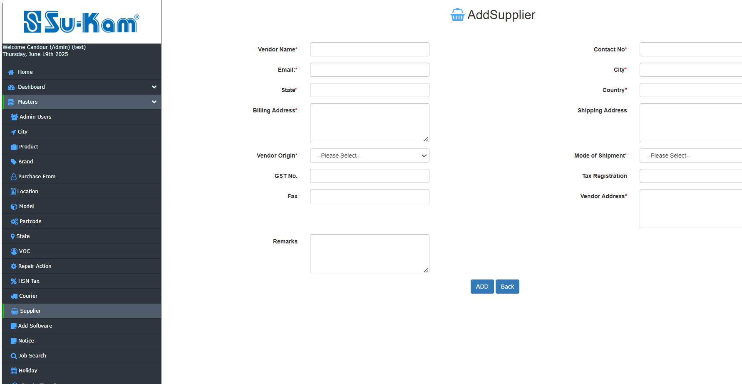

Edit details are on the next page…..to be continued.

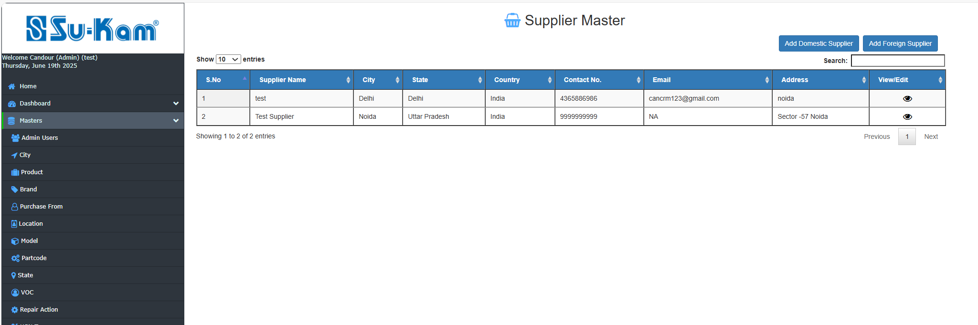
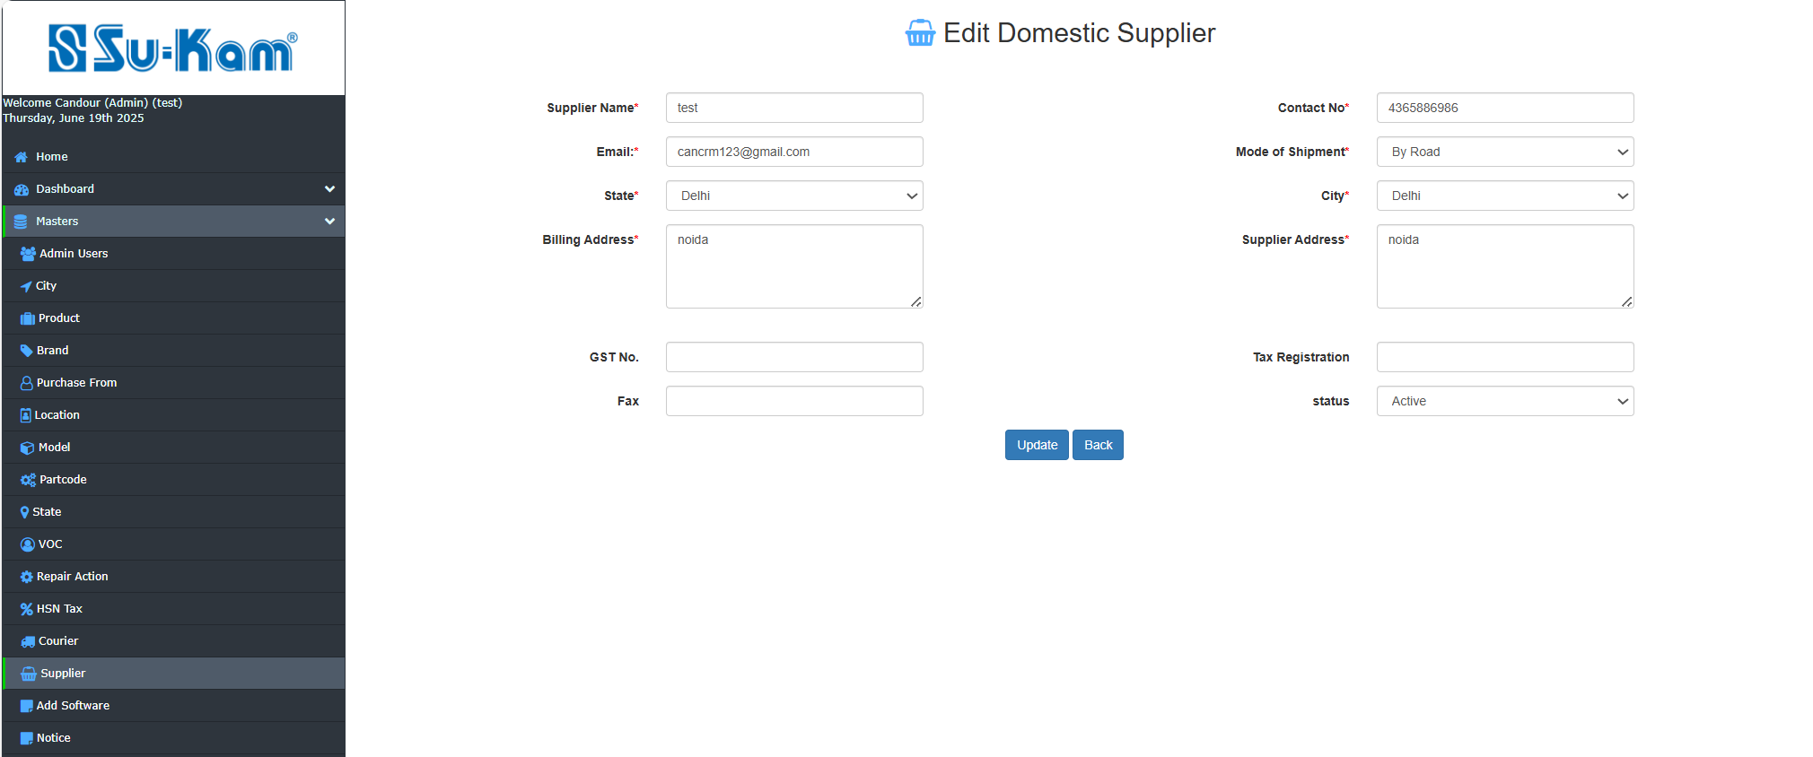
Fill all the information according to your requirements and click on update and back icon.

Add software Master

First of all click on add new software and after that edit / view software. Check the details.

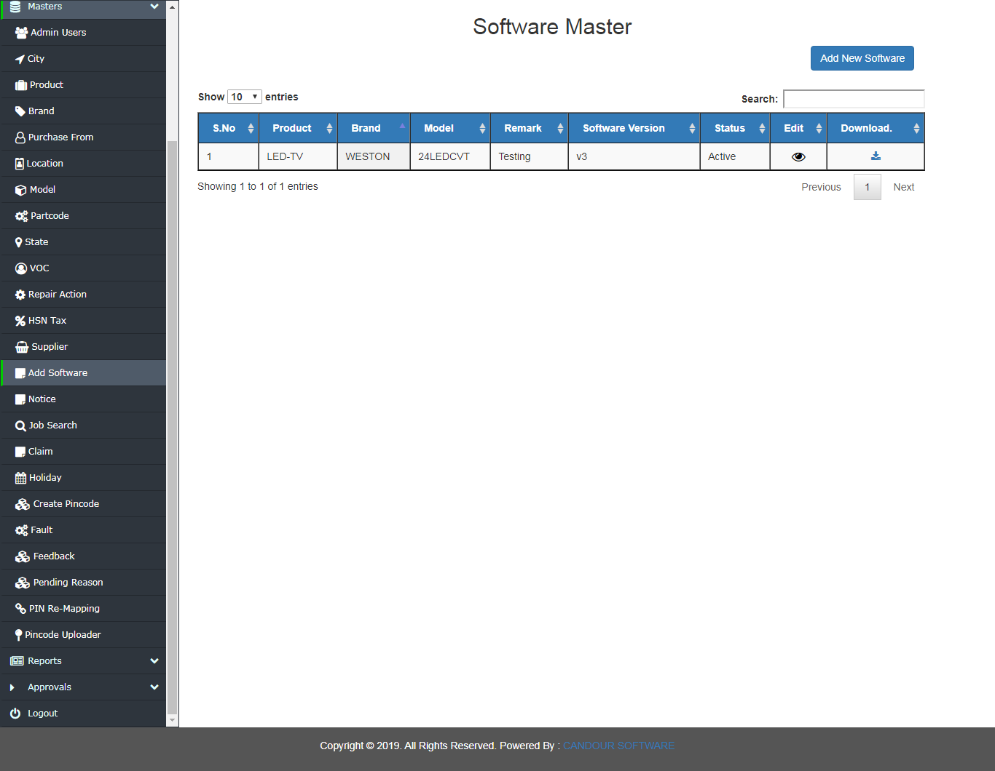

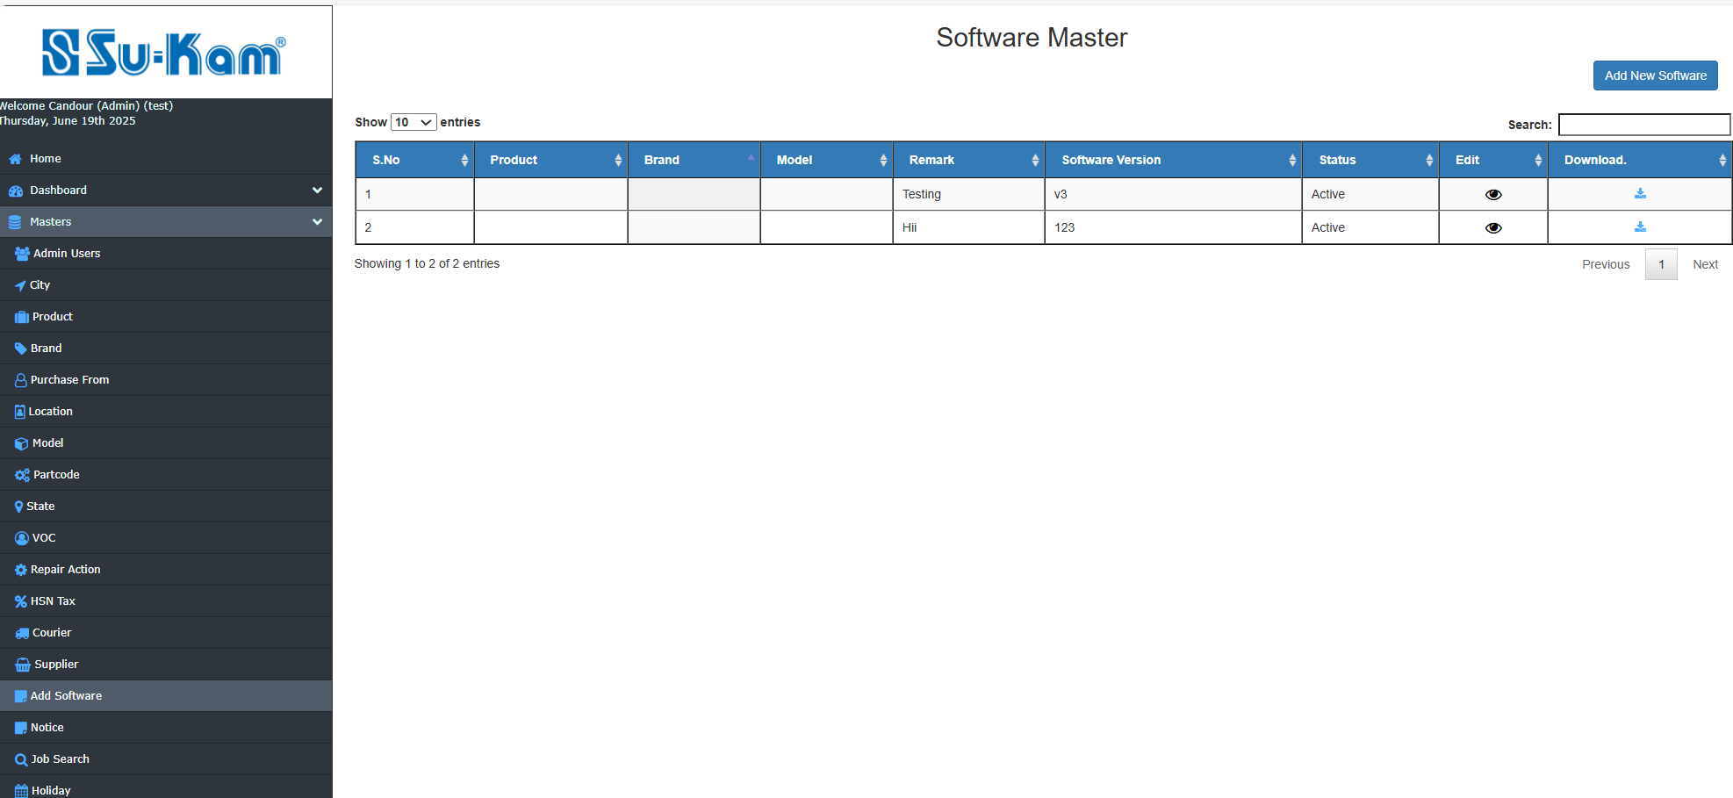



Fill all the information according to your requirements and click on update button.

Notice Master
First of all click on add new notice .After that select edit notice on the following basis:
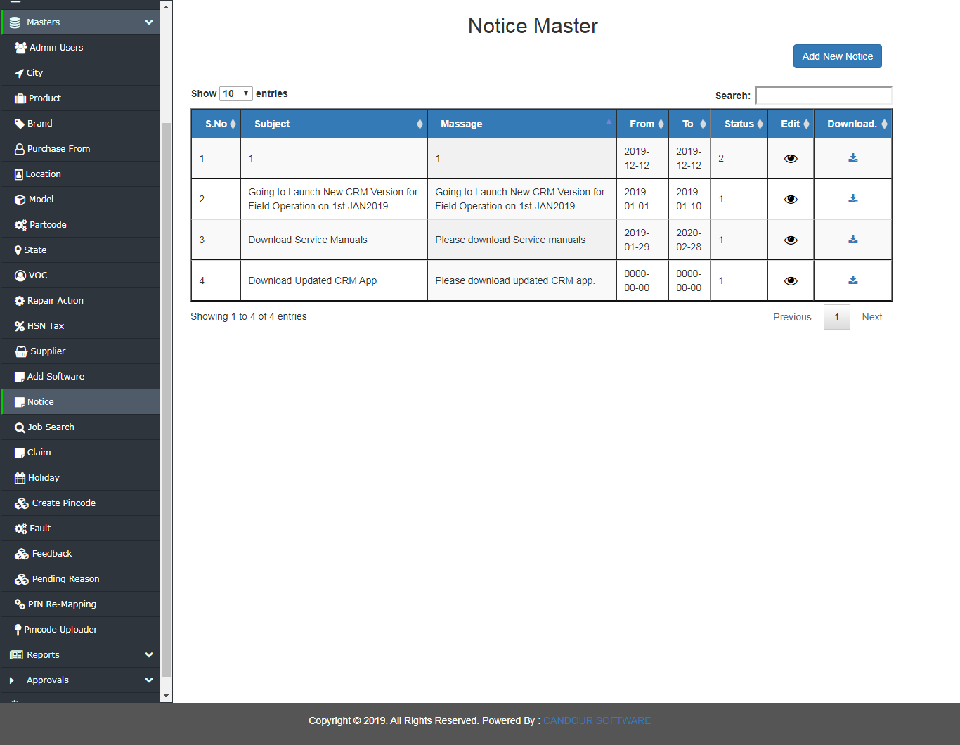
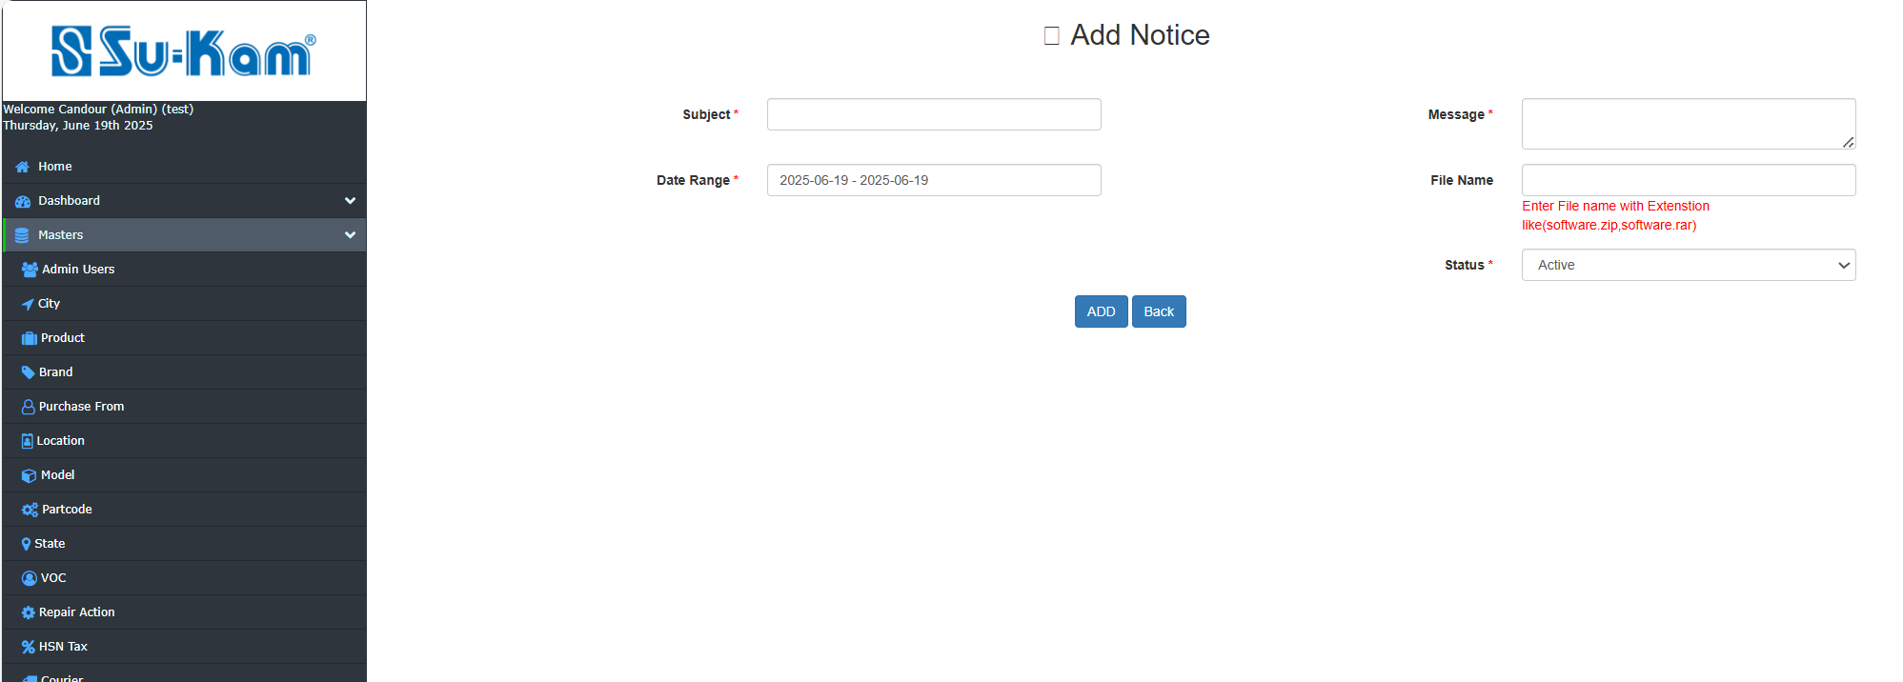


Fill all the information according to your requirements and click on update button.

Job Search / complaint

First of all, fill all the details given as below and update it.

- Product
- Model
- Brand

CLICK ON GO button ahead:

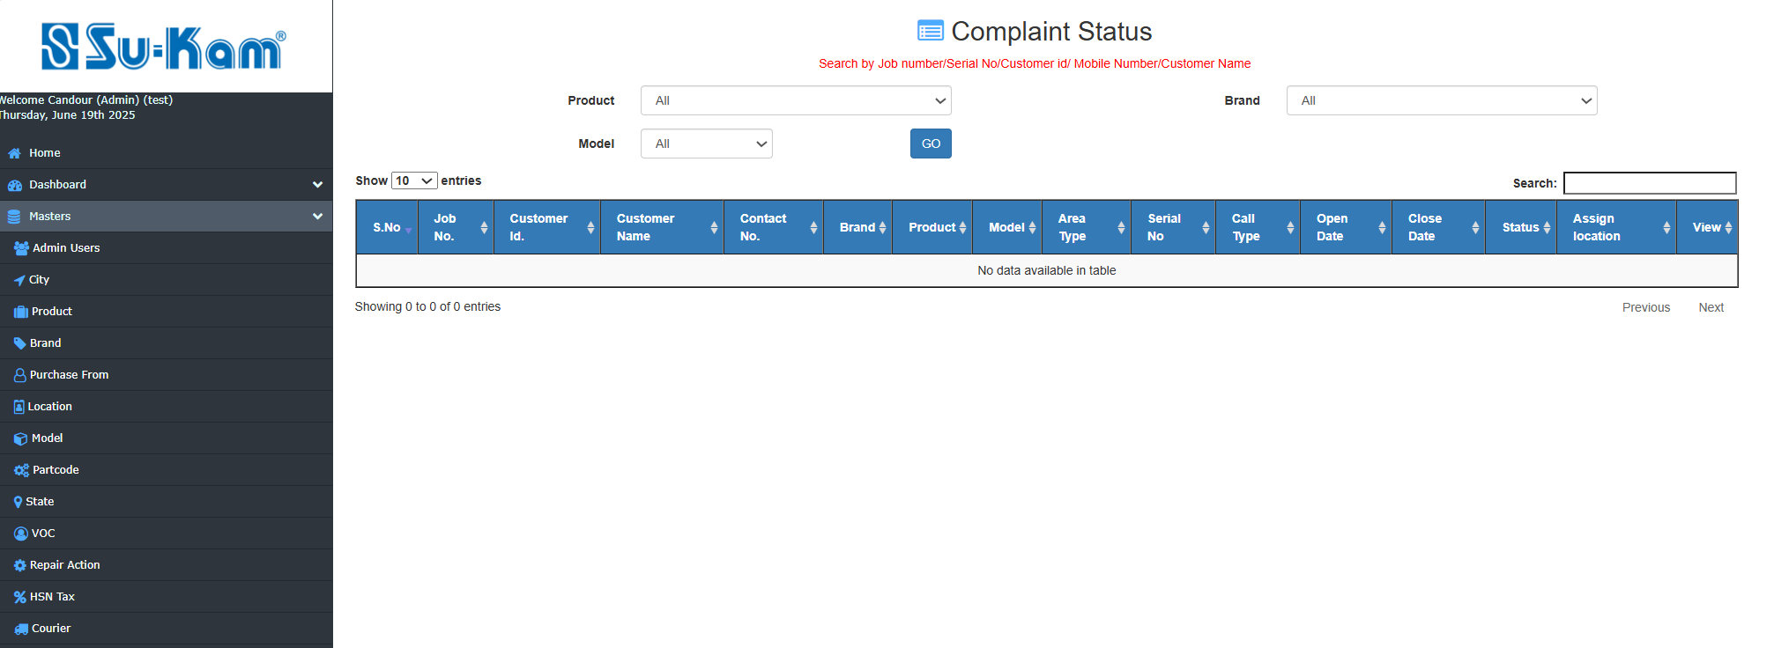
Fill and check all the details according to your requirements.

Holidays Master
This menu provides to create holidays on the basis of:
- Click on Add new holidays
- Select edit /view holidays
- Update it

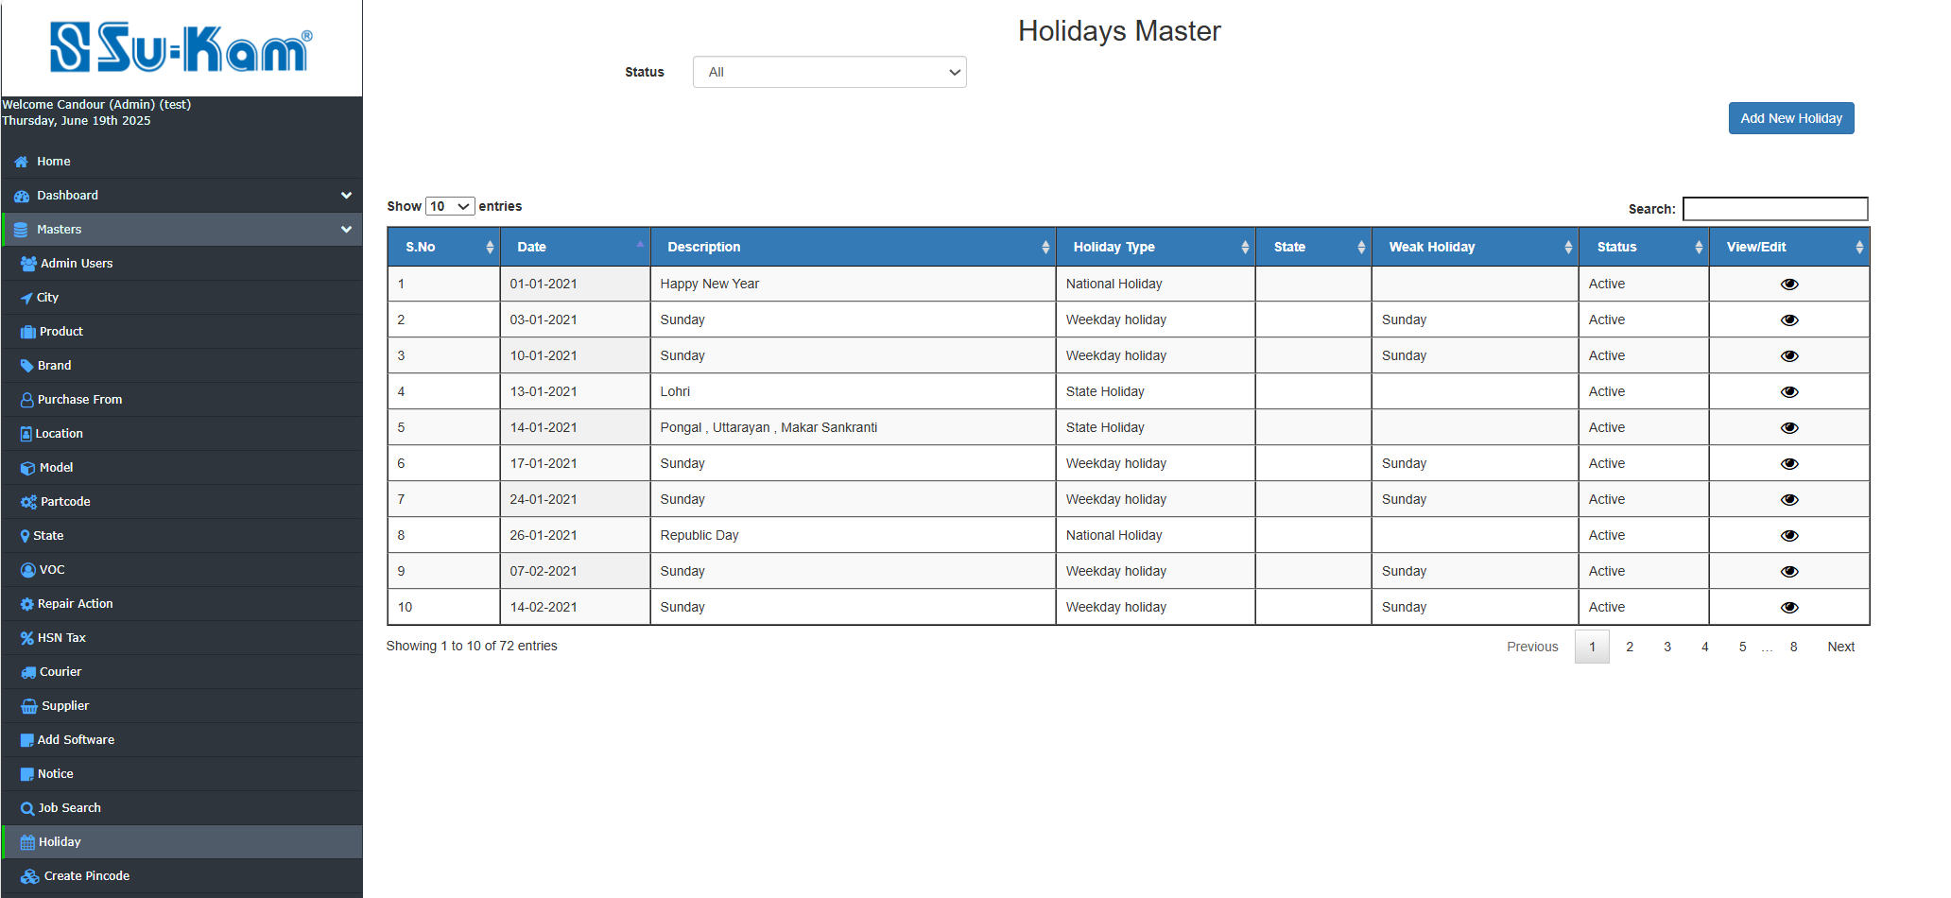

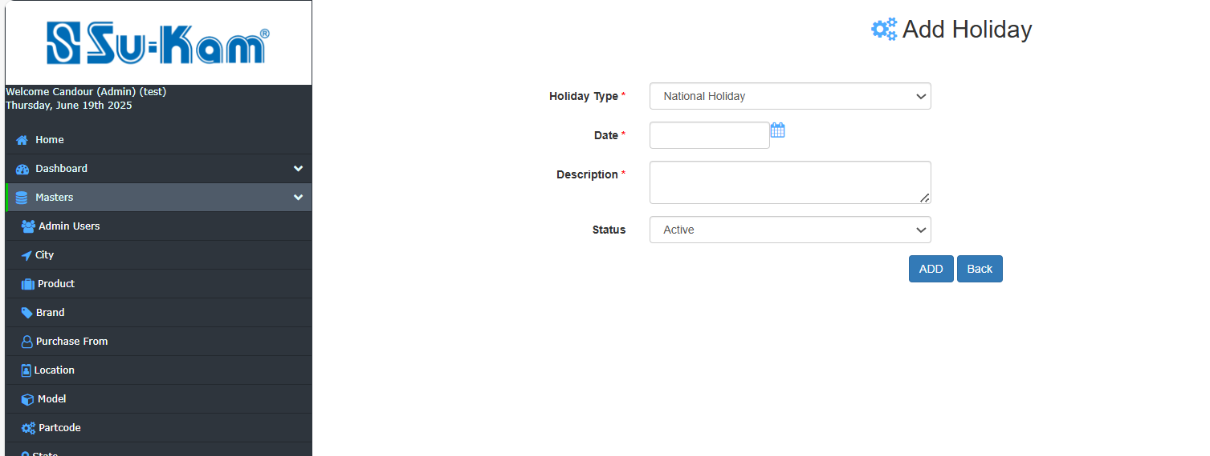
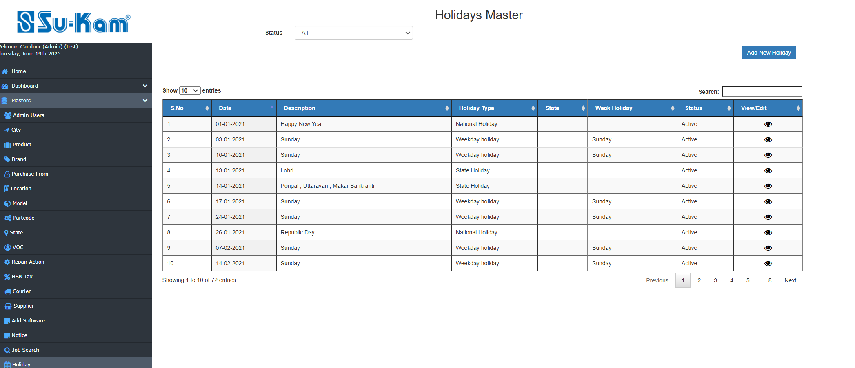
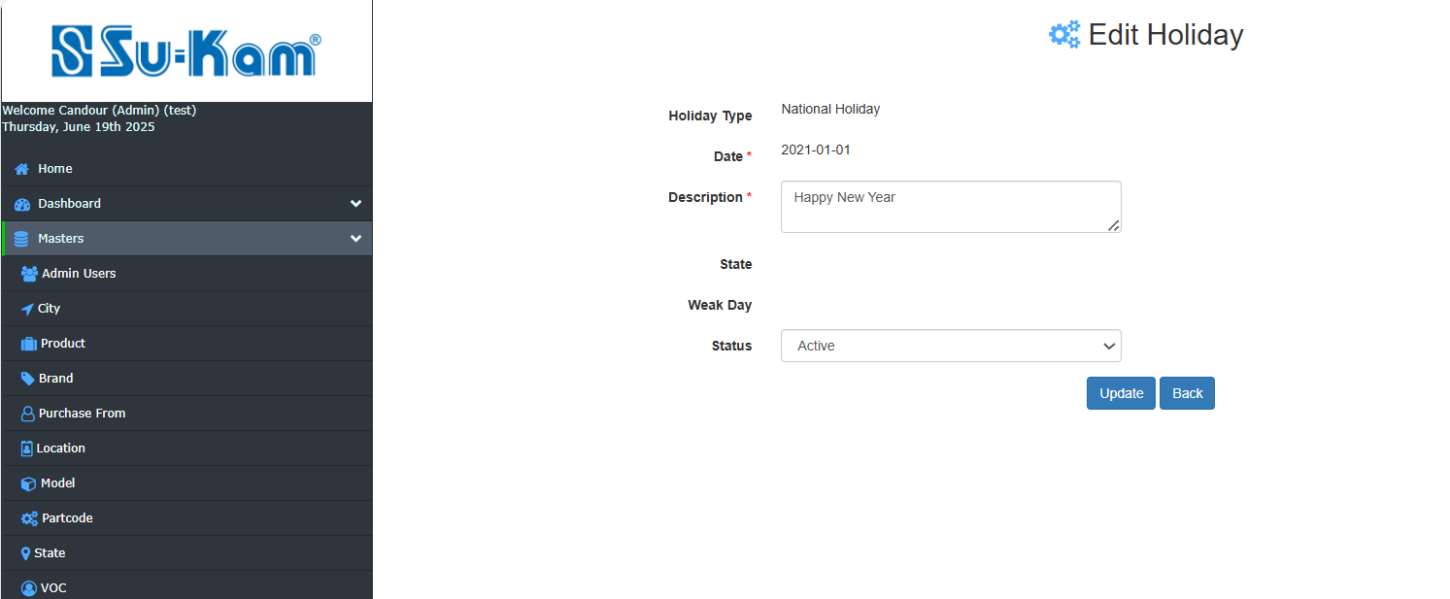
Fill all the details according to your requirements and click on update button.

Create Pin code
This Menu helps to create New Pincode by tab on Add New Pincode given below:
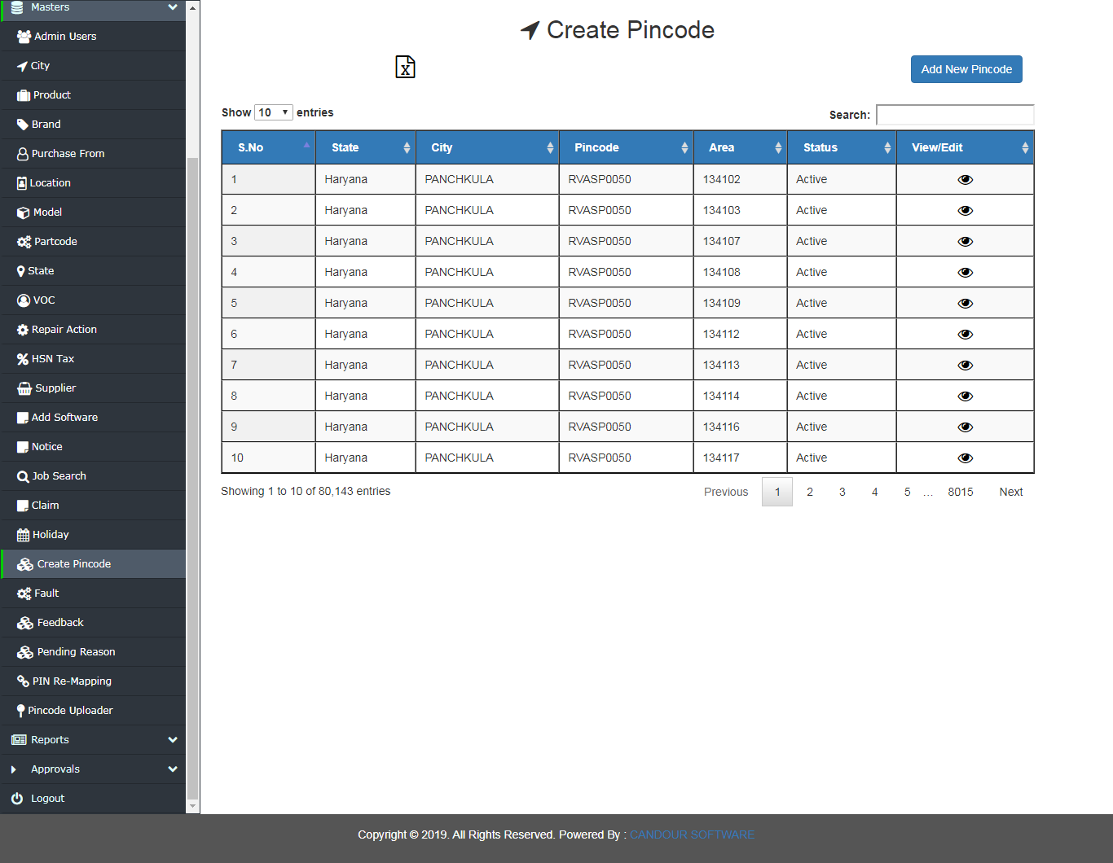
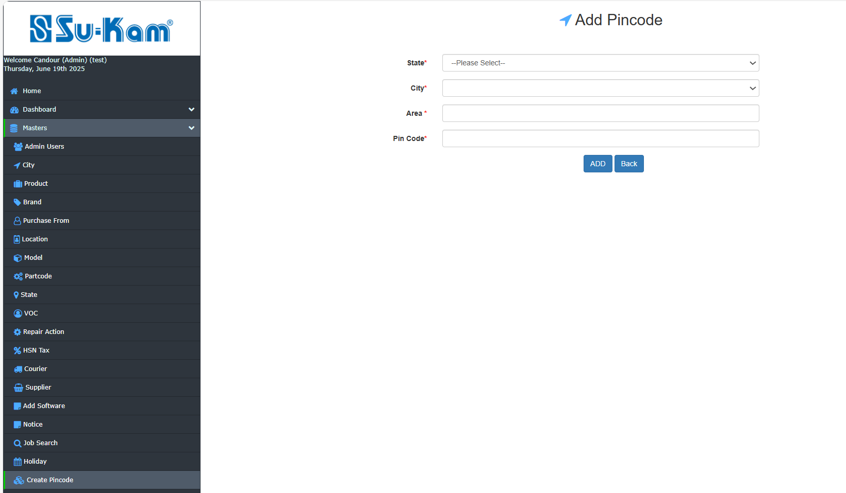
Add all the necessary details above as required according to the requirement.

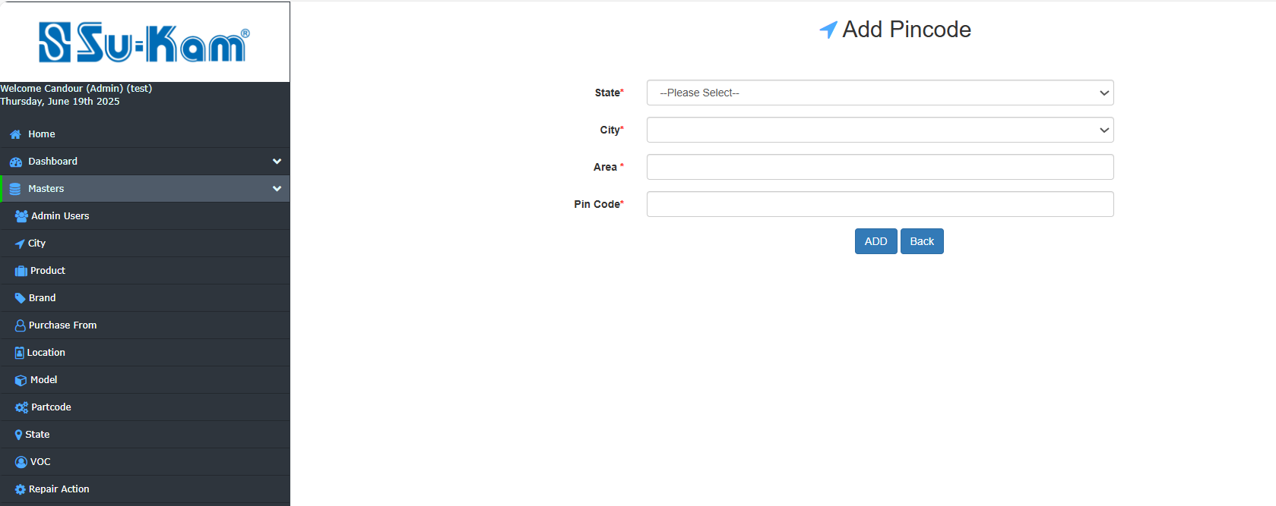
Fill all the above information as required to update it.

Defect Master (Fault)

First of all click on the following options as provided to :

- Click on Add new defect
- Select edit / view defect
- Add and Update it

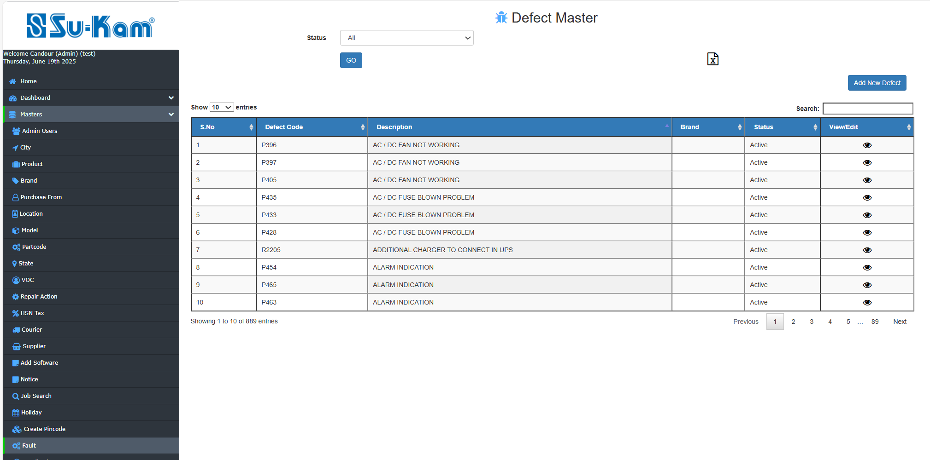

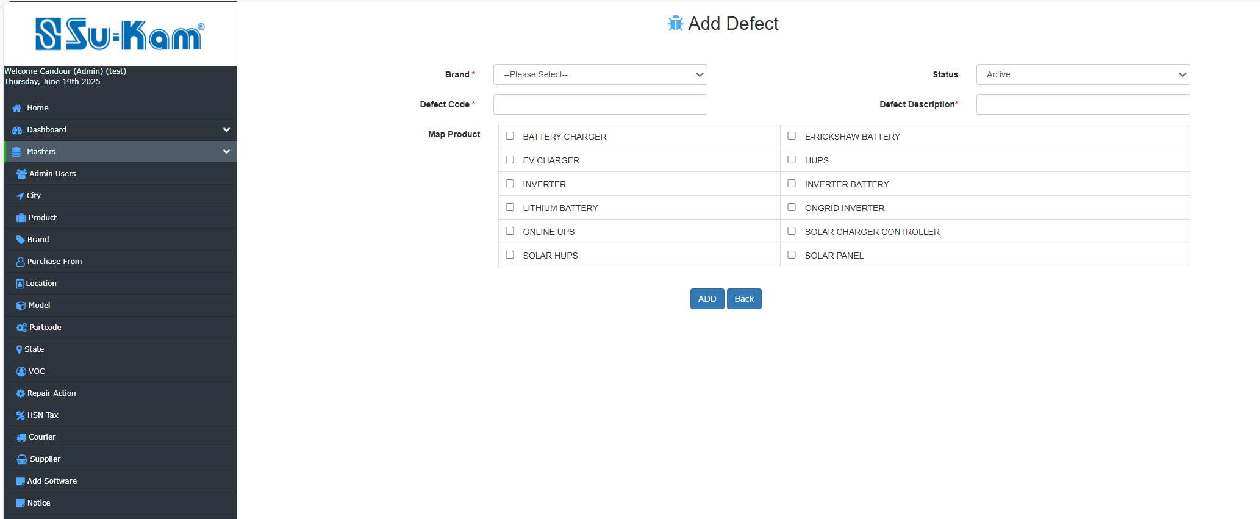

Fill all the information according to your requirements and click on update button.

Feedback Master

This menu creates to provide you feedback regarding services as provided to:

- Click on Add New Feedback
- Select edit /view feedback
- Update and save it.

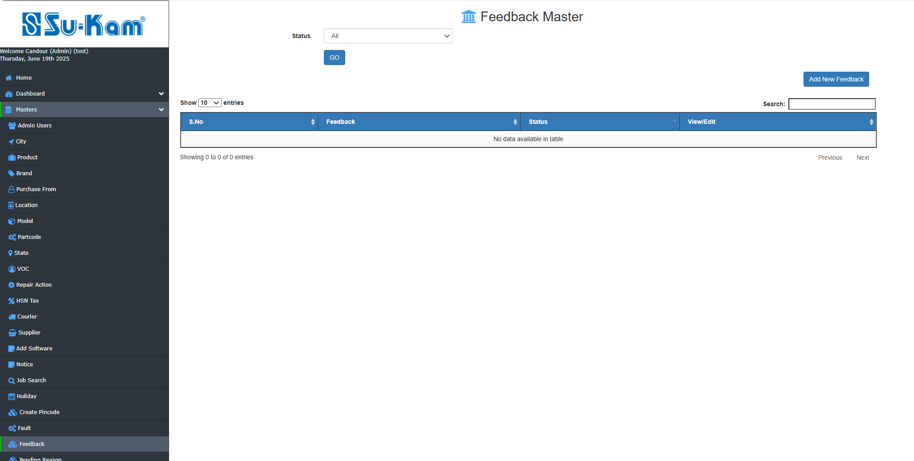

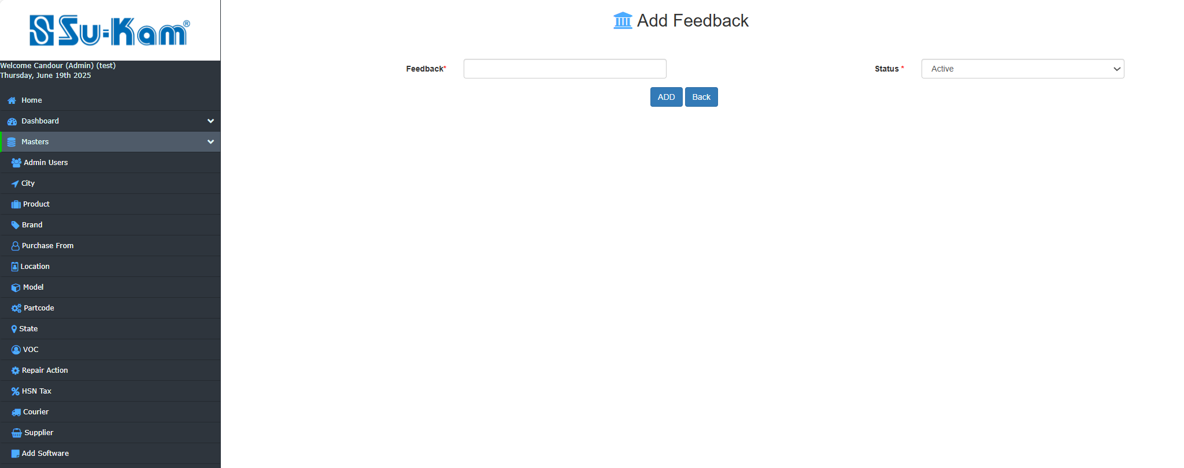

Fill all the information according to your requirements and click on update .

Pending Reason Master
Here, User can check the pending reason and can ADD New Reason as shown below:
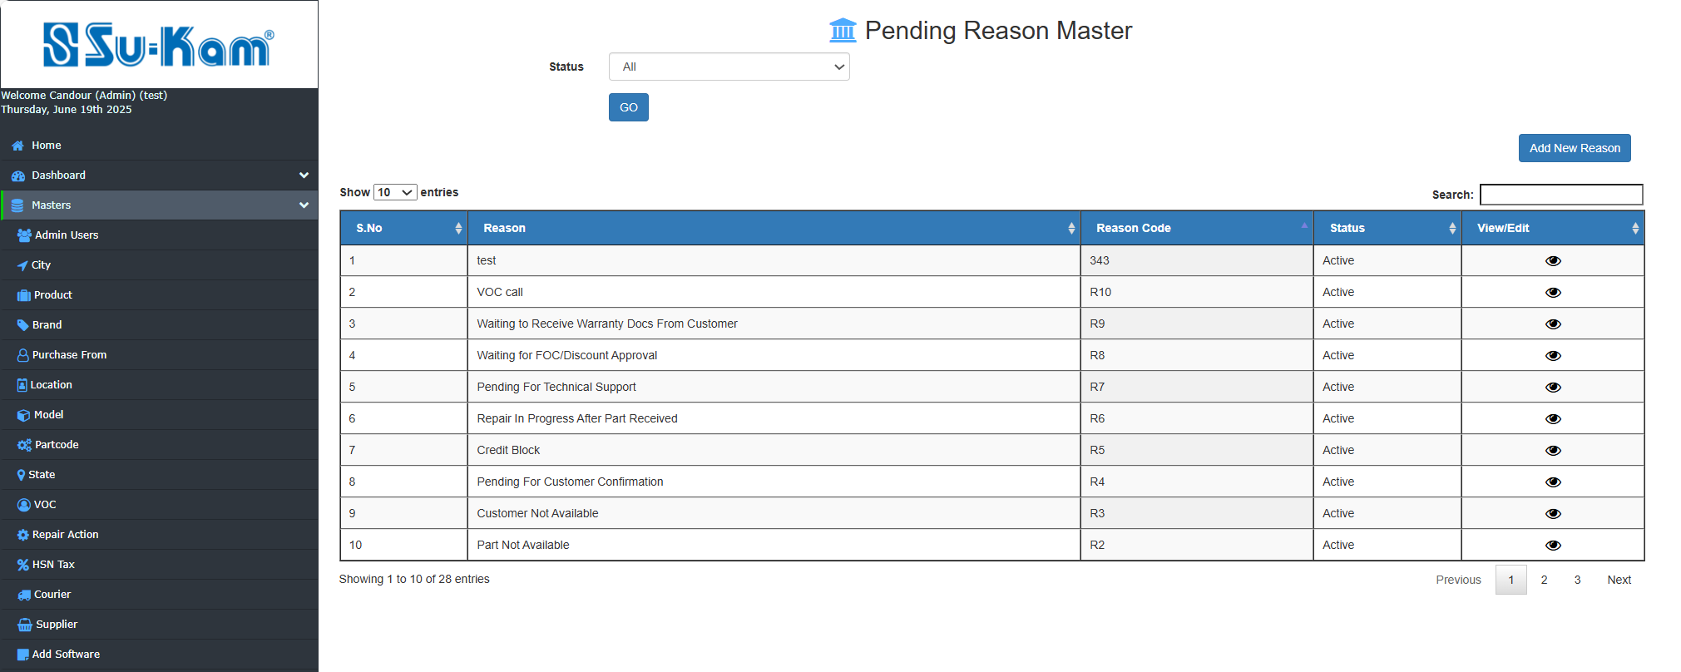

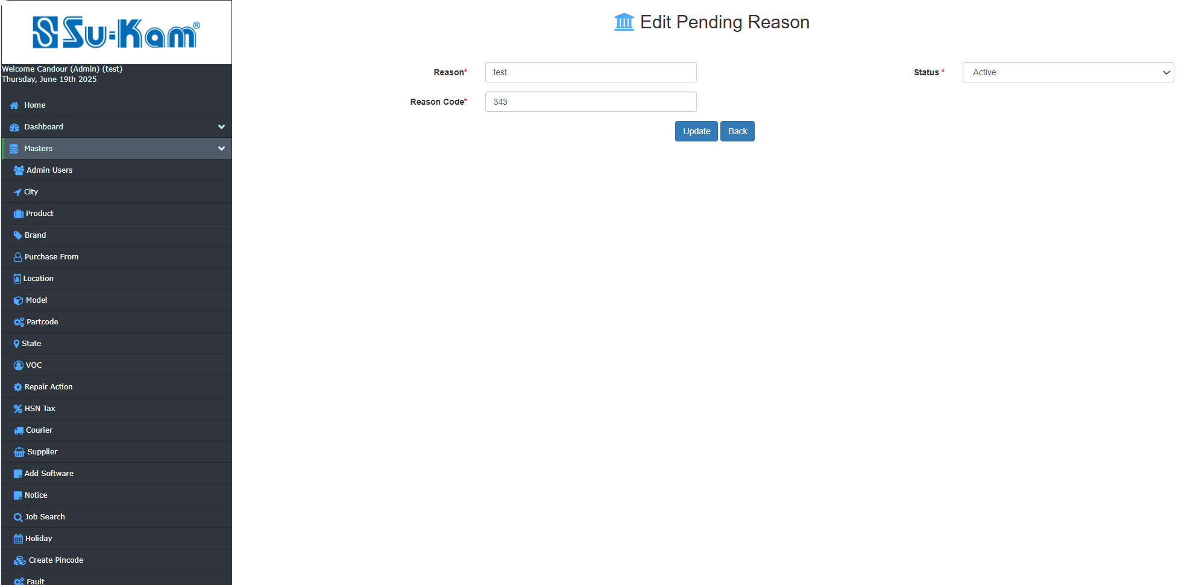
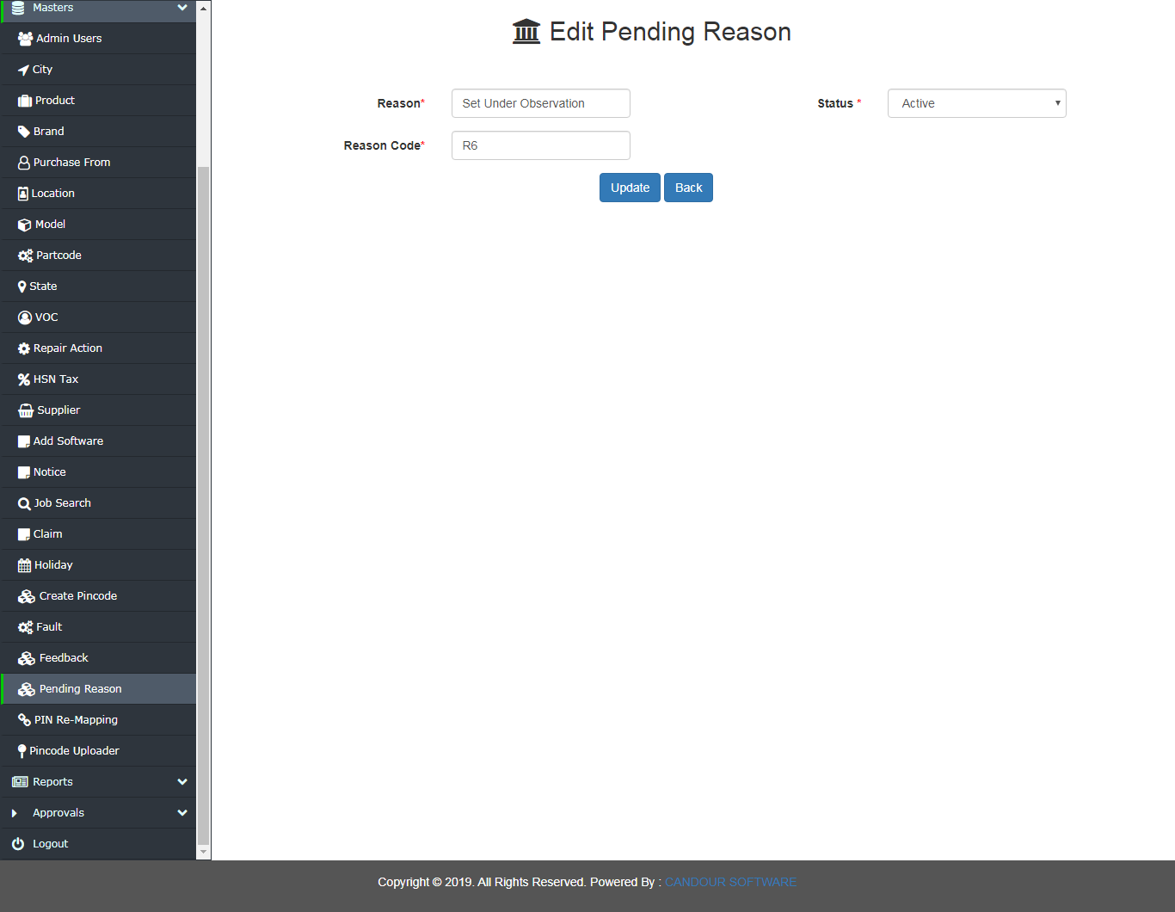
Fill all the information according to your requirements and click on update.

PIN Re-Mapping
The pin codes can be remapped with locations by uploader.
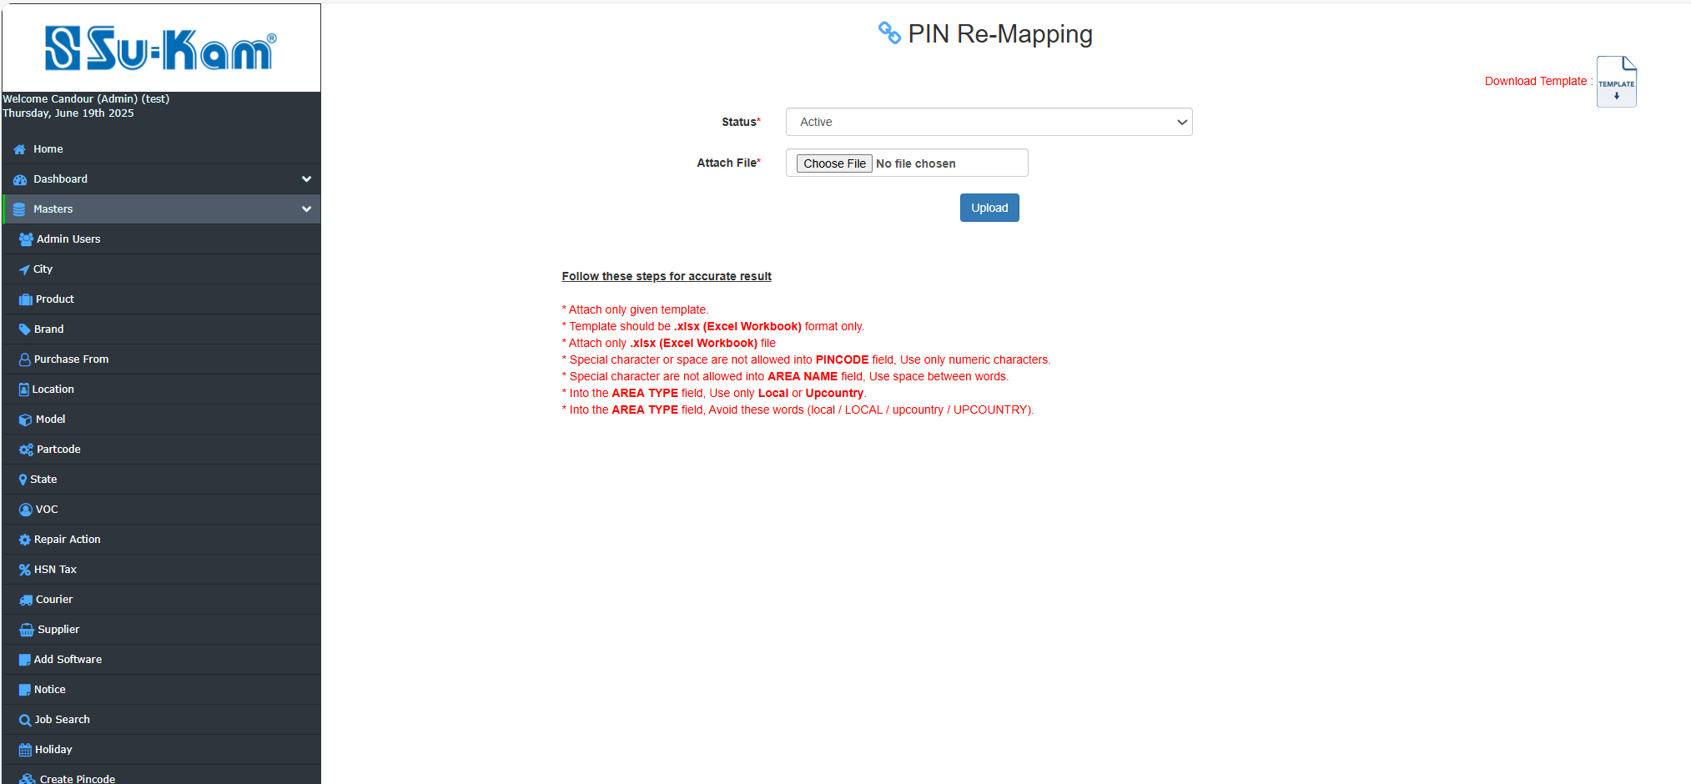

PIN(Code)Uploader
The Pin code up loader is given here to upload state wise pin code with the help of given Template.
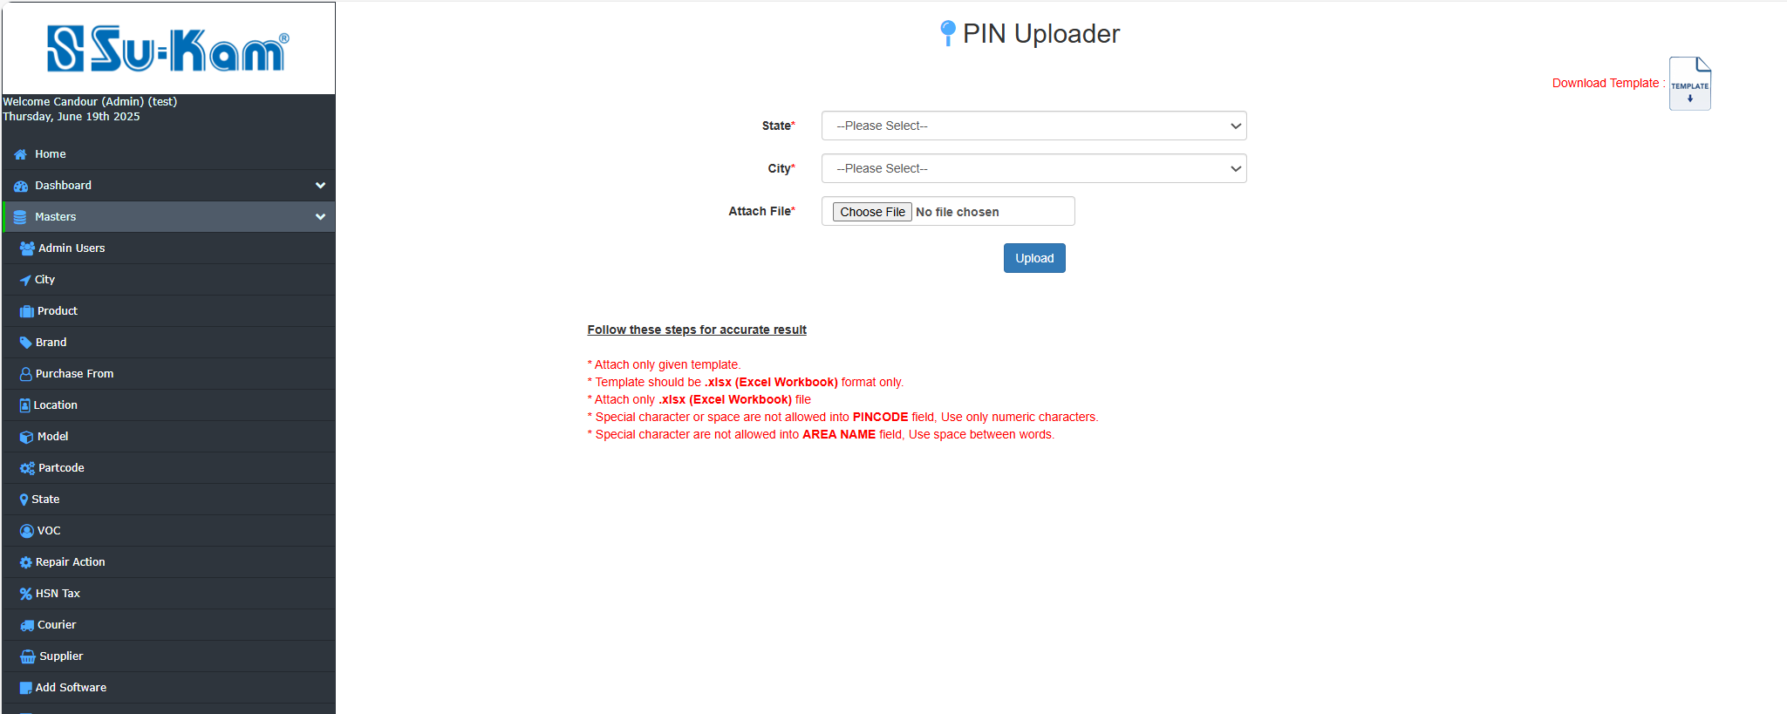

Reports
Click on Reports tab and open below page as shown in the given figure:

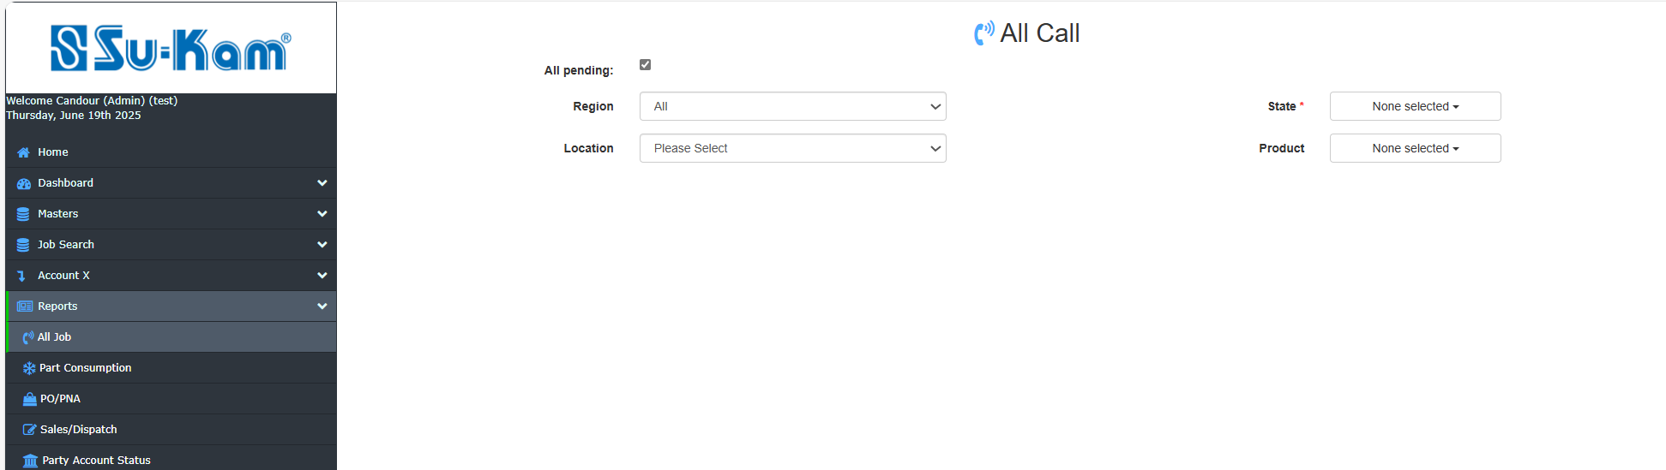
GO One by One on Options to be selected and get details on it as to be shown.

ALL Jobs
This Menu creates to provide the details regarding the calls to be pending by click on:

- Data range
- Region
- Location
- Brand
- Status
- State
- Product
- Model

Fill all the details according to your requirements and click on GO button .

Part Consumption

First of all click on the details as given below:

- Data Range
- State
- Product
- Model
- Brand
- Data type
- Location

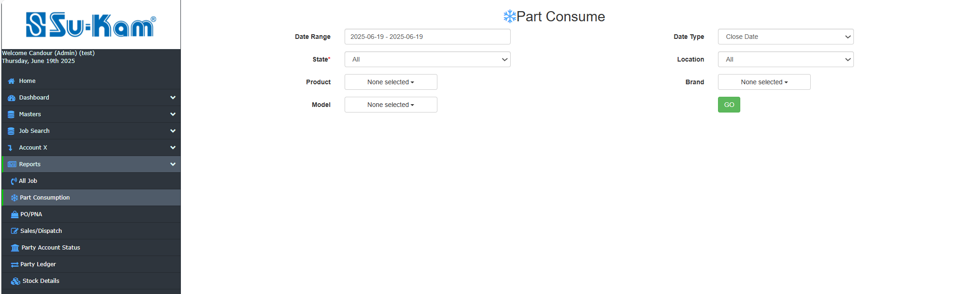

Fill all the details according to your requirements and click on Go button.

Pending PO/PNA
This menu provides you to create the details of Pending PO/PNA by click on these options:

- Date Range
- State
- Location
- Product
- Model
- Status
- City
- Type
- Brand
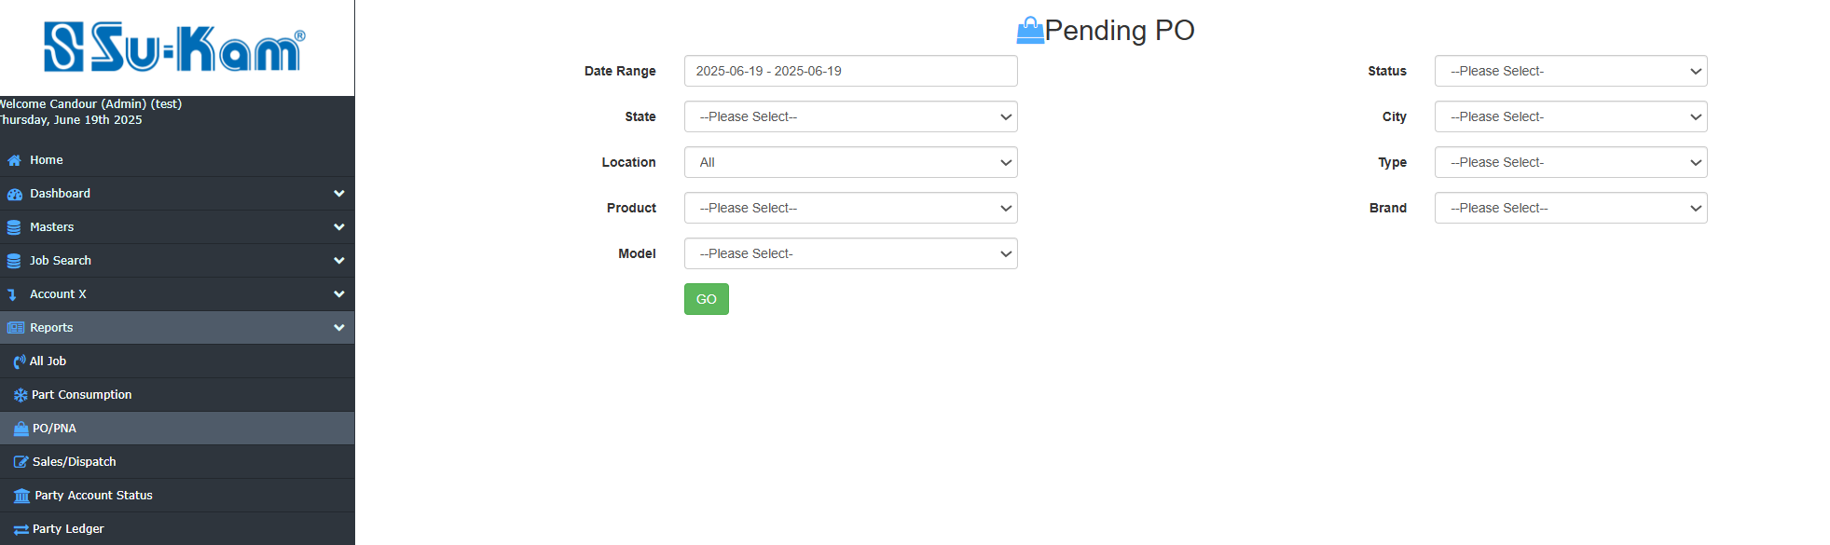

Fill all the details according to your requirements and click on Go button.

Sales/Dispatch Report

This menu provides you to create the details of sales by click on these options:

- Data Range
- From State
- To State
- Product
- Model
- From Location
- To Location
- Brand

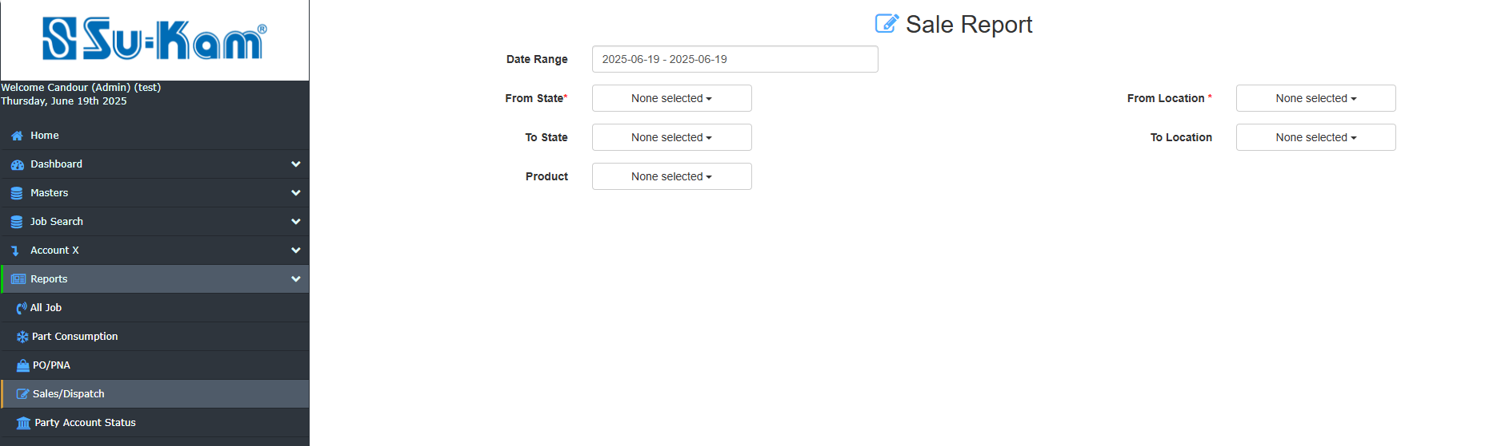
Fill all the details according to your requirements and click on GO button.

Party Account Status

First of all, click on the options to get the details on it:

- Date range
- State
- Location

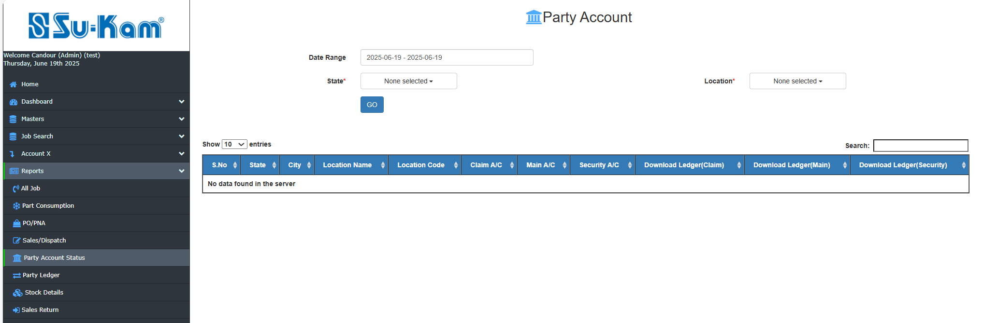
Fill all the details according to your requirements and Click on Go button to download the ledger.

Stock details (status)
This Menu creates to provide the stock status or details by click on :

- Product
- Location
- Brand
- Model

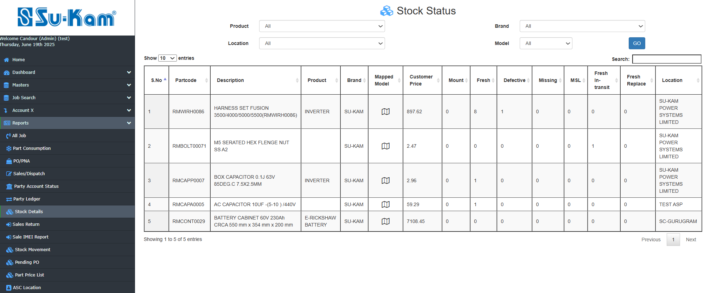
Fill all the details according to your requirements and Click on Go button for further details.

Sales Return

This menu provides you to create the details of sales return by click on these options:

- Data Range
- From Location
- To Location
- From State
- To State
- Product
- Model
- Brand

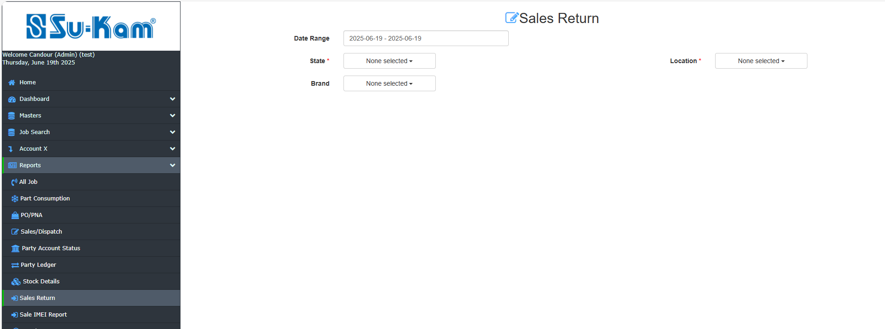

Fill all the details according to your requirements and Click on Go button for further details.

Stock Movement

This menu creates to provide the details of stock Movement by click on:

- Date Range
- Product
- Location
- Brand
- Model

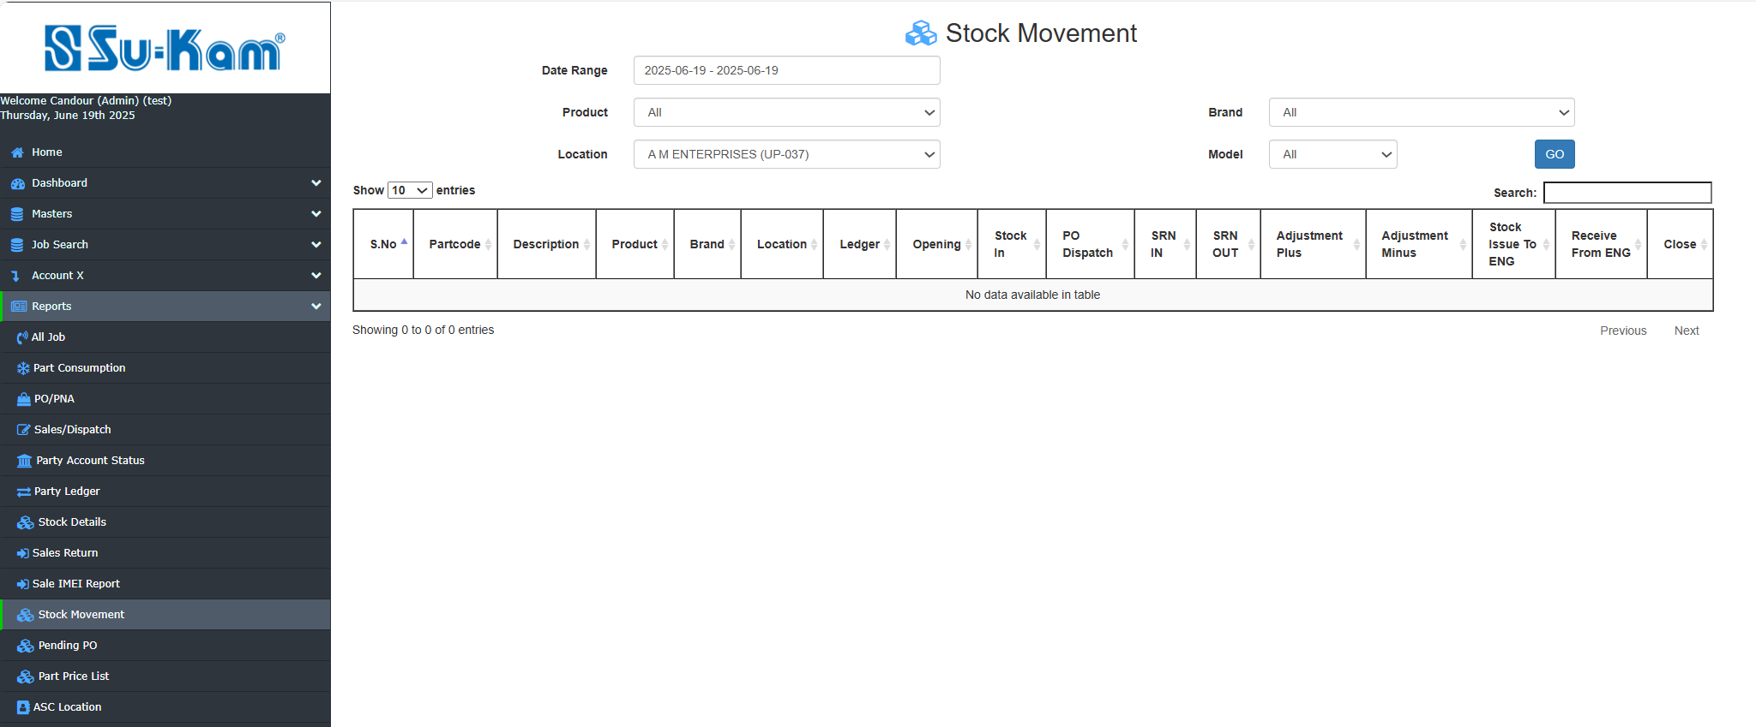

Fill all the details according to your requirements and click on GO button for further details.

Pending PO

First of all click on the following details as shown below:

- Date Range
- State
- Type
- Status
- Location

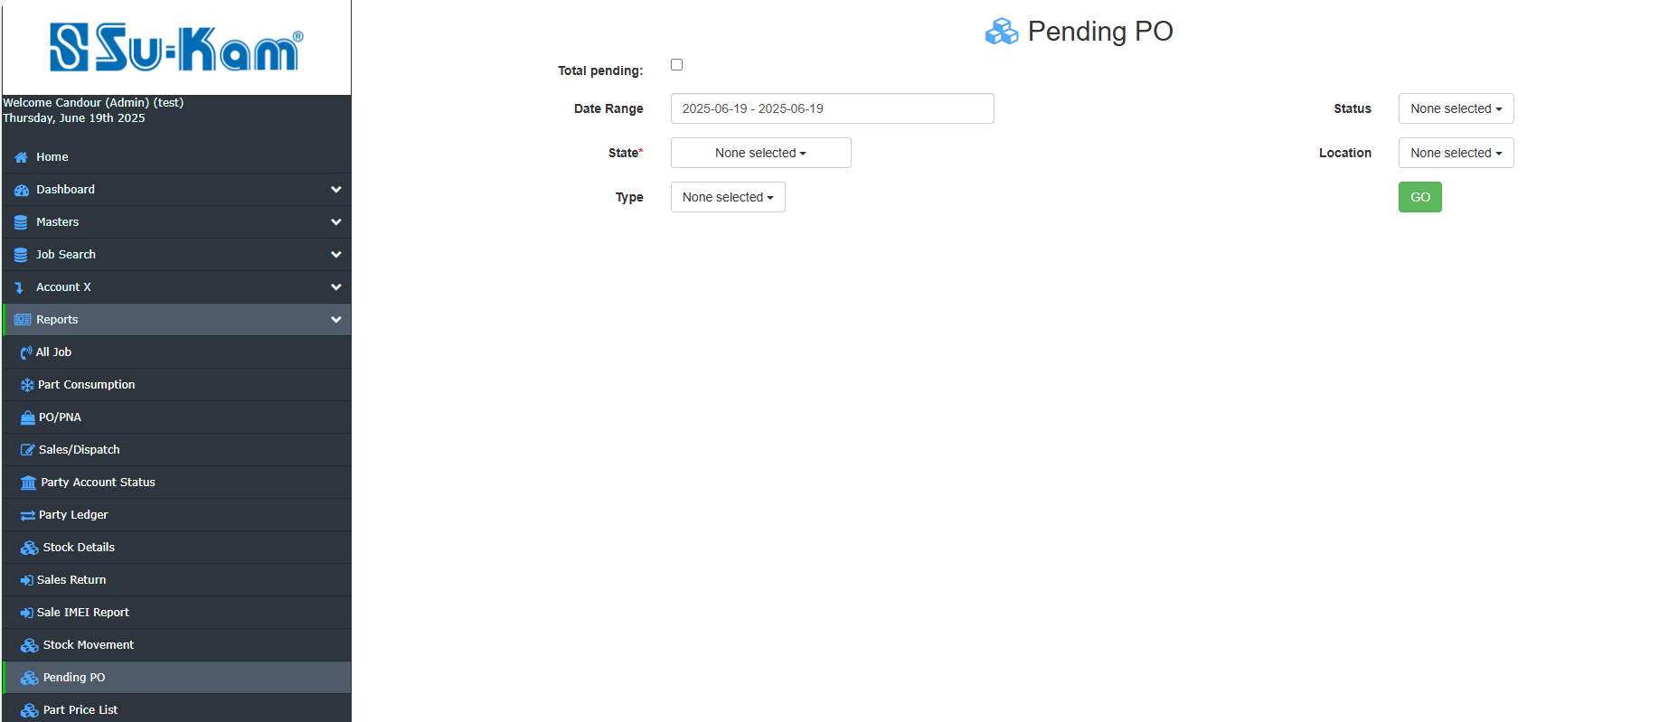

Fill all the details according to your requirements and click on GO button above for further details.

Partprice list(partcode) search

This menu provides the details on partcode search on the given options:

- Product Name
- Brand
- Model

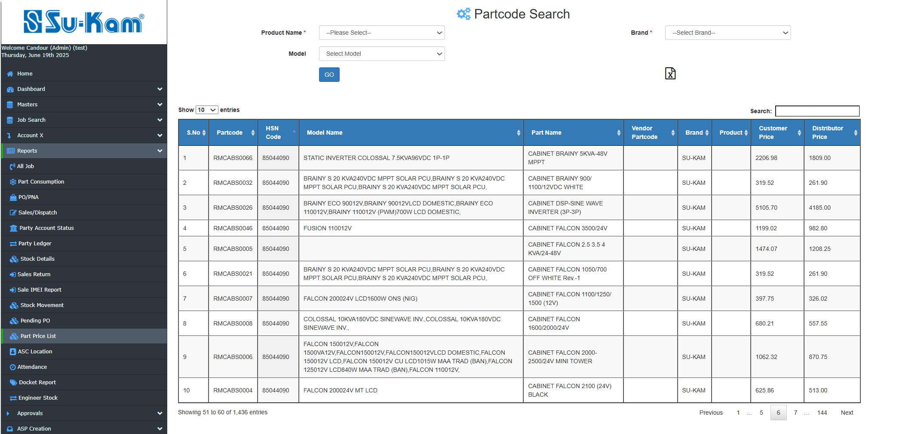
Fill all the details according to your requirements.

ASC Location
Click on the given details :
- State
- City

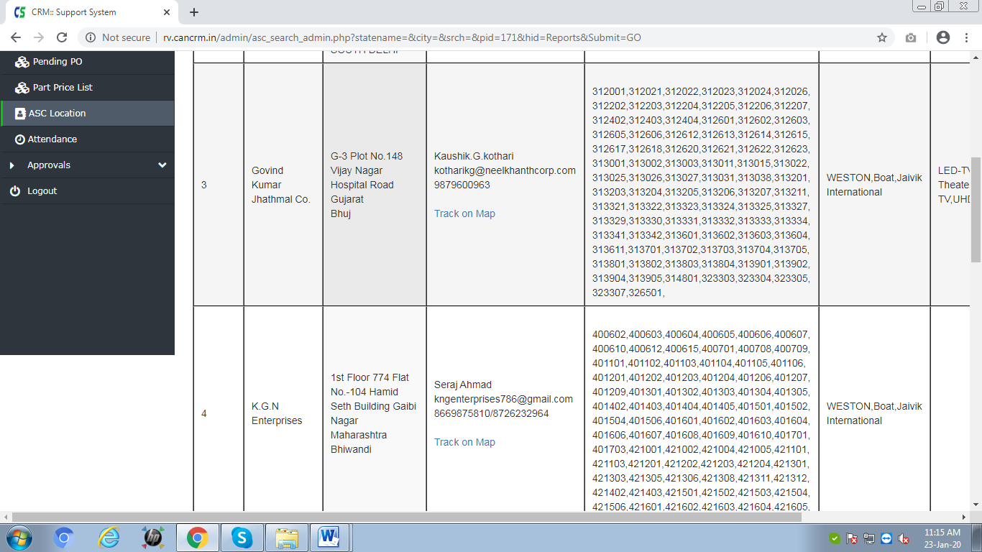
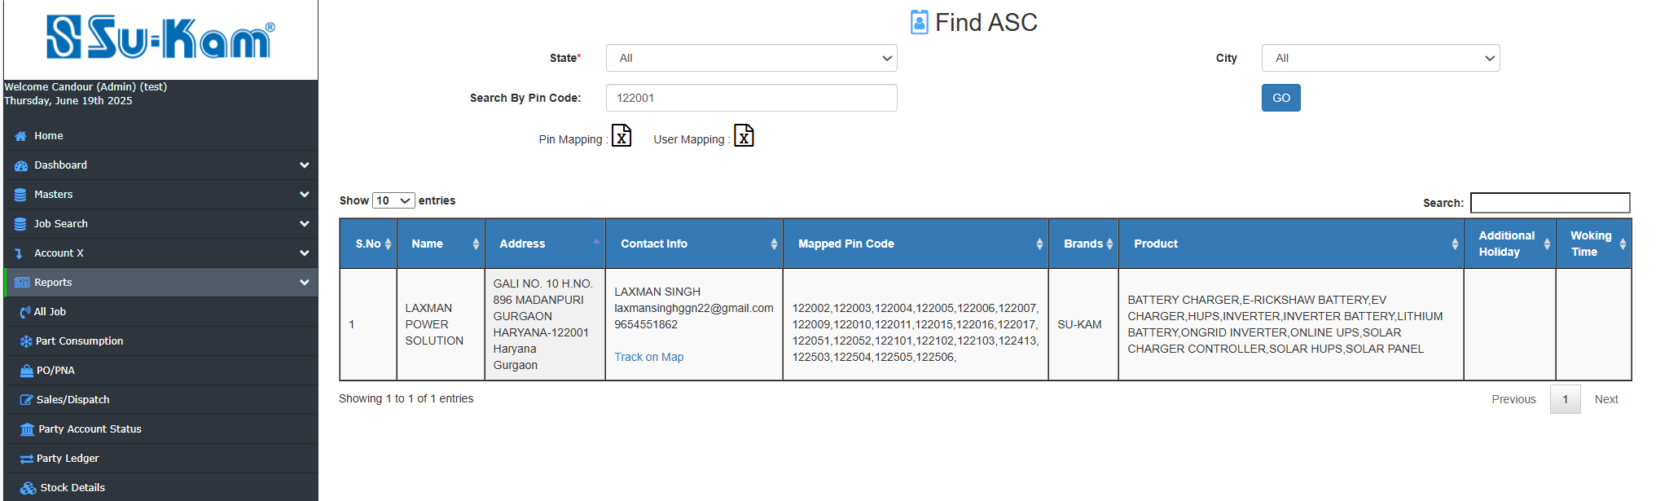

Fill all the above details and click on GO button for further information.

Attendance
The Attendance is mandatory for engineer to for day beginning without attendance, he can't be able to update any complaint, as mention the In date ,In Address , out date and Out Address.
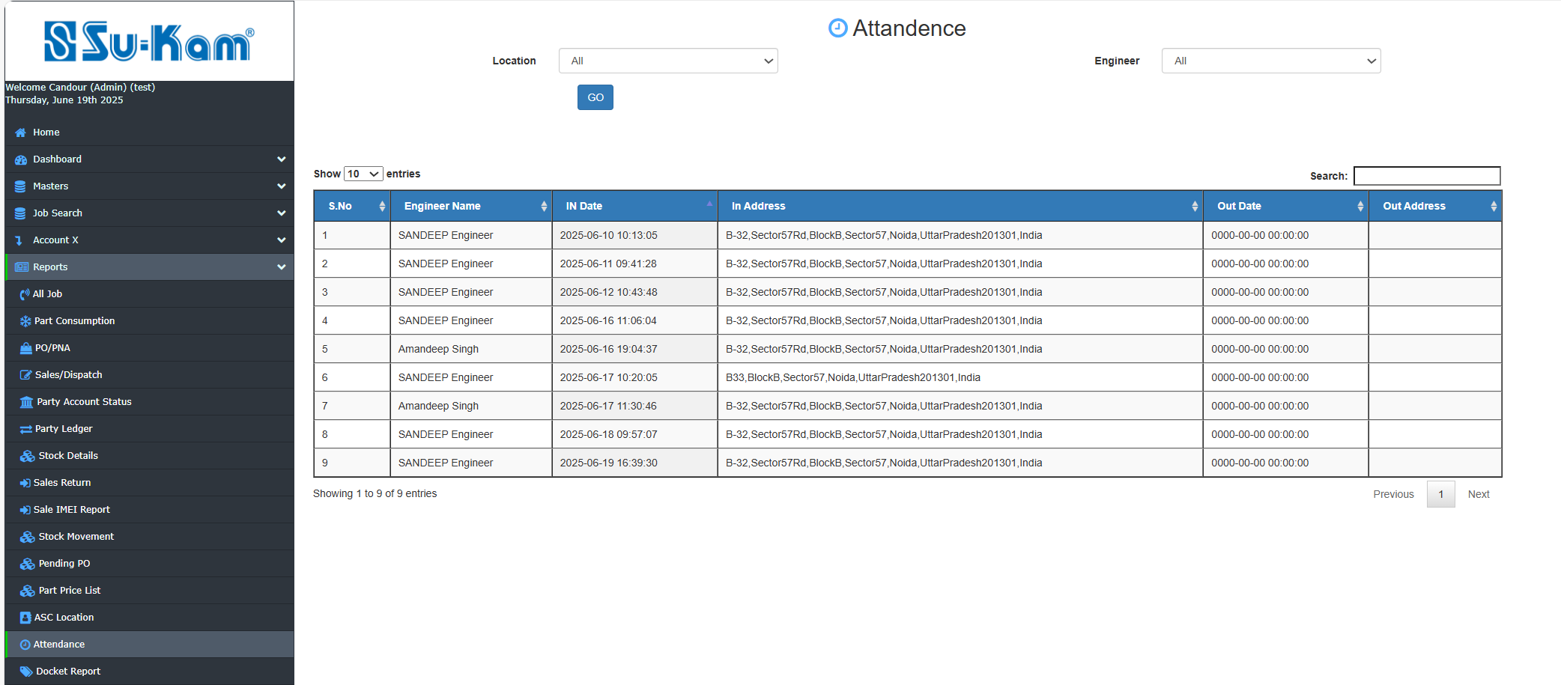

Approvals

Click on Approvals tab and open below page as shown in the given figure:

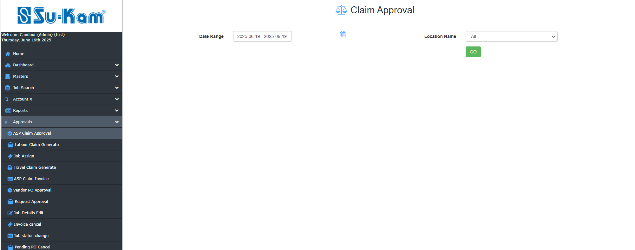
Go One by One on Options to be selected and get details on it as to be shown.

ASP Claim Approval

This menu creates to provide the ASP Claim Approval as shown below :

- Date Range
- Location name

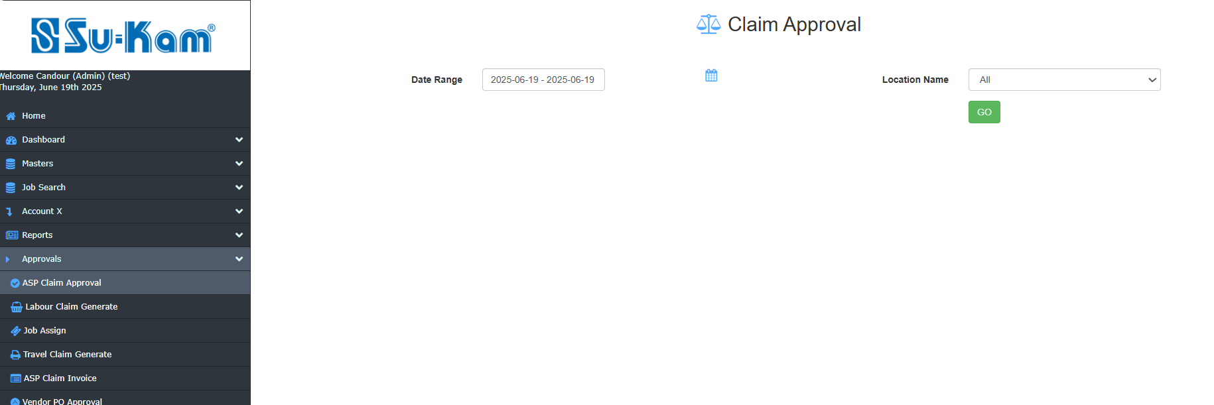

Fill all the details above according to your requirements and Click on GO button above to show approved status and claim.

Labour claim generate
This menu creates to provide the details of claim generate on the basis of:
- Month
- Location
- Year
- Area Type
- Product
- Brand
- Range

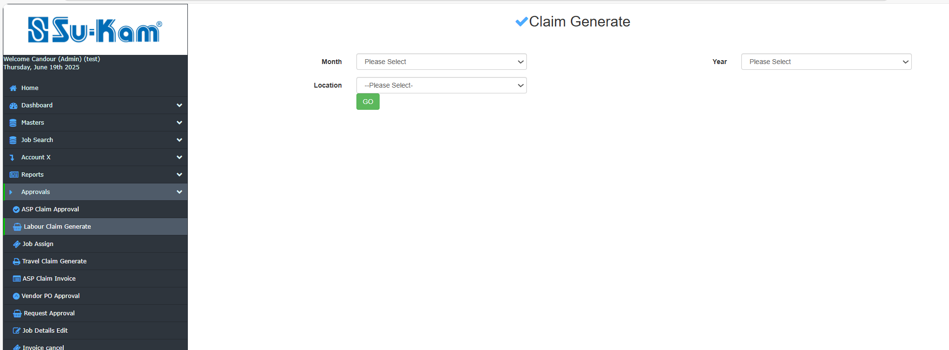



Fill all the details as given above and click on GO button to generate the claim .

Reassign jobs/Job Assign

The admin has right to reassign/assign the given job in this section.

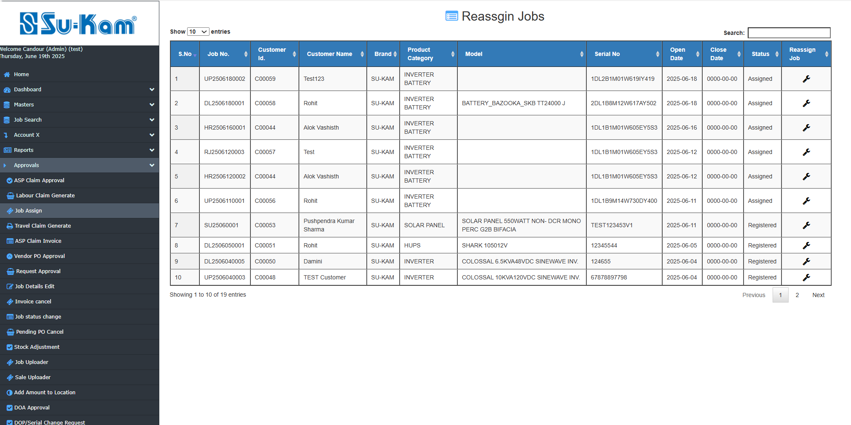

Travel claim generate

Click on the Travel claim generate tab under approvals and open the below page by using Go option:

- Click on generate as :

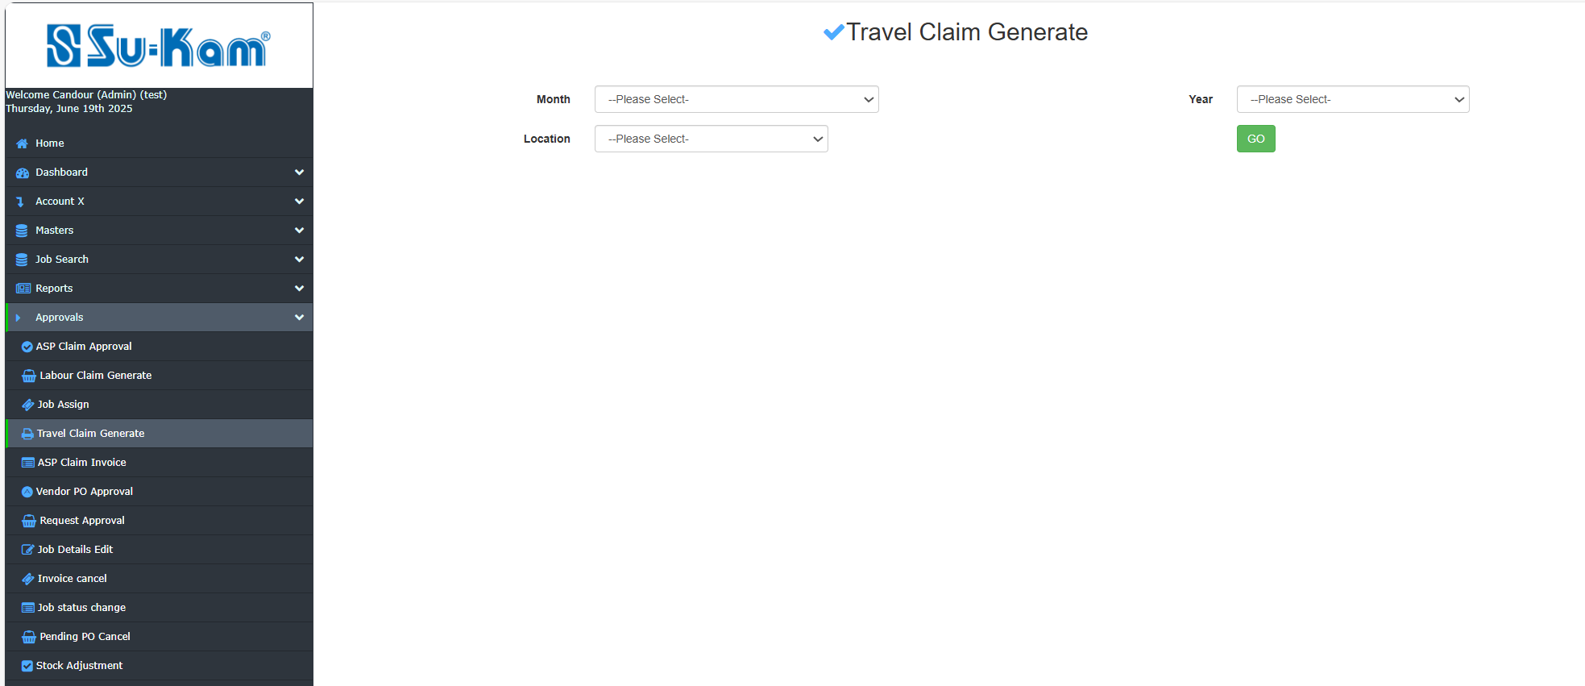
claim Release view page is shown on the next page as given below:

Fill all the details above according to your requirements and click on release button.

ASP Claim Invoice

Click on the given options : Go on for search as:

- Month
- Location name
- Year

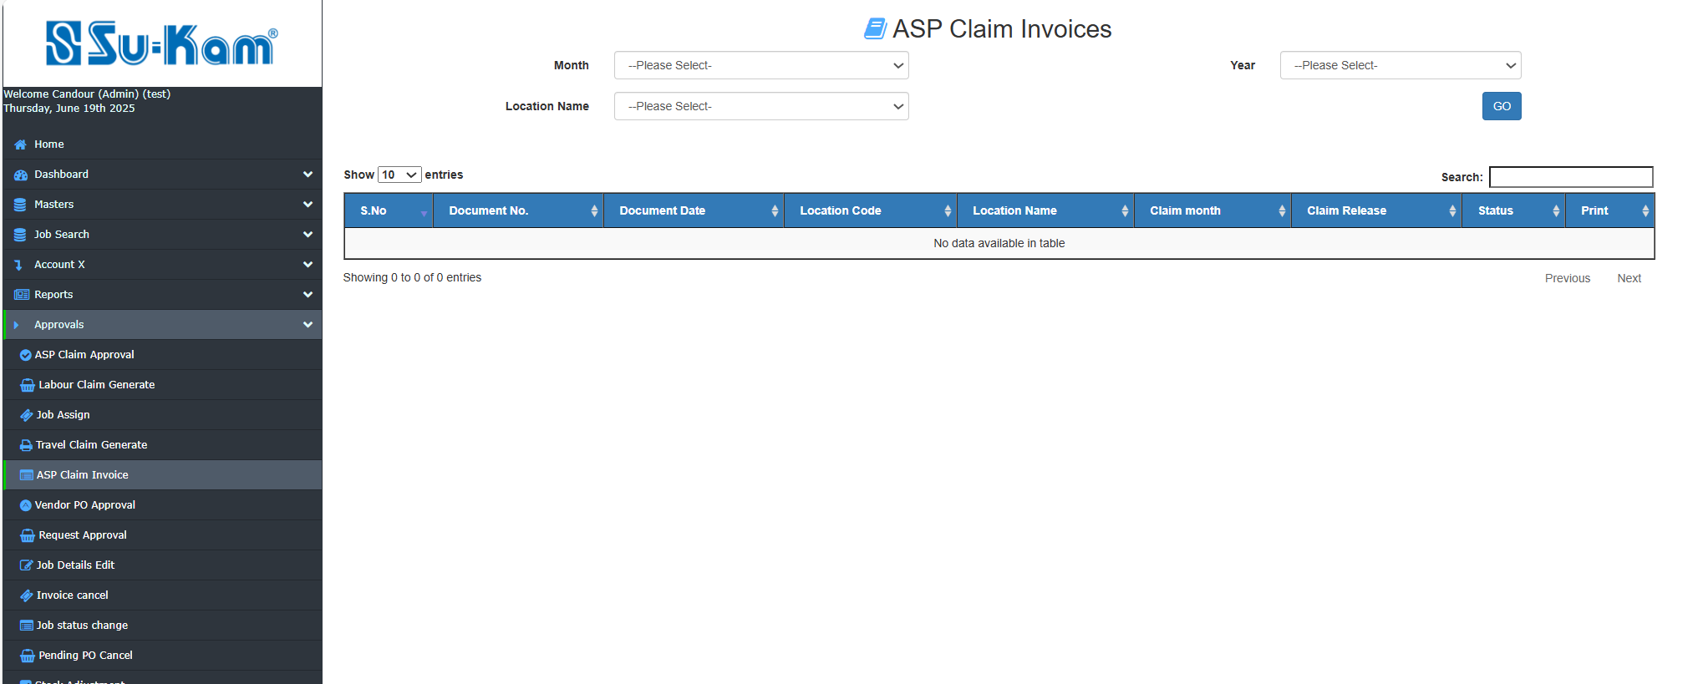

Fill all the required details and click on Release button.

Vendor PO Approval

Click on Vendor PO Approval / Admin Approval tab and Open below page:

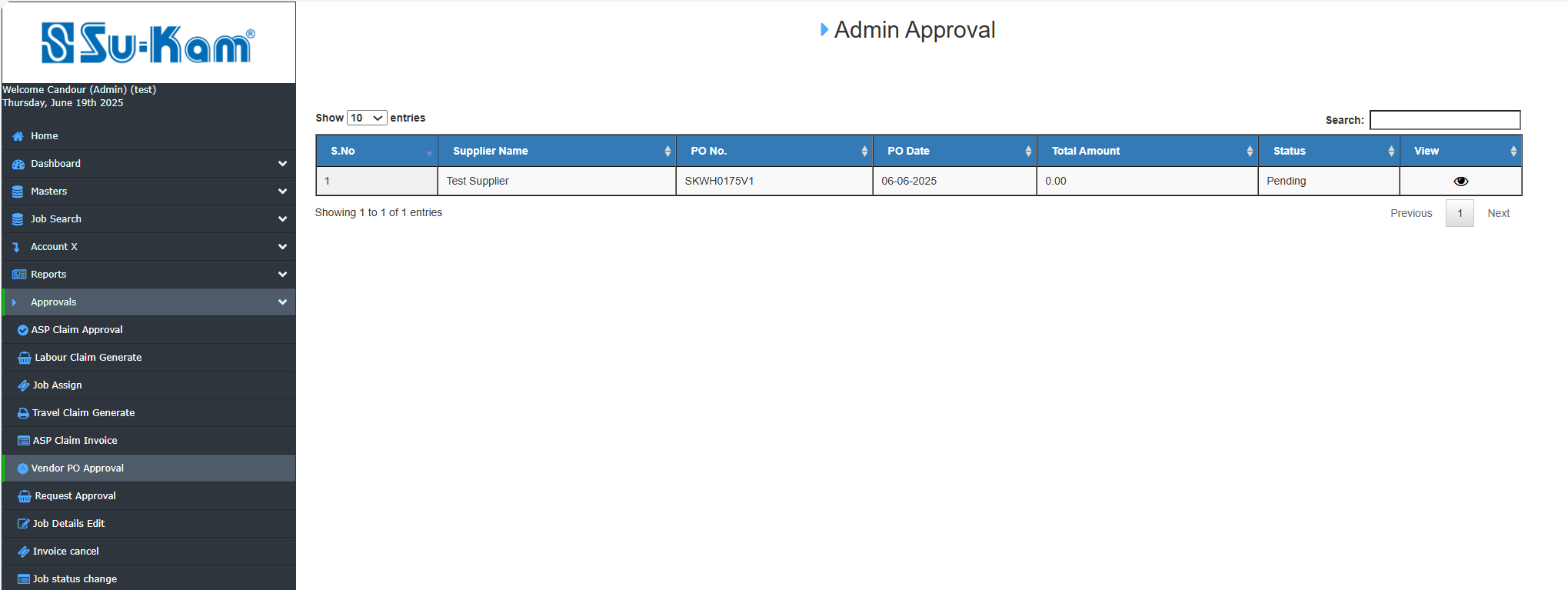

Click on View TAB and open below page:

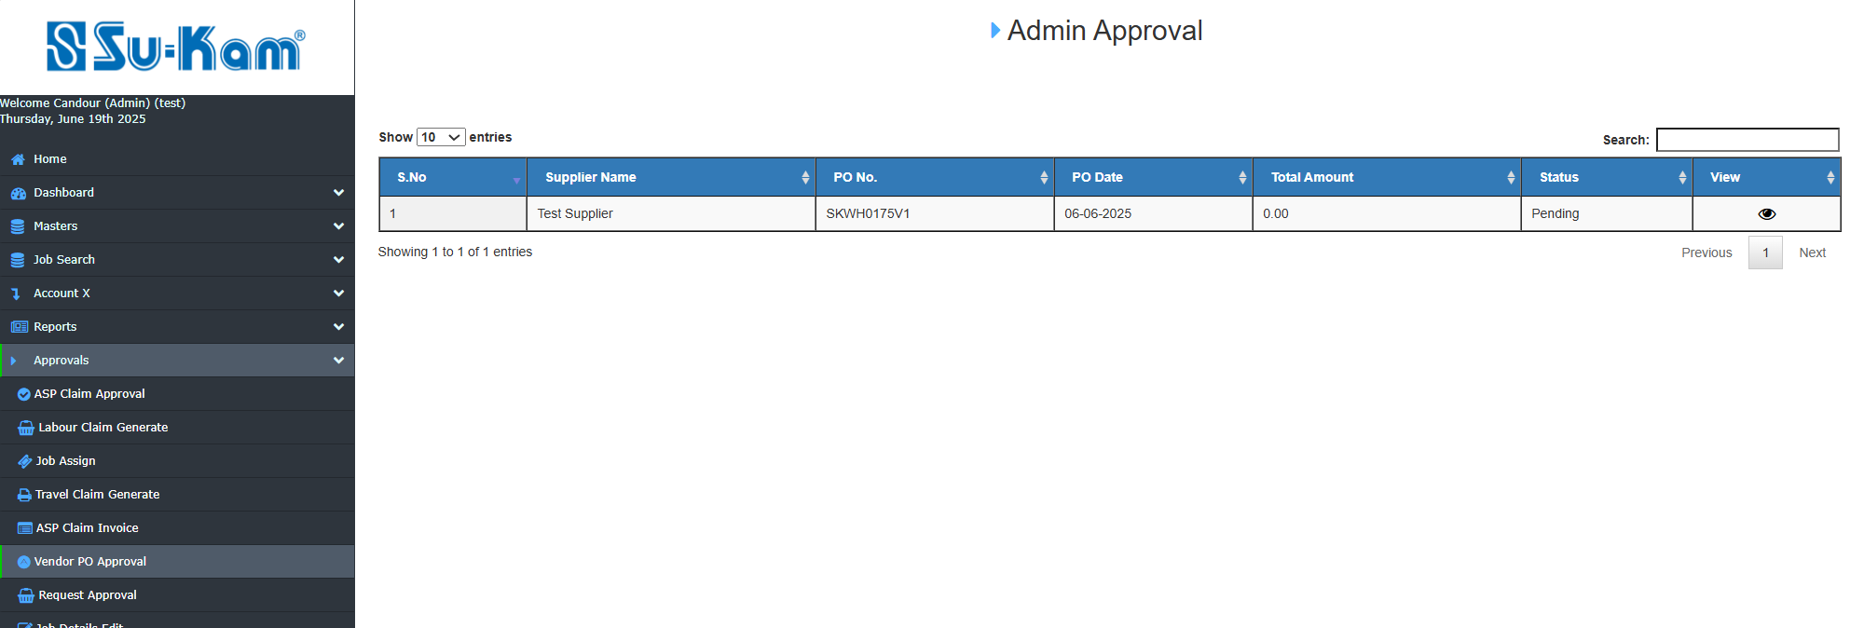

Admin Checked Vendor PO Approval details as per requirement.

Request Approval

Click on Request Approval tab and open below page:

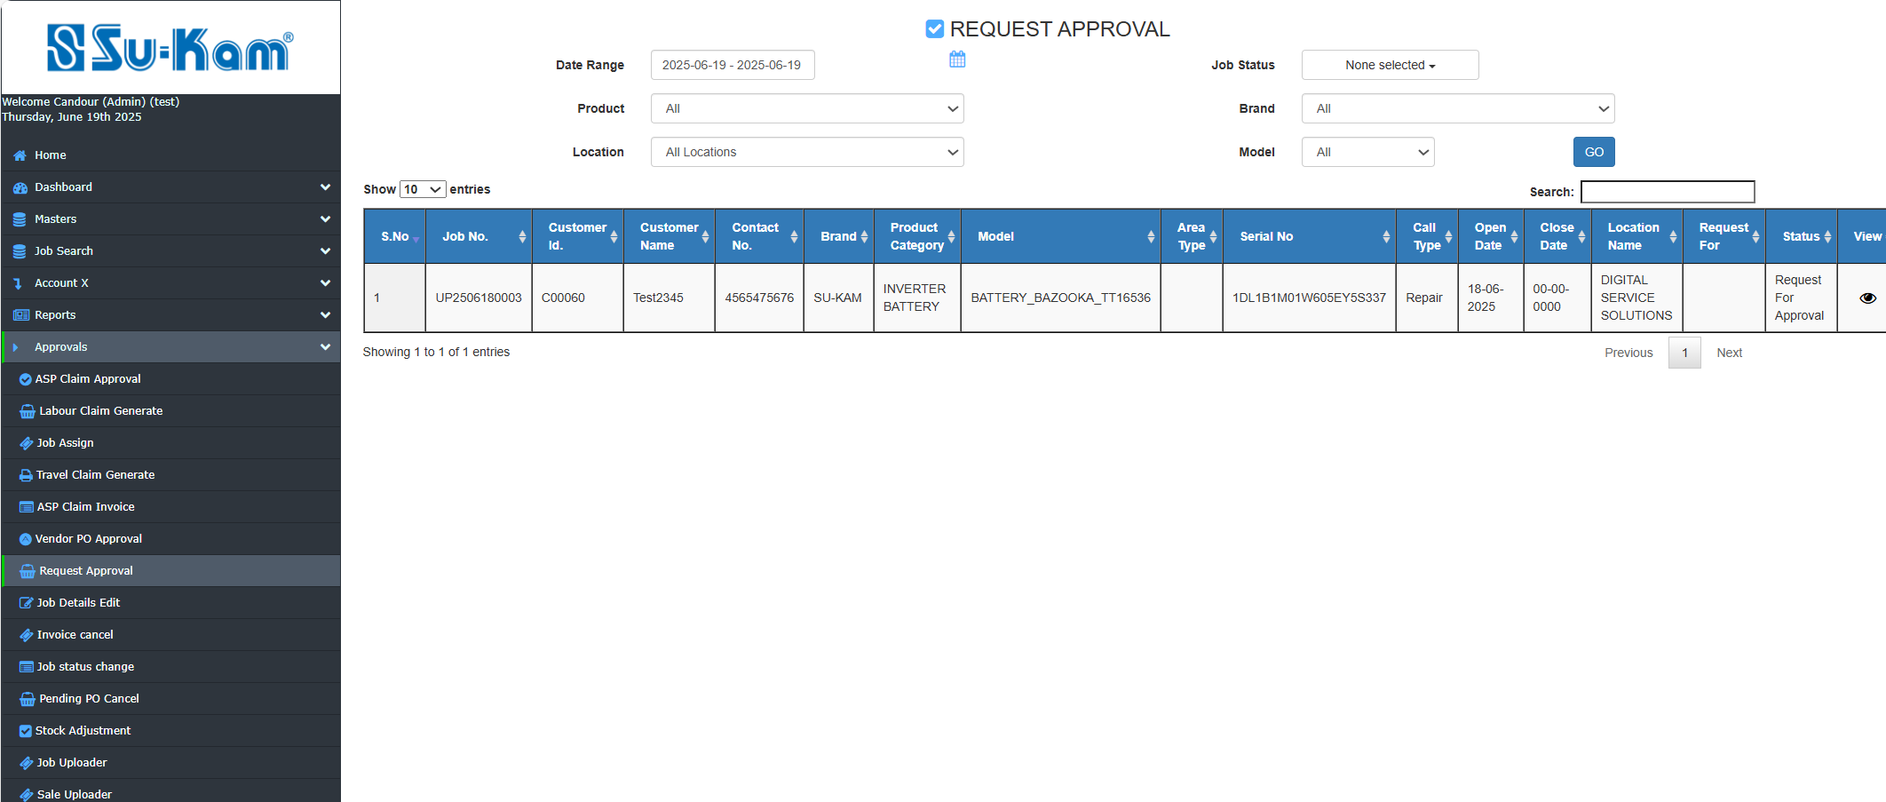

Fill all the details according to your requirements and click on Go button for further details.

Invoice Cancellation

This Menu provides the details of Invoice cancel in this way:

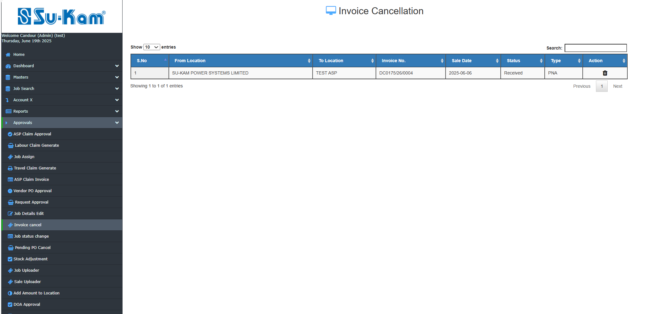

Check out the details here by click on tab as shown above:

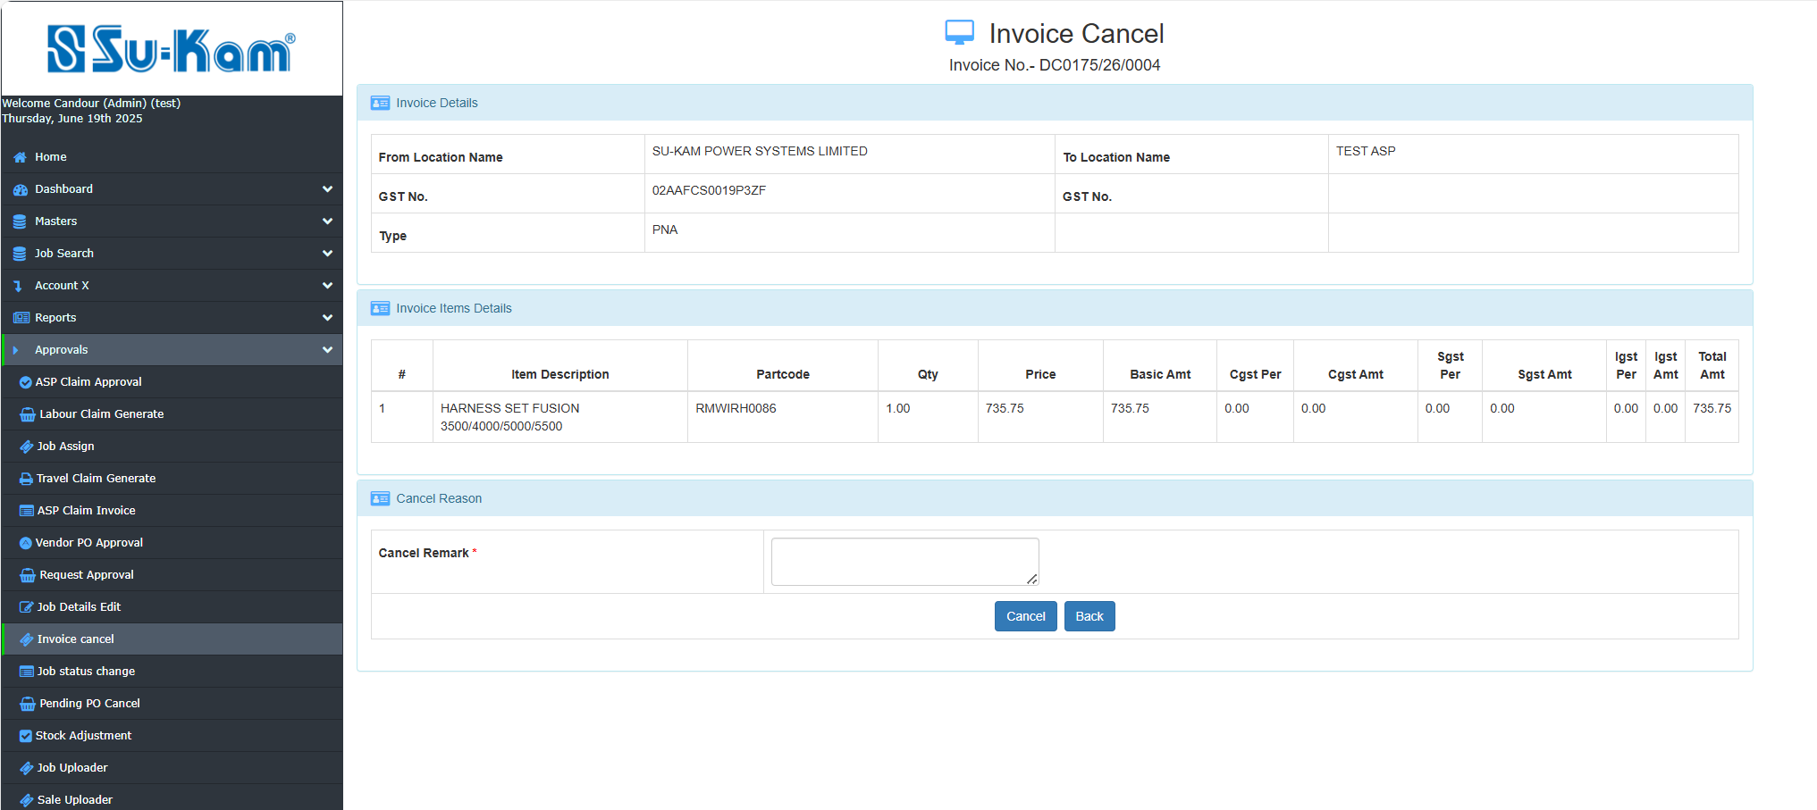

Fill all the details according to your requirements and go for cancel remark.

Job Status Change

Click on the Job Status Change tab under approvals and open the below page:

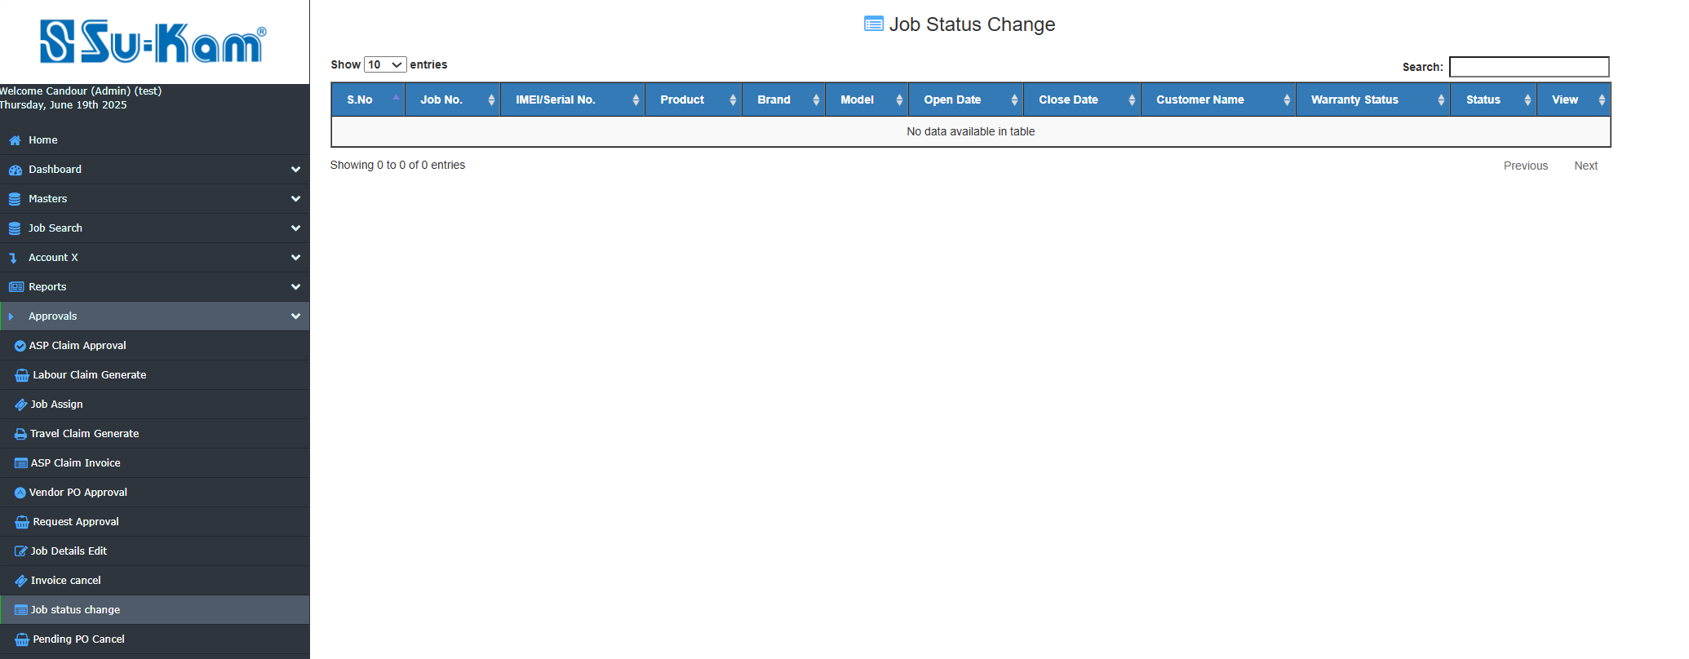
Admin checked all the details of Job status change as per requirement.

Pending PO Cancel

This Menu creates to provide the details of cancellation of Pending PO as shown below:
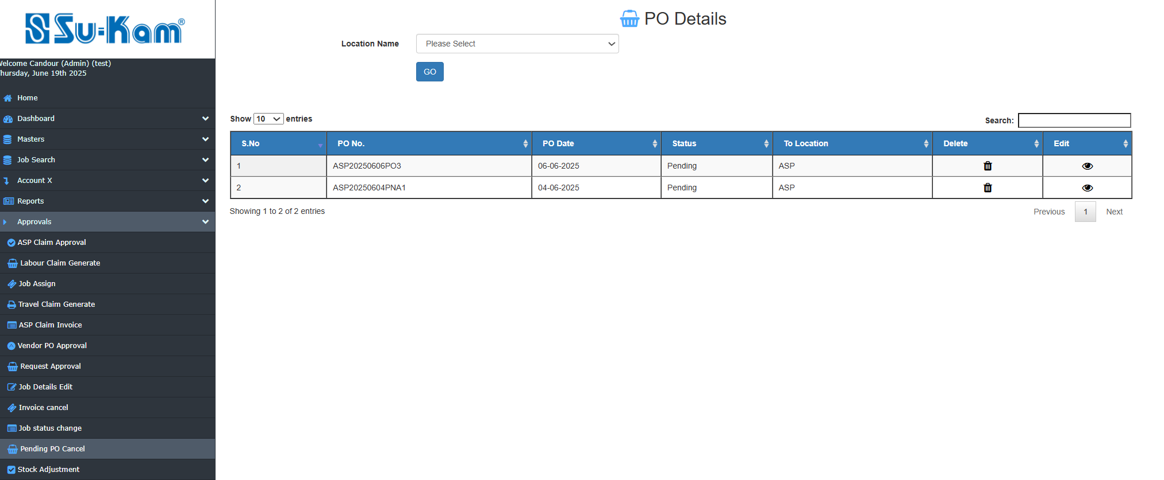

View and check all the details and click on Edit details for further check as per requirements.

Stock Adjustment
This Menu creates to provide the details of stock Adjustment by click on add new entry tab :

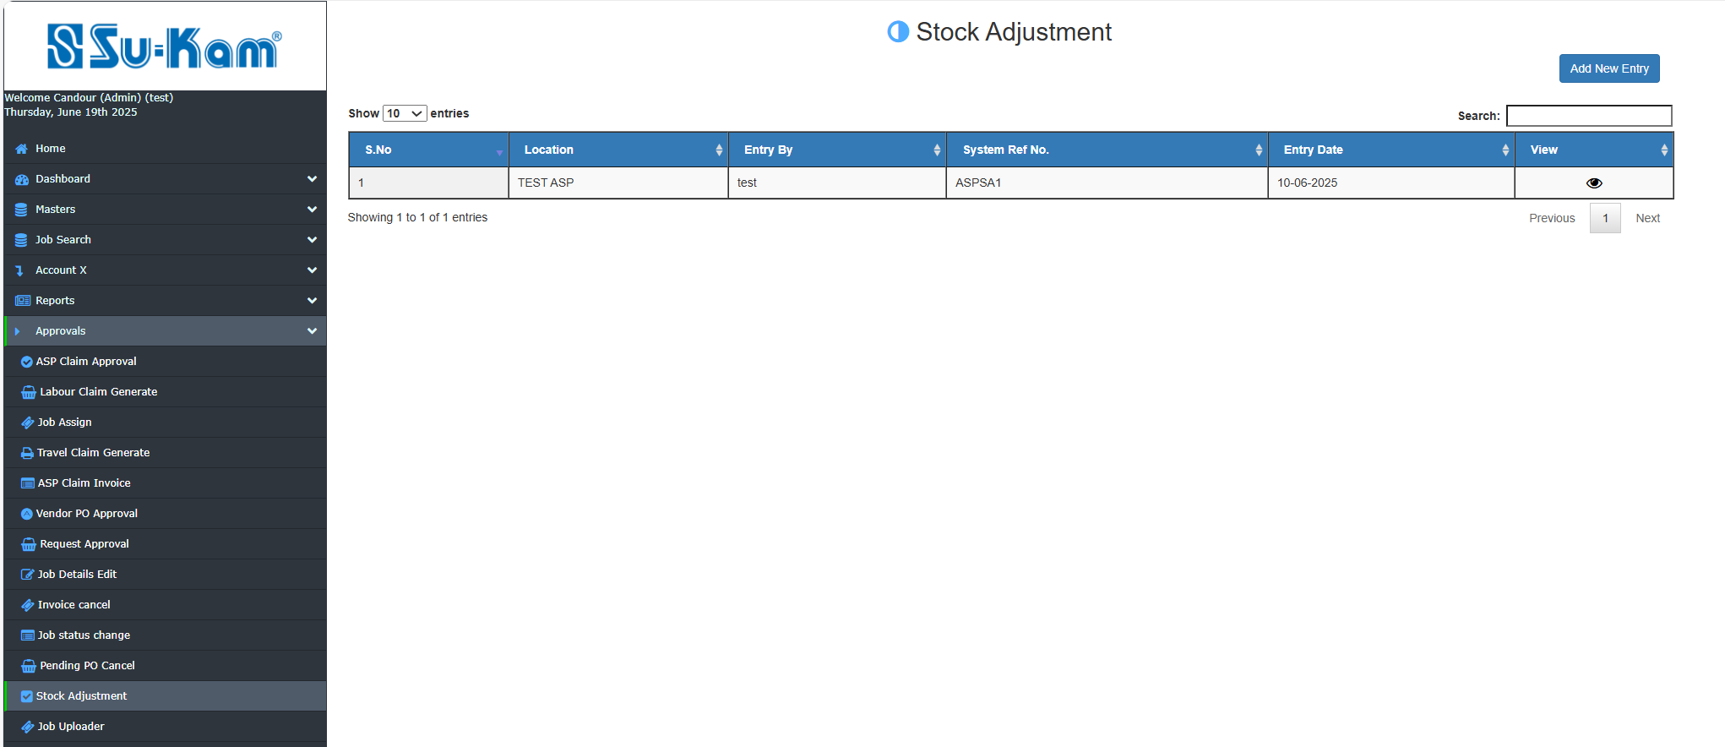

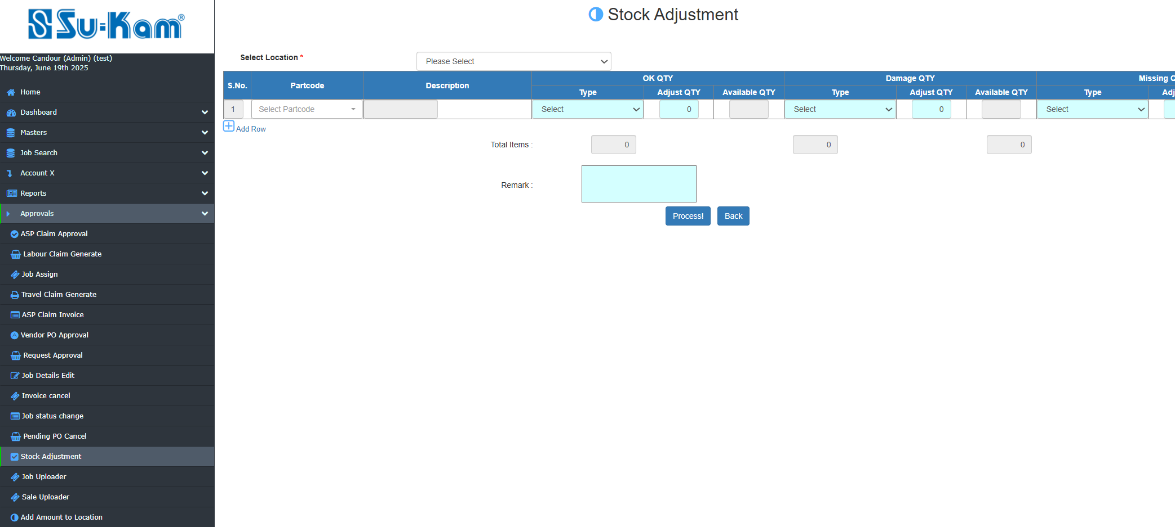
Check all the details of stock adjustment according to admin requirements and process it as well.

Job Uploader
The Job uploader is given to upload Jobs by uploader using given Template.
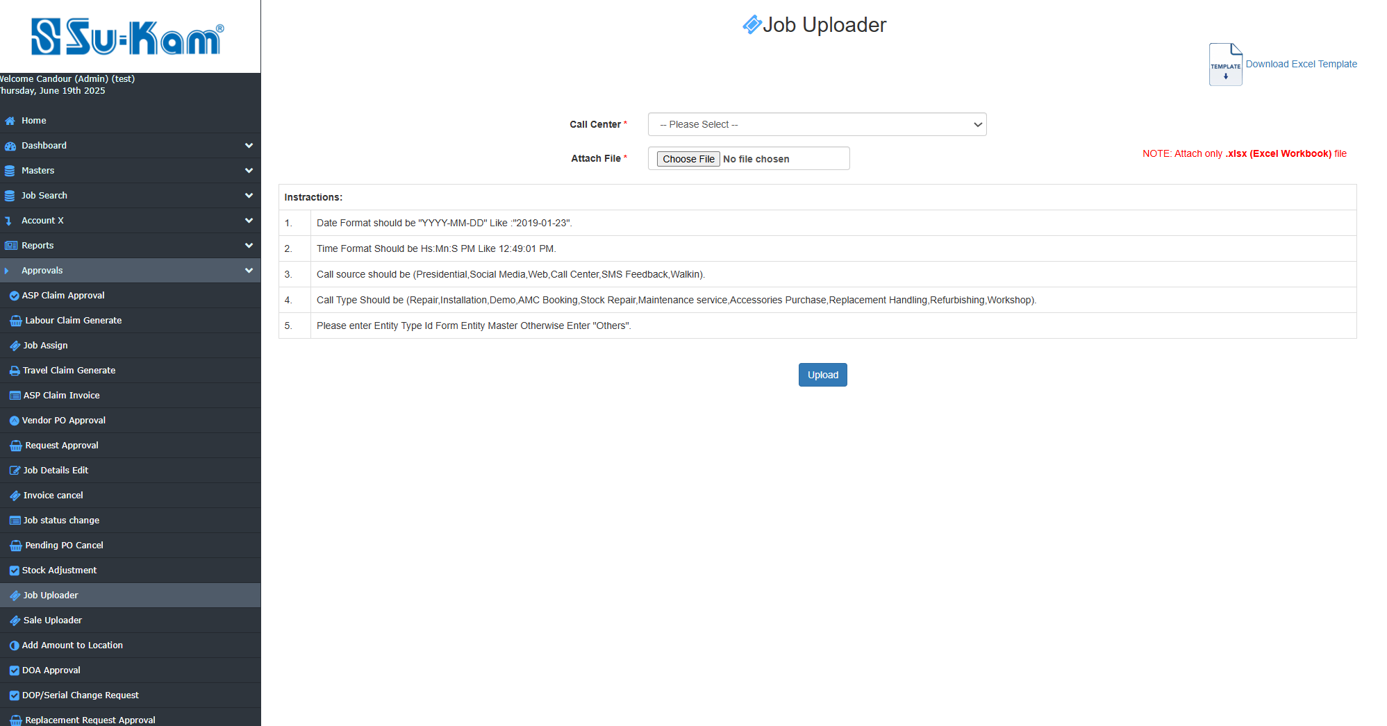

Battery Replacement Process
Battery replacement recommendation/approval request by Engineer will appear in this tab
After approval battery replacement will take place.

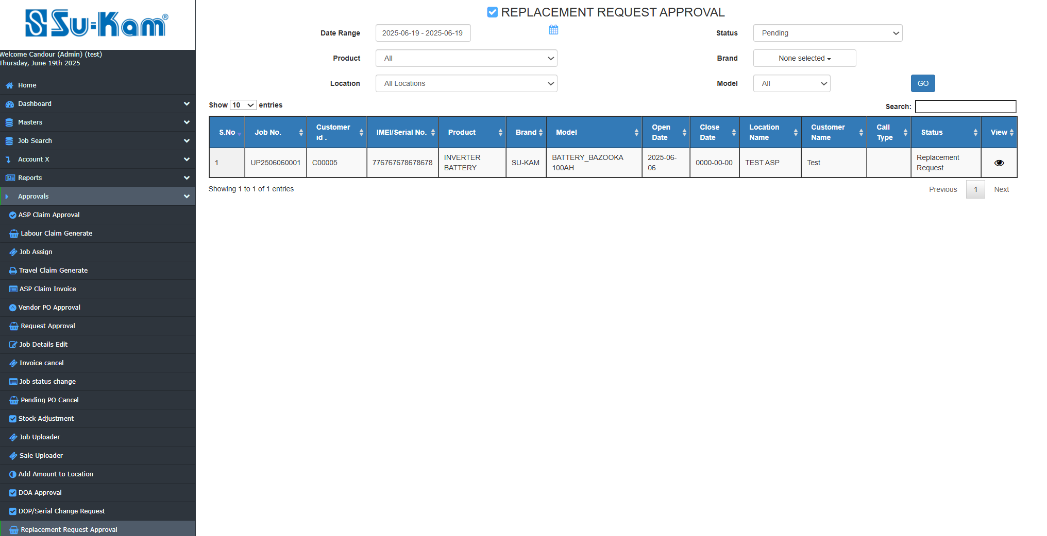
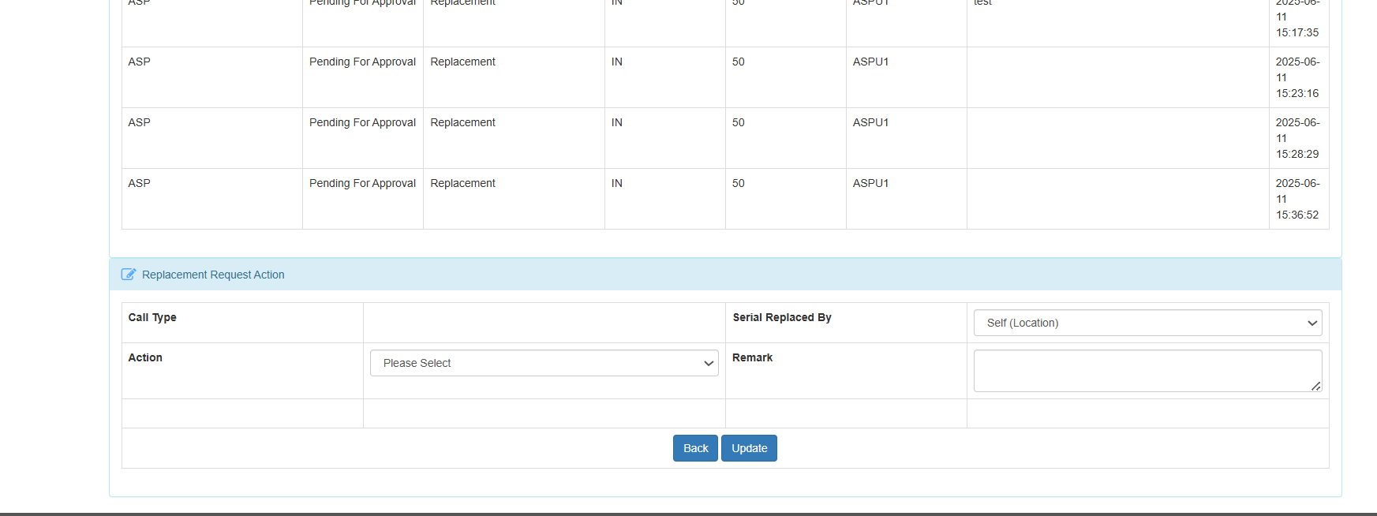

Inverter Replacement Process
Inverter replacement recommendation/approval request by Engineer will appear in this tab
After approval replacement will take place. 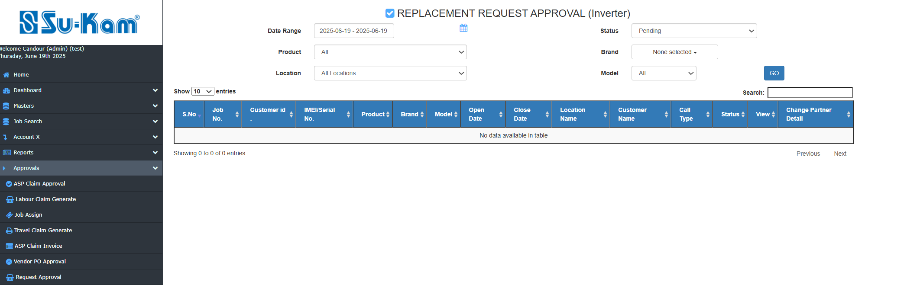

Logout

ADMIN can logout after completion all process as shown in the given image below:

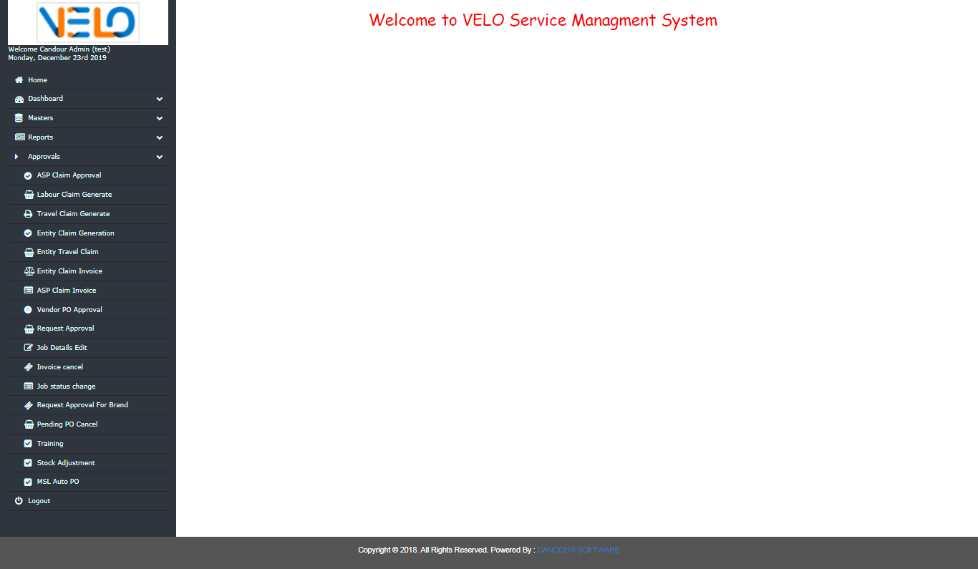

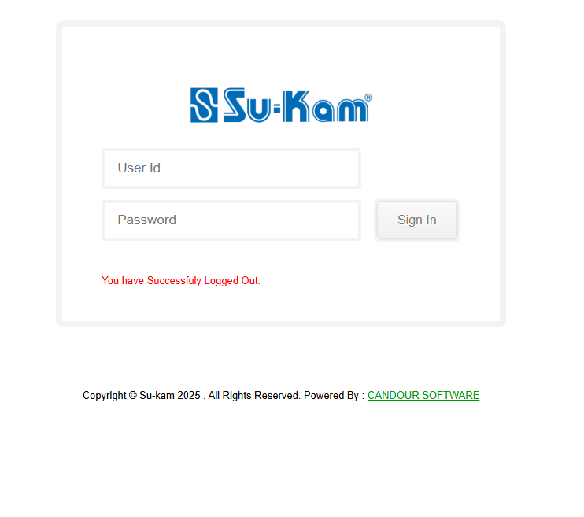

Thank you

